INDEX

S NO | NAME OF THE CHAPTER | PAGE NUMBER
 | ELECTRIC CHARGES AND FIELDS | 04-15
 | ELECTROSTATIC POTENTIAL AND CAPACITANCE | 16-27
 | CURRENT ELECTRICITY | 28-36
 | MOVING CHARGES AND MAGNETISM | 37-47
 | MAGNETISM AND MATTER | 48-57
 | ELECTROMAGNETIC INDUCTION | 58-65
 | ALTERNATING CURRENT | 66-75
 | ELECTROMAGNETIC WAVES | 76-83
 | RAY OPTICS AND OPTICAL INSTRUMENTS | 84-96
 | WAVE OPTICS | 97-110
 | DUAL NATURE OF RADIATION AND MATTER | 111-120
 | ATOMS | 121-126
 | NUCLEI | 127-134
 | SEMICONDUCTOR ELECTRONICS: MATERIALS, DEVICES AND SIMPLE CIRCUITS | 135-144

KVS ZIET BHUBANESWAR
XII PHY CH_1_ELECTRIC CHARGES AND FIELDS
Q. NO | QUESTION
MCQ s 1 MARK EACH
Two similar spheres having +Q and -Q charges are kept at a certain distance. The force F acts between the two charges. If at the middle of two spheres, another similar sphere having +Q charge is kept, then it experiences a force in magnitude and direction as
(A) zero having no direction (B) 8F towards +Q charge
(C) 8F towards -Q charge (D) 4F towards -Q charge.
A charge q is placed at the centre of the line joining two exactly equal positive charges Q. the system of three charges will be in equilibrium, if q is equal to:
(A) –Q/4 (B) +Q (C) –Q (D) Q/2
Which of the following statements is / are incorrect regarding the point charge?
(A). The charge Q on a body is always given by q=ne, where n is any integer, positive or negative.
(B). By convention, the charge on an electron is taken to be negative.
(C). The fact that electric charge is always an integral multiple of e is termed as quantization of charge
D. The quantization of charge was experimentally demonstrated by Newton in 1912.

A charge is a property associated with the matter due to which it produces and experiences:
(A) electric effects only
(B) magnetic effects only
(C) both electric and magnetic effects
(D) none of these
Directions: These questions consist of two statements, each printed as Assertion and Reason. While answering these questions, you are required to choose any one of the following four responses.
(A) If both Assertion and Reason are correct and the Reason is a correct explanation of the Assertion.
(B) If both Assertion and Reason are correct but Reason is not a correct explanation of the Assertion.
( C) If the Assertion is correct but Reason is incorrect.
(D ) If both the Assertion and Reason are incorrect.

Assertion : Charge is quantized
Reason : Charge which is less than 1C is not possible

Assertion : -In electrostatics, electric lines of force can never be closed loops.
Reason : -The number of electric lines of force originating from or terminating on a charge is proportional to the magnitude of charge.

Assertion : - If a conducting medium is placed between two charges, then electric force between them becomes zero
Reason : - Reduction in a force due to introduce material is inversely proportional to dielectric constant.
Two point-charges are placed in four media A, B, C and D having dielectric constant 10, 20, 30, 40 respectively. The separation between them is the same in all media. The electrostatic force between the charges will be
- Maximum in medium A and minimum in medium C
- Maximum in medium C and minimum in medium A
- Maximum in medium C and minimum in medium B
- Maximum in medium A and minimum in medium D
Let F₁ be the magnitude of the forces between two small spheres, charged to a constant potential in free space and F₂ be the magnitude of the force between them in a medium of dielectric constant K. Then F₂/F₁ is
- 1/K (b) K (c) K² (d)1/K²
Which of the following tables correctly depicts the variation of electrostatic field (E) with distance (r) due a point charge?
A | Separation | r | 2r | 3r
A | Field | E | E/2 | E/3

B | Separation | r | 2r | 3r
B | Field | E | E/4 | E/9

C | Separation | r | 2r | 3r
C | Field | E | 2E | 3E

D | Separation | r | 2r | 3r
D | Field | E | 4E | 9E

Two conducting spheres X and Y having radii in the ratio 1:2 contain equal positive charges. When the two spheres are connected by a conducting wire
- electrons would move from X to Y
- protons would move from X to Y
- electrons would move from Y to X
- protons would move from Y to X
Four electric dipoles a, b, c and d are present in a constant electrostatic field as shown in the figure. Their dipole moments are indicated by the arrows. Which of the following statements is incorrect? 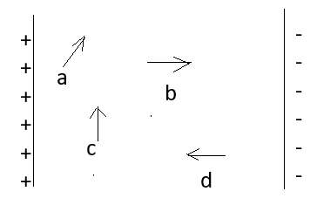

- dipole ‘a’ is in a state of minimum potential energy
- dipole ‘c’ experiences maximum torque
- dipoles b and d are in equilibrium
- dipole ‘c’ has zero potential energy
Some point charges are enclosed by four closed surfaces S₁, S₂, S₃ and S₄ as shown in the figures. The ratio of areas of these surfaces are 1:2:3:4. The Electric flux through the surface
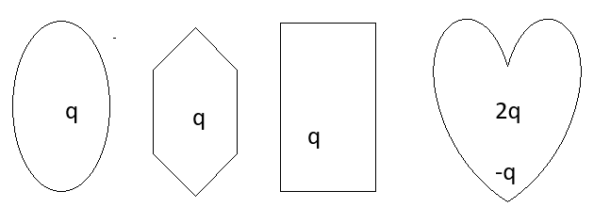
S1 S2 S3 S4

- S₁ is maximum and S₄ is minimum
- S₂ is maximum
- S₄ is maximum
- is the same for all the figures.
Three large plane sheets having charge densities σ, - σ and σ are placed parallel to each other as shown in the figure. The magnitudes of electric field at point X, Y and Z are respectively

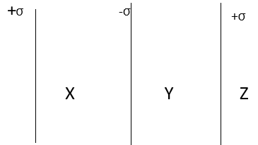

- σ/ϵ₀, σ/ϵ₀, σ/2ϵ₀,
- σ/2ϵ₀, σ/ϵ₀, σ/2ϵ₀
- σ/2ϵ₀, σ/2ϵ₀, σ/2ϵ₀
- σ/ϵ₀, σ/2ϵ₀, σ/2ϵ₀
A hemisphere is uniformly charged positively. The electric field at a point on a diameter away from the Centre is directed
- perpendicular to the diameter
- parallel to the diameter
- at an angle tilted towards the diameter
- at an angle tilted away from the diameter
Three particles are projected in uniform electric field with same velocity perpendicular to the electric field as shown in the figure. The particle having highest charge to mass ratio is-
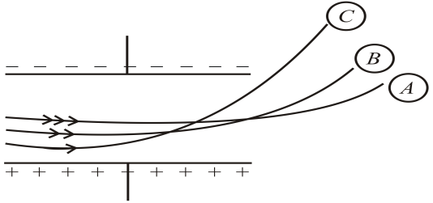
- B
- A
- C
- All have same

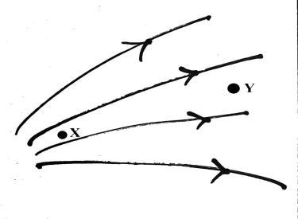
The correct statement for the electric fields at point X and Y is-
- $E_{X}=E_{Y}$
- $\vec{E_{X}}=\vec{E_{Y}}$
- $E_{X}>E_{Y}$
- $E_{X}<E_{Y}$
Three identical positive point charges are kept at the vertices of an isosceles right-angled triangle. The direction of electric field at the midpoint P of the hypotenuse along-
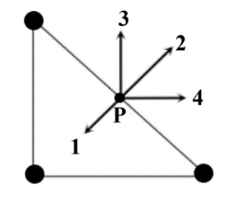
- 4
- 1
- 3
- 2

A conducting circular ring is charged with +Q. The electric field at the centre O of the ring due to the charge on the part APB of the ring is E. The electric field at the centre O of the ring due to the charge on the part BDCA of the ring is-
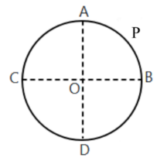
- 3E along PO
- E along OP
- E along PO
- 3E along OP
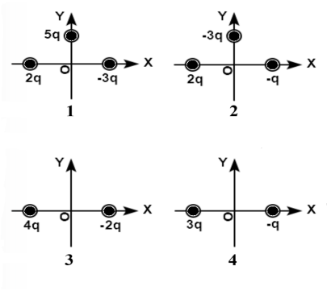
In the following four situations, the charges are kept at an equal distance from the origin O. The correct choice for the magnitude of the net electric field at origin is-

- $E_{1}>E_{2}>E_{3}>E_{4}$
- $E_{2}>E_{1}>E_{3}>E_{4}$
- $E_{1}>E_{3}>E_{2}>E_{4}$
- $E_{4}>E_{3}>E_{2}>E_{1}$

 | Why does the gravitational force between Earth and Moon predominate over electrical forces?
 | If a proton at a particular distance from a charged particle is repelled with a given force, by how much will the force decrease when the proton is three times farther away from the particle? What is the sign of charge on the particle?
 | Why will dust be attracted to a CD wiped with dry cloth?
 | At higher altitude the leaves of a charged electroscope collapse more rapidly. Why is that so?
 | When an object acquires a positive charge by the transfer of electrons, what happens to its mass? What happens to its mass if it acquires a negative charge?
VSA 2 MARKS EACH
 | A free proton and a free electron are placed in a uniform field. Which of the two experience greater force and greater acceleration?
a) Explain the meaning of the statement 'electric charge of a body is quantised'.
(b) Why can one ignore quantisation of electric charge when dealing with macroscopic
i.e., large scale charges?

 | How much positive and negative charge is there in a cup of water (180g)?
 | Two charges q and –4q are fixed on x-axis at x=0 and x =a. Where should a third charge 2q be placed such that it will be in equilibrium?
 | Two-point charges A and B having charges Q and -Q exert a force F on each other when separated by a distance d. If 25% percent of charge of A is transferred to B, what will be the force between them?
Two identical plates A and B having charge densities $+σ$and $-σ$are kept as shown in the figure. Obtain the value of electric field in-
- region-I
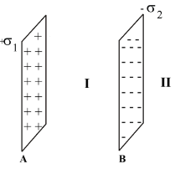
- region-II

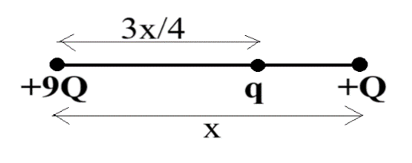
Two charges +9Q and +Q are kept fixed at a separation of x. An unknown charge q placed on the line joining two charges at a distance of $\frac{3x}{4}$ from +9Q so that it may be in equilibrium.

What is your opinion about the stability of equilibrium related to the nature of the unknown charge and why?
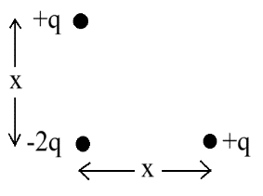
Two charges +q and +q are kept at a same distance x from another charge -2q as shown in the figure.

What is the net dipole moment of this system of charges?
Find the magnitudes of charge $q$ in fig (a) and fig (b) shown below
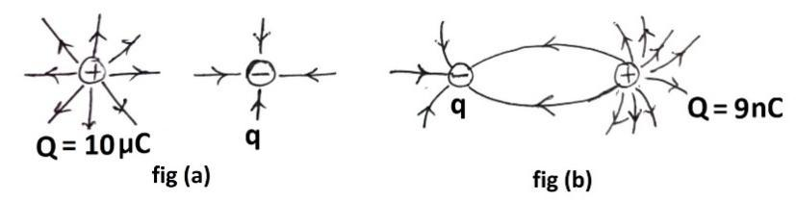
$e^{-}+e^{+}→γ+γ$ is an example of charge conservation, where electron $e^{-} and positron e^{+}$annihilate to give rise to two gamma rays. In pair production $γ→e^{-}+e^{+}$, the converse of annihilation, charge is also conserved. In this process a gamma ray transforms into an electron and a positron.
Why are there two photons, not one in case of pair annihilation as it is converse of production?
 | No work is done in moving a test charge over an equipotential surface. Explain.
SA 3 MARKS EACH
 | A point charge of 2.0 x10⁻⁶ C is at the centre of a cubic Gaussian surface 9.0 cm on edge. What is the net electric flux through the surface?
Using Gauss’ law derive an expression for the electric field intensity due to a large plane sheet of surface charge density σ.
A test charge q₀ placed at a small distance from a large plane sheet of charge experiences a force F. What will be the force on it if the distance is doubled?
 | A wire PQ of length L has a linear charge density λ = kx, where x is measured from end P of the wire. The wire is enclosed by a Gaussian cylindrical surface. Find the expression for the electric flux through this surface.
 | Riya takes two identical charged balls having mass m and charge q and suspends them from ceiling with the help of two strings of length $l$. If each threads makes a very small angle $θ$ with the vertical, prove that, in equilibrium the separation between two balls will be $x={(\frac{q^{2}l}{2πϵ_{0}mg})}^{\frac{1}{3}}$
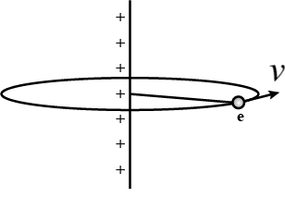
An electron is revolving around an infinitely long positively charged wire having linear charge density $λ$ with a uniform velocity v as shown in the figure. Prove that, the kinetic energy of the electron is $K=\frac{eλ}{4πϵ_{0}}$

What is the ratio of magnitude of the repulsive electrostatic force to gravitational force between two of the protons that are separated by $4.0 ×{10}^{-15}$ m?
What does this ratio signify?
a. A point charge $q$ is at a distance of $d/2$ directly above the centre of a square of side$d$. Use Gauss’s law to obtain the expression for electric flux through the square.
b. If the point charge $q$ is now moved to a distance $d$ away from the centre of the square and the side of the square is doubled, explain how the electric flux will be affected.
If the magnitude of an electric field in air exceeds a certain critical value, the air undergoes electrical breakdown, a process whereby the field removes electrons from the atoms in the air. The air then begins to conduct electric current because the freed electrons are propelled into motion by the field. As they move, they collide with any atoms in their path, causing those atoms to emit light.
- What is name of this critical value of electric field?
- Electric filed produced by tips of a comb is stronger in comparison to field produced by a large charged sphere for both having same amount of charge. Why?
 | CASE BASED QUESTIONS 4 MARKS
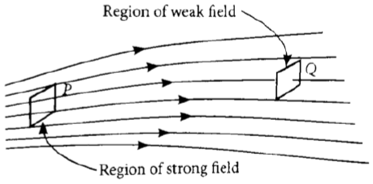
Electric field strength is proportional to the density of lines of force i.e., electric field strength at a point is proportional to the number of lines of force cutting a unit area element placed normal to the field at that point. As illustrated in given figure, the electric field at P is stronger than at Q.

(i)Electric lines of force about a positive point charge are
(A) radially outwards
(B) circular clockwise
(C) radially inwards
(D) parallel straight lines
(ii) Which of the following is false for electric lines of force?
(A) They always start from positive charge and terminate on negative charges.
(B) They are always perpendicular to the surface of a charged conductor.
(C) They always form closed loops.
(D) They are parallel and equally spaced in a region of uniform electric field. ? (iii) Which one of the following patterns of electric line of force is not possible in field due to stationary charges?
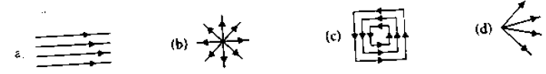
(iv) Electric field lines are curved
(A) in the field of a single positive or negative charge
(B) in the field of two equal and opposite charges.
(C) in the field of two like charges.
(D) both (b) and (c)
An electric dipole is a system consisting of two equal and opposite point charges separated by a small distance. If a dipole is placed in an external uniform electric field it experiences a torque whereas the net force on the dipole is zero.
- the torque on the diploe is given by
- Ʈ= p x E. b) Ʈ= E x p c) Ʈ= p.E d) Ʈ= -p x E.
- Which of the following configuration corresponds to maximum torque on the dipole?
- p parallel to E
- p antiparallel to E
- p perpendicular to E
- p making 30⁰ with E
- A plastic comb rubbed on dry hair attracts tiny bits of paper although the paper is electrically neutral. Explain why.
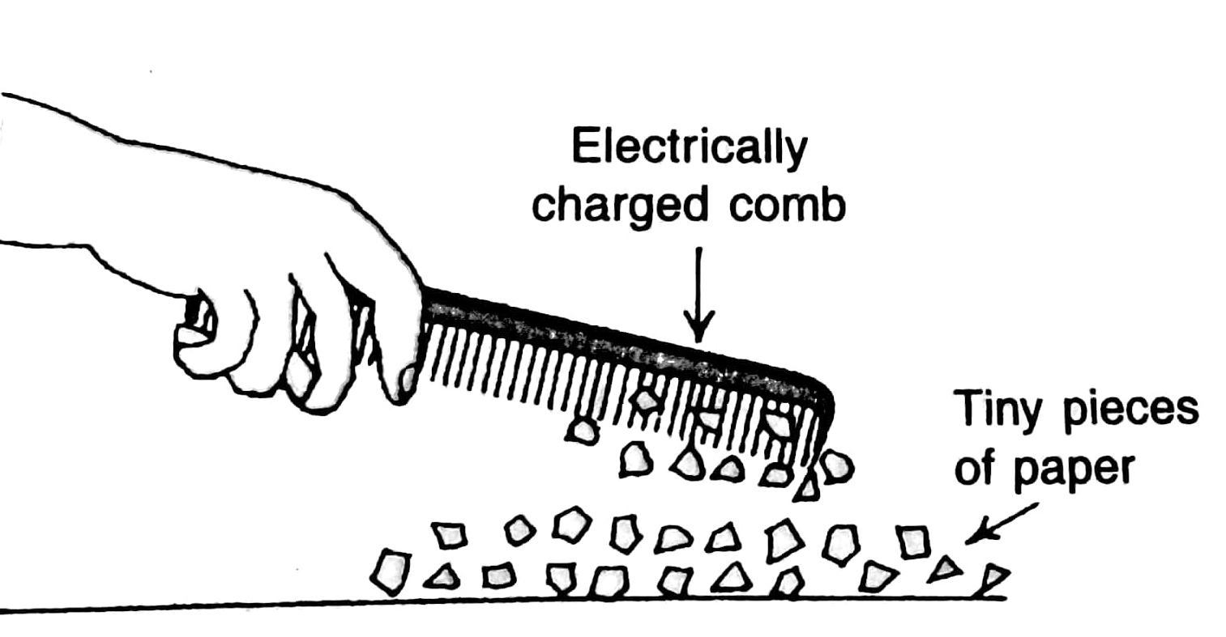
Diya and Raj, two students of Kendriya Vidyalaya having discussions on electric charge. Diya concludes the discrete nature of charges known as quantization of charges.
Quantization of Electric Charges
The smallest charge that can exist in nature is the charge of electron. During friction it is only the transfer of electrons which makes the body charged. Positive charge means absence of electrons whereas negative charge means excess of electrons. The net charge on a body is an integral multiple of charge of an electron; $q=±ne$, where $n=$ 1, 2, 3… Hence, no body can have a charge valued 1.1e, 2.5e, 0.6e etc.
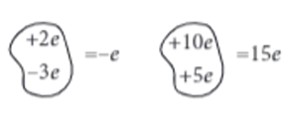
Now Raj concludes the continuous nature of charges known as continuous charge distribution.
Continuous Charge Distribution
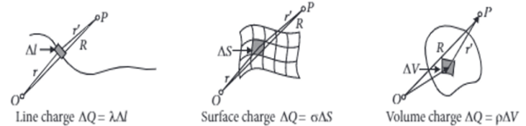
In reality the magnitudes of charges are much higher than magnitude of charge of electron. So the discrete nature of charges is ignored and it is imagined that the charge is distributed in a space in continuous manner. Such a charge distribution is known as continuous charge distribution. There are three types of continuous charge distribution: (1) Linear charge distribution, (2) Surface charge distribution (3) Volume charge distribution.

- The following charge that is not possible in reality-
- $3.2×{10}^{-18} C$ (b) $5.8×{10}^{-18} C$ (c) $4.8×{10}^{-19} C$ (d) $9.6×{10}^{-18} C$
- If a body has a charge of $-1 nC$, then no. of electrons accepted by the body is-
- $1.6×{10}^{19}$ (b) $6.25×{10}^{27}$
- $1.6×{10}^{19}$ (d) $6.25×{10}^{9}$
- The SI unit of linear charge density is-
(a) $Cm$ (b) $Cm^{-1}$ (c) $Cm^{-2}$ (d) $Cm^{-3}$
- The charge is required to electrify a sphere of radius 25 cm to set up a surface charge density of magnitude $\frac{3}{π}$ is-
- 0.75 C (b) 7.5 C (c) 75 C (d) zero
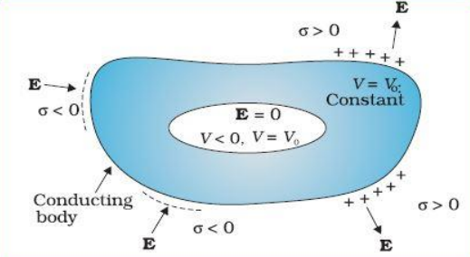
The electric field inside the cavity is zero, whatever be the size and shape of the cavity and whatever be the charge on the conductor and the external fields in which it might be placed. The electric field inside a charged spherical shell is zero. But the vanishing of electric field in the (charge free) cavity of a conductor is, as mentioned above, a very general result. A related result is that even if the conductor is charged or charges are induced on a neutral conductor by an external field, all charges reside only on the outer surface of a conductor with cavity.
The proofs of the results noted in Fig. are omitted here, but we note their important implication. Whatever be the charge and field configuration outside, any cavity in a conductor remains shielded from outside electric influence: the field inside the cavity is always zero. This is known as electrostatic shielding. The effect can be made use of in protecting sensitive instruments from outside electrical influence.

- The electric field inside the cavity is depend on-
(a) size of the cavity (b) shape of the cavity
(c) charge on the conductor (d) none of these
- A metallic shell having inner radius $r_{1}$ and outer radius $r_{2}$ has a point charge Q kept inside cavity. Electric field in the region $r_{1}<r<r_{2}$ where $r$ is the distance from the centre is given by-
- depends on the value of r (b) zero
(c) constant and nonzero everywhere (d) none of these
- Electrostatic shielding is based on-
- electric field inside the cavity of a conductor is less than zero
- electric field inside the cavity of a conductor is zero
- electric field inside the cavity of a conductor is greater than zero
- electric field inside the cavity of a plastic is zero
- During the lightning thunderstorm, it is advised to stay-
- inside the car (b) under trees
(c) in the open ground (d) on the car
Smallest charge that can exist in nature is the charge of an electron. During friction it is only transfer of electrons which makes the body charged. Hence net charge on anybody is an integral multiple of charge of an electron [1.6 x 10⁻¹⁹C] i.e. q= ±ne, where n= 1,2,3…..
Hence nobody can have a charge represented as1 i.e. 2.7 e,3/5 e, etc. units called quarks.
Recently, it has been discovered that elementary particles such as protons or neutrons are composed of more elemental.
- Which of the following properties is not satisfied by an electric charge?
- Total charge conservation
- Quantization of charge
- Two types of charge
- Circular line of force

- Which of the following charges is possible?
- 5.8 x 10⁻¹⁸C
- 3.2 x 10⁻¹⁸ C
- 4.5 x 10²⁸ C
- 6.25 x 10-¹⁹C

- If a charge on a body is 1nC, then how many electrons are present on the body?
- 6.25 x 10 ²⁷
- 1.6 x 10¹⁹
- 6.25 x 10²⁸
- 6.25 x 10⁹

- If a body gives out 10⁹ electrons every second, how much time is required to get a total charge of 1C from it?
- 190.19 years
- 150.12 years
- 198.19 years
- 188.21 years
Gaussian surface is the surface around a charge (point or continuous distribution) is an imaginary closed surface, such that the intensity of electric field at all points on its surface is same. Gaussian surface is an imaginary geometric surface and it may be in empty space or embedded in a solid body.

(i) Charge q is first kept in a sphere of radius 7 cm and then it is kept in a cube of side 7 cm. The outgoing flux
(a) will be more in case of sphere
(b) will be more in case of cube
(c) will be same in both cases
(d) cannot be determined

(ii) The electric flux through a cubical Gaussian surface enclosing net charge q is q/ε₀, while the electric flux through one face of the cube is
(a) q/ε₀
(b) q/4ε₀
(c) q/6ε₀
(d) q/8ε₀

(iii) The electric flux of a flat square having an area of 10 m² placed in a uniform electric field of 8000 N/C passing perpendicular to it is
(a) 8 x 10⁵ Nm²/C
(b) 8 x 10⁴ Nm²/C
(c) 16 x 10⁵ Nm²/C
(d) 4 x 10⁴ Nm²/C

(iv) Gauss’s law is valid for
(a) any open surface
(b) any closed surface
(c) only regular closed surface
(d) only irregular open surface
ANSWERS FOR MCQs
 | C
 | A
 | D
 | C
 | C
 | B
 | A
 | D
 | A
 | B
 | C
 | A
 | D
 | C
 | A
 | (c) C
 | (c) $E_{X}>E_{Y}$
 | (d) 2
 | (b) E along OP
 | (c) $E_{1}>E_{3}>E_{2}>E_{4}$
 | As both are neutral, there is zero electrostatic force.
 | Force will reduce to 1/9th of original value. Charge is positive.
 | Due to friction, charge transfer takes place between CD and cloth and CD becomes charged.
 | At higher altitude, cosmic radiation ionises air surrounding leaves and they discharge rapidly and collapse faster.
 | In case of gained positive charge, body loses electrons, thus it loses slight mass and in case of gained negative charge, body receives electrons, thus it gains a slight mass.
ANSWERS FOR VSA ( 2 MARKS)
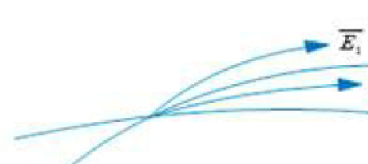
As F = q E and a = F/m as charge on both e-1 and proton are equal and opposite in nature, so force on them would be equal but as mass of proton is more than that of electron, so acceleration of electron would be more.

(a) Electric charge of a body is quantized. This means that only integral (1, 2, …., n)
number of electrons can be transferred from one body to the other. Charges are not
transferred in fraction. Hence, a body possesses total charge only in integral multiples of
electric charge.
(b) In macroscopic or large scale charges, the charges used are huge as compared to the
magnitude of electric charge. Hence, quantization of electric charge is of no use on
macroscopic scale. Therefore, it is ignored and it is considered that electric charge is
continuous.

1 mole water contains N_{A} molecules
18 g of water contains 6x10²³ molecules
180 g of water contains 6x10²⁴ x 10 electron=6x10²⁵ x 1.6x10⁻¹⁹C = 10⁻⁷ coulomb

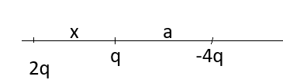
Solving for x, you get x = -a
F=kQ²/d²
Now charge of A=0.75Q and charge of B= Q/4-Q=-0.75Q
New Force, F’ = k (0.75Q)²/d²= (9/16). F
In region-I,
Total field $\vec{E}=\vec{E_{A}}+\vec{E_{B}}=\frac{σ}{2ϵ_{0}}\hat{r}+\frac{σ}{2ϵ_{0}}\hat{r}=\frac{σ}{ϵ_{0}}\hat{r}$ (Since, they are in same direction)
In region-II,
Total field $\vec{E}=\vec{E_{A}}+\vec{E_{B}}=\frac{σ}{2ϵ_{0}}\hat{r}+\frac{σ}{2ϵ_{0}}(-\hat{r})=0$ (Since, they are in opposite direction)
If unknown charge q is considered as negative and it is shifted slightly towards +Q, due to strong attraction from +Q it will never come back to its equilibrium position. Thus, the equilibrium will be unstable for negative charge.

If unknown charge q is considered as positive and it is shifted slightly towards +Q, due to strong repulsion from +Q it will again come back to its equilibrium position. Thus, the equilibrium will be stable for positive charge.

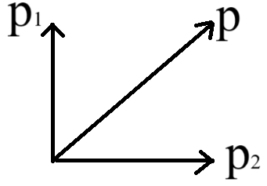
It can be considered as two dipoles with charges -q and +q.
Thus, net dipole moment $\vec{p}=\vec{p_{1}}+\vec{p_{2}}$
$∴p={({p_{1}}^{2}+{p_{2}}^{2})}^{\frac{1}{2}}={[{(qx)}^{2}+{(qx)}^{2}]}^{\frac{1}{2}}=√2 qx$

- $q=5μC$
- $q=4.5 nC$
 | Due to conservation of linear momentum
 | For a definite work done, there should be a potential difference.
ANSWERS FOR SA ( 3 MARKS)
1 | Hence, electric flux through one face of the cube i.e., through the square,  = q / 6€₀  = 2.0 x10⁻⁶ C / 6 x8.85 x10⁻¹²  =1.88 x10⁵ Nm² C⁻²
2 | Derivation (2)  No change in the force as the field E is uniform (1)
3 | Charge in the wire PQ  Q = $\int_{0}^{L}{}kx dx$ = kx²/2=kL²/2  Flux = Q/ϵ₀ = kL²/2ϵ₀
4 | 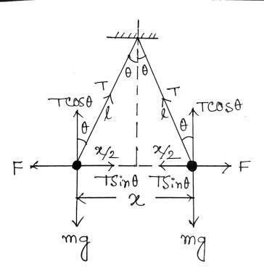  At equilibrium,  $Tsinsin θ =\frac{1}{4πϵ_{0}}\frac{q^{2}}{x^{2}}$ ------------- (1)  $Tcoscos θ =mg$ ---------------- (2)  (1)$÷$(2)$⇒$ $tantan θ =\frac{q^{2}}{4πϵ_{0} mg x^{2}}$ ------ (3)  Now for very small $θ (θ→0°)$, $tantan θ ≈sinsin θ =\frac{\frac{x}{2}}{l}=\frac{x}{2l}$  Substituting the value of $tantan θ$ into equation (3),  $$x={(\frac{q^{2}l}{2πϵ_{0}mg})}^{\frac{1}{3}}$$
5 | 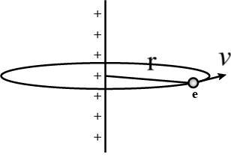  $eE=\frac{mv^{2}}{r}$ (r is the radius and E is the electric field due to infinitely long charged wire)  $⇒e.\frac{λ}{2πϵ_{0}r}=\frac{mv^{2}}{r}$  $⇒mv^{2}=\frac{eλ}{2πϵ_{0}r}$  $∴K.E=K=\frac{1}{2}mv^{2}=\frac{eλ}{4πϵ_{0}r}$
6 | - ${10}^{36}$  - $Gravitaoinal force is too weak than electrostaic force.$
7 | - $q/6ϵ_{0}$  - Flux will remain unchanged.
8 | - Dielectric Strength  - Due to higher surface charge density at tips due to smaller surface area.
ANSWERS FOR CBQ ( 4 MARKS)
1 | (i) a (ii) c (iii) c (iv) d
2 | A  C  The non-uniform field produced by the comb induces dipoles in the molecules of paper. The charges in the dipole experience unequal forces causing a net force towards the comb.
3 | - (b) ii. (d) iii. (b) iv. (a)
4 | i. (d) ii. (b) iii. (b) iv. (a)
5 | - D  - B  - D  - C
6 | - C  - C  - B  - B

XII PHY CH_2_ELECTROSTATIC POTENTIAL AND CAPACITANCE
Q. NO | QUESTION
MCQ s 1 MARK EACH
1 | 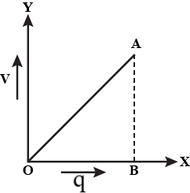  The charge q on a capacitor varies with potential difference as shown in the figure. The area under the curve represents-  - electric field between the plates  - electric flux between the plates  - energy density  - energy stored by the capacitor
2 | 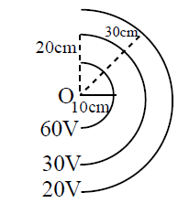  The figure shows some concentric equipotential surfaces. The correct choice related to the electric field and its direction is-  - $E∝\frac{1}{r}$ and radially inward  - $E∝\frac{1}{r^{2}}$ and radially outward  - $E∝\frac{1}{r}$ and radially outward  - $E∝\frac{1}{r^{2}}$ and radially inward
3 | Two identical metallic plates A and B are kept parallel to each other in air, separated by 1 cm distance as shown in the figure. The work done in moving a charge of $20 nC$ from X to Y is-  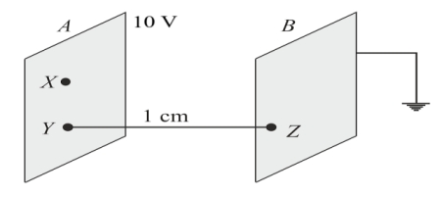  - 1000 J  - 20 J  - 200 J  - Zero
4 | Two charges +q and +q are placed at two vertices of an equilateral triangle of sides $l$. Aditya brings an unknown charge Q and placed it at the third vertex, but he has done no work in this process. The charge Q is-  - $-\frac{q}{2}$  - $-q$  - $+q$  - Zero
5 | Shruti found that the electric field and potential of a point charge varies with distance as $\frac{1}{r^{2}}$ and $\frac{1}{r}$ respectively. But for electric dipole these quantities varies with distance as $\frac{1}{r^{3}}$ and $\frac{1}{r^{2}}$ respectively. Then electric field and potential for an electric quadrapole varies with distance as-  - $E∝\frac{1}{r^{4}}$ and $V∝\frac{1}{r^{3}}$  - $E∝\frac{1}{r^{5}}$ and $V∝\frac{1}{r^{4}}$  - $E∝\frac{1}{r^{4}}$ and $V∝\frac{1}{r^{3}}$  - $E∝\frac{1}{r^{5}}$ and $V∝\frac{1}{r^{3}}$
6 | 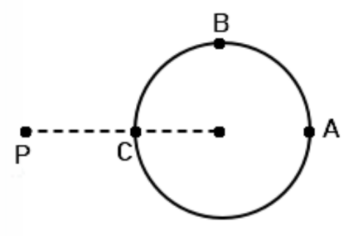  A hollow conducting sphere is placed in an electric field produced by a point charge placed at P as shown in the figure. $V_{A}$, $V_{B}$ and $V_{C}$ are the potentials at points A, B and C respectively. Now looking at this scenario, four friends Ajay, Bijay, Durjay and Srinjay concluded as below,  Ajay- $V_{A}<V_{B}<V_{C}$  Bijay- $V_{A}>V_{B}>V_{C}$  Durjay- $V_{C}>V_{B}=V_{A}$  Srijay- $V_{A}=V_{B}=V_{C}$  The correct conclusion made by-  - Ajay  - Bijay  - Durjay  - Srinjay
7 | Two points are at a distance a and b $(a<b)$ from a long straight conducting wire having linear charge density $λ$. Now Suranjan wants to find the value of potential difference between two points. After getting value Suranjan found that the potential difference between two points is directly proportional to-  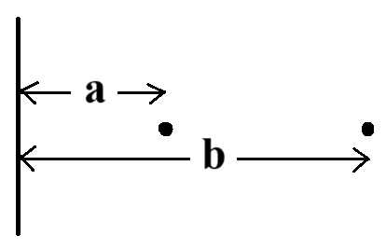  - $\frac{b}{a}$  - $\frac{b^{2}}{a^{2}}$  - ${(\frac{b}{a})}^{\frac{1}{2}}$  - $lnln (\frac{b}{a})$
8 | Samir founds that a conductor has a potential $V≠0$ and there are no charges anywhere else outside. Then he concludes-  - There must be charges on the surface or inside itself.  - There can’t be any charge in the body of the conductor.  - There must be charges only on the surface.  - There must be charges inside the surface.  The correct conclusions are-  - 1 and 4  - 1, 2 and 3  - 1 and 2  - all
9 | The decreasing order of the electrostatic potential energies for the given system of charges will be-  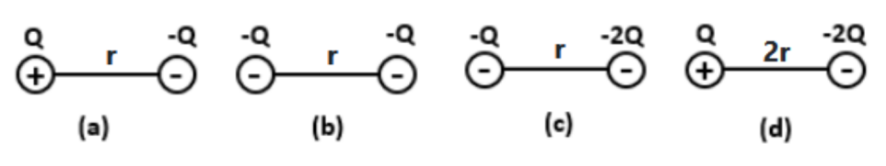  - $c>b>a>d$  - $d>a>c=b$  - $a>c>d=b$  - $c>b>a=d$
10 | To find the equivalent capacitance between X and Y of the given circuit, Ritu, Puja, Abhiraj and Aayan gave the answers 6C, 4C, $\frac{3C}{4}$ and $\frac{6C}{11}$ respectively.  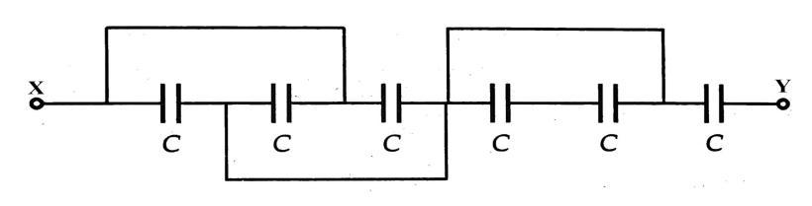  The correct answer is given by-  - Ritu  - Puja  - Abhiraj  - Aayan
11 | An electron moves from point i to point f, in the direction of a uniform electric field. During this displacement:  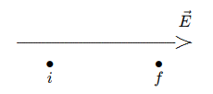  a) The work done by the field is positive and the potential energy of the electron-field system increases.  b) The work done by the field is negative and the potential energy of the electron-field system increases.  c) The work done by the field is positive and the potential energy of the electron-field system decreases.  d) The work done by the field is negative and the potential energy of the electron-field system decreases.
12 | The diagram shows four pairs of large parallel conducting plates. The value of the electric potential is given for each plate. Rank the pairs according to the magnitude of the electric field between the plates, least to greatest  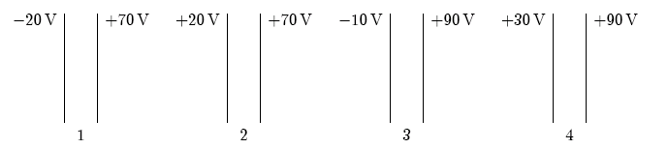  ) 1, 2, 3, 4 b) 4, 3, 2, 1 c) 2, 3, 1, 4 d) 2, 4, 1, 3
13 | Two conducting spheres, one having twice the diameter of the other, are separated by a distance large compared to their diameters. The smaller sphere (1) has charge q and the larger sphere (2) is uncharged. If the spheres are then connected by a long thin wire:  a) 1 and 2 have the same potential  b) 2 has twice the potential of 1  c) 2 has half the potential of 1  d) 1 and 2 have the same charge
14 | The capacitance of a parallel-plate capacitor with plate area A and plate separation d is given by:  a) ɛ₀d/A b) ɛ₀d/2A c) ɛ₀A/d d) ɛ₀A/2d
15 | If both the plate area and the plate separation of a parallel-plate capacitor are doubled, the capacitance is:  a) doubled b) halved c) unchanged d) tripled
16 | An electron is accelerated from rest through a potential difference V. Its final speed is proportional to:  a) V b) V/2 c) √V d) 1/V
17 | Capacitors A and B are identical. Capacitor A is charged so it stores 4 J of energy and capacitor B is uncharged. The capacitors are then connected in parallel. The total stored energy in the capacitors is now:  a) 16 J b) 8 J c) 4 J d) 2 J
18 | a) If both Assertion and Reason are true and Reason is correct explanation of Assertion.  b) If both Assertion and Reason are true but Reason is not the correct explanation of Assertion.  c) If Assertion is true but Reason is false.  d) If both Assertion and Reason are false.  Assertion(A): No work is done in moving a test charge from one point to another over an equipotential surface.  Reason(R): Electric field is always normal to the equipotential surface at every point.
19 | Assertion (A): Capacity of a conductor is independent on the amount of charge on it.  Reason (R): Capacitance depends on the dielectric constant of surrounding medium, shape and size of the conductor.  a) If both Assertion and Reason are true and Reason is correct explanation of Assertion.  b) If both Assertion and Reason are true but Reason is not the correct explanation of Assertion.  c) If Assertion is true but Reason is false.  d) If both Assertion and Reason are false.
20 | 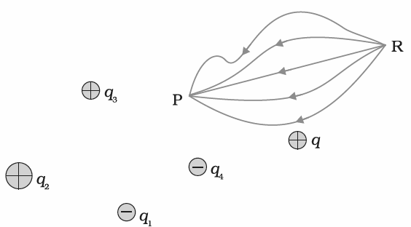  In the given charge distribution, a test charge q₀ is moved from R to P along various paths as shown in the figure. The work done in moving the test charge is:  - Minimum along the straight path  - Maximum along the straight path.  - Maximum along the longest path  - Same along all paths
21 | 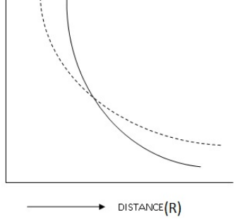  The dotted line (A) and the solid line (B) represent the variation of two physical quantities with distance from a point charge. Identify the correct option:  - A represent Electric field and B represent electric potential  - B represent Electric field and A represent electric potential  - A represent potential energy and B represent electric potential  - A represent electrostatic force and B represent electric field
22 | In which of the following cases will the potential be same at every point on a thin metallic plate (almost zero thickness)  - The plate is positively charged  - The plate is negatively charged  - The plate is placed close to a charged body  - The plate is uncharged  Choose correct option:  - i and ii  - iii and iv  - only iv  - i, ii, iii and iv
23 | An uniform electric field exists in the negative-Y direction. Which of the following statement(s) is/are correct:  - The potential decreases as one moves along positive Y axis  - The potential remains constant as one moves along negative Y axis  - The potential remains constant as one moves along negative Z axis  - The potential remains constant as one moves along positive X axis  - i, ii, iii and iv  - i and ii  - iii and iv  - i, iii and iv
24 | A small metallic ball having charge q is placed inside an insulated box. The insulated box is then placed inside a metallic box. The net charge enclosed inside the metallic box is:  - Zero  - q  - –q  - 2q
25 | When an earthed conductor is placed near a positively charged conductor:  - The potential of the conductor increases  - The potential of the conductor decreases  - The capacitance of the system increases  - The capacitance of the system decreases  - i and iii  - i and iv  - ii and iii  - ii and iv
VSA 2 MARKS EACH
 | Capacitance of a parallel plate capacitor having plate separation d and area of the plates A is C when it is filled with air. Biju learned that capacitance of a parallel plate capacitor can be increased by using dielectric material in between the plates. So he inserts a dielectric slab of dielectric constant K of thickness d/3 between the plates. What will be the value of new capacitance?
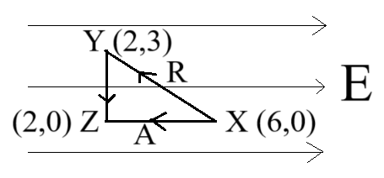
Two charges of same nature and magnitude +q are kept fixed at points X inside a uniform electric field. Now to shift the charges, Rahul used a path $X→Y→Z$ (shown as ‘R’ in the diagram) and Amol used a different path of direct $X→Z$ (shown as ‘A’ in the diagram). Find the ratio of their work done to move the charge from X to Y.
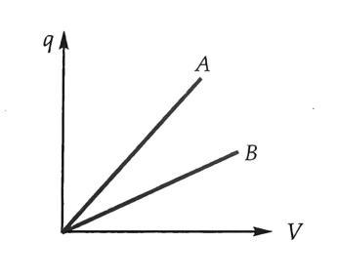
The graph shows the variation of charge q with potential difference V for two capacitors $C_{1}$ and $C_{2}$.
For two capacitors the ratio of separation between two plates is and the ratio of area of the plates is . Which of the lines in the graph represent and ?

(i) Can two equi-potential surfaces intersect each other? Give reasons.
(ii) Two charges −q and +q are located at points A (0, 0, −a) and B (0, 0, +a) respectively. How much work is done in moving a test charge from point P (7, 0, 0) to Q (−3, 0, 0)?
 | Derive the expression for the electric potential at any point along the axial line of an electric dipole?
In the given figure, the potential difference between points A and B is 240V. If mid-point M of AB is earthed, what are the potential of point A and B?
A B
M

A parallel plate capacitor is charged by a battery. The battery is disconnected and a dielectric slab is inserted between the plates. What will be the effect on its
- Capacitance
- Charge
- Potential difference
- Electric field
 | Electric field intensity in a given region is zero. Can we conclude that electric potential must be zero?
Draw the equipotential surfaces due to:

- an electric dipole
- two equal positive charges separated by some distance
The figure shows a metallic solid sphere having a charge 3 µC. What will be the work done in moving a charge of 2 nC from its surface to its centre without acceleration?

Justify your answer.
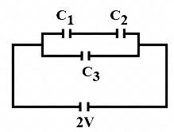
Two capacitors (C₁and C₂) of 6 µF each are connected in series. This combination is connected in parallel with another 8 µF capacitor (C₃) and a cell of e.m.f. 2 volt as shown in figure. Determine the magnitude of charge stored in either plates of capacitor C₁ and C₃.
SA 3 MARKS EACH
1. | 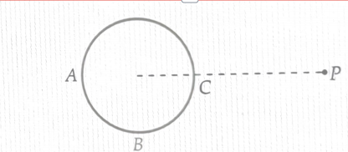  - Four identical metallic balls were placed diametrically opposite on the circumference of an imaginary circle of radius 10m. The first three balls were charged with 30mC, 40mC and -70mC charge. Evaluate the value of charge given to the fourth ball so that the net potential at the center of the circle becomes zero .  - A hollow conducting sphere is placed in an electric field produced by a point charge kept at point P, r distance away from the center of the said sphere. Evaluate the relation between the potentials at points A, B and C on the surface of the sphere as shown in the figure.
2. | Dhruv took three capacitances namely C₁ , C₂ & C₃ having capacitances 3μF , 4 μF and 2 μF and placed C₁ in series with the parallel combination of C₂ & C_{3 .} He applied a potential difference V_{AB} of +1200V across C₁ and grounded the end point C of the parallel combination .  - Draw the required circuit diagram.  - Evaluate the charge on each capacitor  - Find the potential at B
3. | - Rini cut out two circular plates of radius 10 cm each, from a thin metallic sheet, and kept them parallel to each other at a distance of 1mm. She applied a source of emf of 10V across the plates. What type of capacitor is this ? State one application of this capacitor.  - If radius of each plates is increased by a factor of √3 and the spacing between the plates is decreased to half of its initial value , calculate the ratio of capacitances in the two cases.  - Suggest any one possible method by which the capacitance in the second case be increased n times.
4. | (a) Depict the equipotential surfaces for a system of two identical positive point charges placed a distance ‘d’ apart.  (b) Deduce the expression for the potential energy of a system of two-point charges q₁ and q₂ brought from infinity to the points r₁ and r₂ respectively in the presence of external electric field E.
5. | A parallel plate capacitor, each with plate area A and separation d, is charged to a potential difference V. The battery used to charge it is then disconnected. A dielectric slab of thickness d and dielectric constant K is now placed between the plates. What change, if any, will take place in  (i) charge on the plates  (ii) electric field intensity between the plates  (iii) capacitance of the capacitor  Justify your answer in each case.
6. | The figure shows the electric field lines due to a point negative charge P and Q are two points in the electric field.  - What is the sign of $V_{Q}$- $V_{P}$?  - What is the potential energy difference of a small negative charge placed between points P and Q?  - What is the sign of work done by external agent in moving small negative charge from Q to P?  Q  P
7. | The equivalent capacitance of the combination between A and B in the given figure is 4µf.  A B  20µF C  - Calculate capacitance of the capacitor C.  - Calculate charge on each capacitor if a 12V battery is connected across terminals A and B.  - What will be the potential drop across each capacitor?
8. | Two-point charges 10 $˟{10}^{-8}$ µC and -2$˟{10}^{-8}$ µC are separated by distance of 60 cm in air. Find at what distance from the 1st charge, would the electric potential will be zero.
9. | 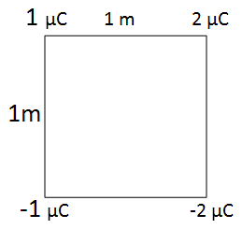  Four charges 1 µC, 2 µC, -1 µC and -2 µC are placed at four corners of a square of 1 m in order. Find the work required to put together this arrangement.
10 | A 5 µF parallel plate capacitor is connected to a 3 V battery. While connected to the battery, the space between the plates of the capacitor is filled with a substance of dielectric constant 4. Determine the ratio of  - Electric field between the plates  - Capacitance  - Magnitude of charge(on either plate) of the capacitor before and after filling the substance.
11 | A solid metallic cube is given charge q. Will the charge be:  - Distributed uniformly throughout the volume of the cube? (yes/no)  - Distributed uniformly throughout the outer surface of the cube? (yes/no)  Justify your answer to each of the above questions a and b.
CASE BASED QUESTIONS 4 MARKS
1. | A dielectric slab is a substance that does not allow the flow of charges through it but permits them to exert electrostatic forces on one another.  When a dielectric slab is placed between the plates, the field E_{o} polarises the dielectric. This induces charge -Q_{p} on the upper surface and + Q_{p} on the lower surface of the dielectric. These induced charges set up a field E_{p} inside the dielectric in the opposite direction of E₀ as shown.  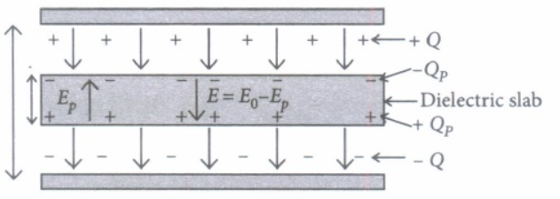  - In a parallel plate capacitor, the capacitance increases from 4μF to 80μF on introducing a dielectric medium between the plates. What is the dielectric constant of the medium?  a) 10 b)20 c) 50 d)100  - A parallel plate capacitor with air between the plates has a capacitance of 8 pF. The separation between the plates is now reduced by half and the space between them is filled with a medium of dielectric constant 5. Calculate the value of capacitance of the capacitor in the second case.  a) 8 pF b) 10pF c) 80 pF d) 100 pF  - A dielectric introduced between the plates of a parallel plate condenser  a) decreases the electric field between the plates.  b) increases the capacity of the condenser.  c) increases the charge stored in the condenser.  d) decreases the capacity of the condenser.  - A parallel plate capacitor of capacitance 1 pF has separation between the plates is d. When the distance of separation becomes 2d and wax of dielectric constant x is inserted in it the capacitance becomes 2 pF. What is the value of x?  a) 2 b) 4 c) 6 d) 8
2. | 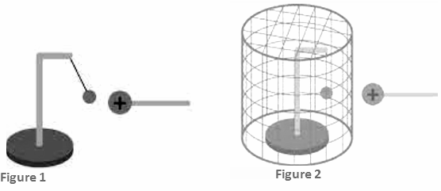  A positively charged ball is brought near an uncharged ball hanging with a thread. It is found that the uncharged ball is attracted towards the charged ball (figure 1). When the uncharged ball is kept inside a metallic cage (Figure 2), it is not attracted towards the charged ball.  - Which phenomenon is responsible for the observation in Figure 1?  - Equipotential surface  - Electrostatic shielding  - Charging by conduction  - Charging by induction  - Which phenomenon is responsible for the observation in Figure 2?  - Equipotential surface  - Electrostatic shielding  - Charging by conduction  - Charging by induction  - Explain the observations in each case?
ANSWERS FOR MCQs
 |  | (d) energy stored by the capacitor
 |  | (b) $E∝\frac{1}{r^{2}}$ and radially outward
 |  | (d) Zero
 |  | - $-\frac{q}{2}$
 |  | - $E∝\frac{1}{r^{5}}$ and $V∝\frac{1}{r^{4}}$
 |  | (d) Srinjay
 |  | (d) $lnln (\frac{b}{a})$
 |  | (c) 1 and 2
 |  | - $c>b>a>d$
 |  | (c) Abhiraj
 |  | b) The work done by the field is negative and the potential energy of the electron-field system increases
 |  | d) 2, 4, 1, 3
 |  | a) 1 and 2 have the same potential
 |  | c) ɛ₀A/d
 |  | c) unchanged
 |  | c) √V
 |  | d) 2 J
 |  | b) If both Assertion and Reason are true but Reason is not the correct explanation of Assertion.
 |  | a) If both Assertion and Reason are true and Reason is correct explanation of Assertion.
 |  | d
 |  | b
 |  | d
 |  | c
 |  | a
 |  | C
ANSWERS FOR VSA ( 2 MARKS)
1 | 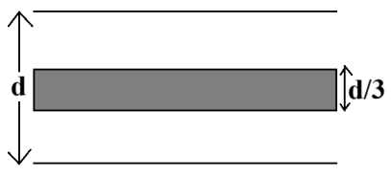  With air, electric field between two plates $E_{0}=\frac{V_{0}}{d}$, where $V_{0}$ is the p.d with air.  With dielectric medium, electric field between two plates $E=\frac{E_{0}}{K}$  So with dielectric medium, p.d between the plates is,  $$V=E_{0}.\frac{2d}{3}+E.\frac{d}{3}=E_{0}.\frac{2d}{3}+\frac{E_{0}}{K}.\frac{d}{3}=E_{0}d(\frac{2}{3}+\frac{1}{3K})=V_{0}(\frac{2K+1}{3K})$$  New capacitance, $C'=\frac{q_{0}}{V}=\frac{q_{0}}{V_{0}(\frac{2K+1}{3K})}=(\frac{2K}{2K+1})C$
2 | Work done is path independent. Ratio $1∶1$
3 | $C_{1}=\frac{ϵ_{0}A_{1}}{d_{1}}$ and $C_{2}=\frac{ϵ_{0}A_{2}}{d_{2}}$  Thus, $\frac{C_{1}}{C_{2}}=\frac{A_{1}}{A_{2}}.\frac{d_{2}}{d_{1}}=\frac{2}{1}×\frac{2}{5}=\frac{4}{5}⇒C_{1}<C_{2}$  Since, slope of q vs V graph gives capacitance, so line A represents capacitor $C_{2}$ and line B represents capacitor $C_{1}$.
4 | (i) Two equipotential surfaces cannot intersect each other because when they will intersect, the electric field will have two directions, which is impossible.  (ii) Charge P moves on the perpendicular bisector of the line joining +q and −q. Hence, this perpendicular bisector is equidistant from both the charges. Thus, the potential will be same everywhere on this line. Therefore, work done will be zero.
5 | The following figure shows an electric dipole of length 2a.  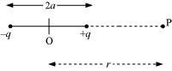  Let P be an axial point at distance r from the centre of the dipole. Electric potential at point P is given as:  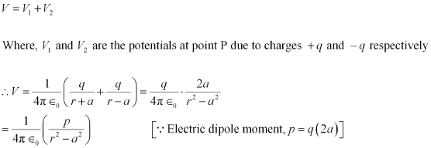
6 | When mid-point of AB is earthed, the potential difference between AB is still 240V. The earthed point has zero potential while point A has a potential of 120V and B has a potential of -120V.
7 | - Capacitance will increase.  - Charge will remain same.  - Potential difference will decrease.  - Electric field will decrease.
8 | Not necessarily. E = -$\frac{ dV}{ dr}$ or 0= - $\frac{dV}{dr}$  Since dr cannot be zero, dv = 0.  This means that electric potential is constant. The constant value can be zero or non zero.
9 | 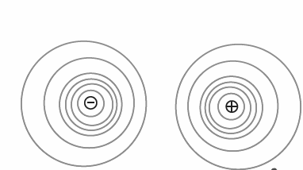  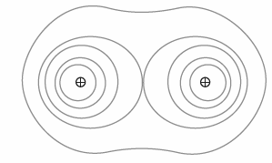  b.
10 | Work done = 0  Because the whole body of a metallic object is equipotential surface, so the potential difference between the surface and centre is zero. Work done = charge x potential difference = 2 nC x 0 = 0
11 | Equivalent capacitance of C1 and C2 in series = 3µF  Charge stored in C1 = C V = 3 µF x 2 V = 6 µC  Charge stored in C3 = C V = 8 µF x 2 V = 16 µC
 | ANSWERS FOR SA ( 3 MARKS)
- Value of fourth charge will be zero
- V_{A} = V_{B =} V_{C}
- Correct diagram
- Q₁ = 2.4 x 10⁻³ C , Q₂ ₌ 1.6 x 10⁻³ C & Q₃= 0.8 x 10⁻³ C
- V_{B} = 400V
- Parallel plate capacitor, can be used in oscillatory LC circuit
- 1:6
- By inserting a dielectric of dielectric constant n between the plates of a capacitor.
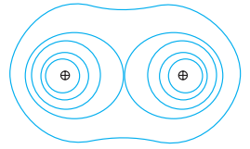
a)

(b) The work done in bringing charge q₁ from infinity to is q₁V().
Work done on q₂ against external field = q₂ V()
Work done on q₂ against the field due to q₁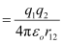
Where, r₁₂ is the distance between q₁ and q_{2.}
By the superposition principle for fields,
Work done in bringing q₂ to is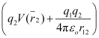.
Thus,
Potential energy of system = The total work done in assembling the configuration
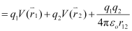

(i) The charge q on the capacitor plates remains constant because the battery is disconnected from the capacitor.
(ii) The electric field intensity between the capacitor plates decreases due to the introduction of a dielectric. Introduction of dielectric field creates an intrinsic electric field directed opposite to the original electric field. This is why the electric field intensity decreases.
(iii) The capacitance of the capacitor increases due to the introduction of a dielectric. Electric field decreases, therefore, the capacitor can get more charge to bring back the electric field to its original value. This increases the capacity of holding the charge and hence the capacitance increases.
- Since $V_{Q}>V_{P}$. $V_{Q}-V_{P}$is positive.
- If a small negative charge is placed at P, it will move towards Q. Since a charge moves from higher potential energy to lower potential energy, $U_{P}>U_{Q}$. Therefore, $U_{P}-U_{Q}$ is positive.
- Since the external agent will have to do work against the force of repulsion in moving a small negative charge from Q to P, the work done will be positive.
Since $C_{eq}$= 4uF.
- Since 20uF and C are in series, we have
$\frac{1}{4}$ = $\frac{1}{20}$ + $\frac{1}{C}$

$\frac{1}{C}$ = $\frac{1}{4}$ - $\frac{1}{20}$ = $\frac{5-1}{20}$

C = $\frac{20}{4}$ = 5uF

- Charge drawn from 12V battery,
Q = $C_{eq}$. V = (4) (12) = 48 uC

- Potential drop across
20 uF = $V_{20}$ = $\frac{Q}{C}$ = $\frac{48 uF}{20 uF}$ = 2.4 V

Potential drop across
5 uF = $V_{5}$ = $\frac{48 uC}{20 uF}$ = 9.6 V
A B
O

X r-x
$V_{OA}$= $V_{OA}$
$\frac{kq_{1}}{x}$ + $\frac{kq_{2}}{r-x}$ = 0
$\frac{{10}^{-7}}{x}$ – $\frac{{2 (10)}^{-8}}{r-x}$ = 0
10(r-x) = 2x
10r = 12x
X = (10/12)r
X = 0.5 m = 50 cm
 | Work done is equal to the potential energy of the system, find potential energy of each pair of charge using the formula (k q₁ q₂ )/r and add to fine the work done = - 34.45 x 10⁻³ J
Let E1, q1 and C1 are the electric field, charge and capacitance before filling the dielectric and E2, q2 and C2 after filling the dielectric.
- Since the battery will maintain constant potential difference, so E=V/d remains constant. So E1:E2 = 1 : 1
- C1 = ϵ₀ A/d, C2= K ϵ₀ A/d = 4 ϵ₀ A/d, C1 : C2 = 1 : 4
- q1 = C1. V1
q2 = C2 V2 = 4 C1. V1 (since p.d. is same)
q1 : q2 = 1 : 4
- No. Since the electric field inside a conductor is zero, no net charge can be enclosed inside a conductor. So, the entire charge appears on the surface.
- No. Since the radius of curvature of the edges, corners and faces are different, the charge density will be different at these places in order to have the potential constant throughout the surface.
 | ANSWERS FOR CBQ ( 4 MARKS)
- b) 20
- c) 80 pF
- b) increases the capacity of the condenser.
- b) 4
- iv. Charging by induction
- ii. Electrostatic shielding
- In figure 1, negative charge is induced at the nearer end of the uncharged ball and positive charge is induced at the farther end. Since the negative charge is close to the positively charged ball, it is attracted due to greater force of attraction.
In figure 2, when the uncharged ball is kept inside a metallic cage, the electric field inside the cage becomes zero due to electrostatic shielding. So no charge is induced in the uncharged ball. So it is not attracted towards the charged ball.

XII PHY CH-3 CURRENT ELECTRICITY
Q. NO | QUESTION
MCQ s 1 MARK EACH
The current in a conductor varies with time t as I =2t+3t², where I is in ampere and t in seconds. Electric charge flowing through a section of the (a) conductor during t=2 sec to t=3 sec is
(a) 10 C (b) 24 C (c) 33 C (d) 44 C
A battery is connected to the conductor of non-uniform cross-sectional area. The quantities or quantity which remain constant is/are
(a) electric field only (b) drift speed and electric field
(c) electric field and current (d) current only
An electric current is passed through a circuit (a containing two wires of same material, connected in parallel. If the lengths and radii of the wires are in the ratio of 3: 2 and 2: 3, then the ratio of the currents passing through the wires will be
(a) 2:3 (b) 3:2
(c) 8:27 (d) 27:8
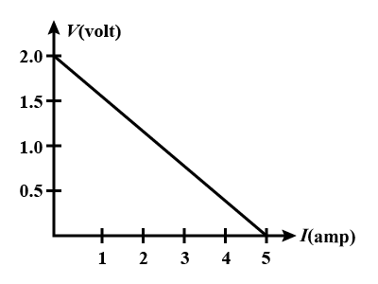
For a cell, a graph is plotted between the potential difference V across the terminals of the cell and the current I drawn from the cell (as shown in figure). The emf and internal resistance of the cell are-
- 2V,0.5ohm
- 2V,0.4ohm
- >2V,0.5 ohm
- >2V,0.4 ohm
A cell of internal resistance r is connected across an external resistance nr. Then the ratio of the terminal voltage to the emf of the cell is
(a) 1/n
(b) 1/(n+1)
(c) n/(n+1)
(d) (n-1)/n
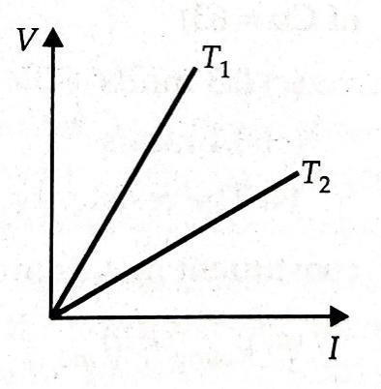
The voltage V versus Current I graphs for a conductor at two different temperatures are shown in the figure. The relation between T₁ and T₂ is:

(a) T₁ > T₂ (b) T₁ < T₂ (c) T₁ = T₂ (d)T₁ =2T₂
Two batteries of emf 4V and 8V with internal resistances 1Ω and 2 Ω respectively are connected to an external resistance R = 9Ω as shown in the figure. The current in circuit and the potential difference P and Q respectively will be
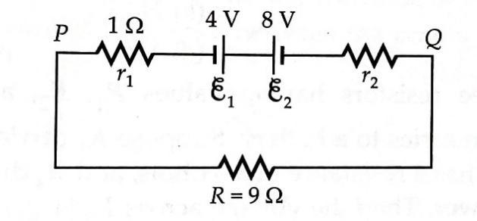

(a) $\frac{1}{9}$ A, 9V (b) $\frac{1}{12}$ A, 12V
(c) $\frac{1}{3}$ A, 3V (d) $\frac{1}{6}$ A, 4V
Figure shows a balanced Wheatstone bridge. Seema by mistake has changed the resistor P to 11 Ω. Then she tried to bring the bridge back to balanced condition. Which of the following steps will not bring the bridge to balance again?
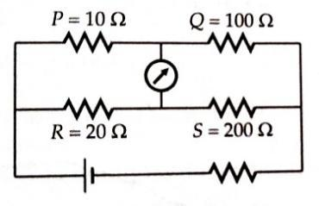
(a) increasing R by 2Ω (b) increasing Q by 10Ω
(c) increasing S by 20Ω (d)making RQ = 2200 Ω²
4 cells of identical emf E, internal resistance r, are connected in series to a variable resistor. The graph shows the variation of terminal voltage of the combination with the current output. What is the internal resistance of each cell?
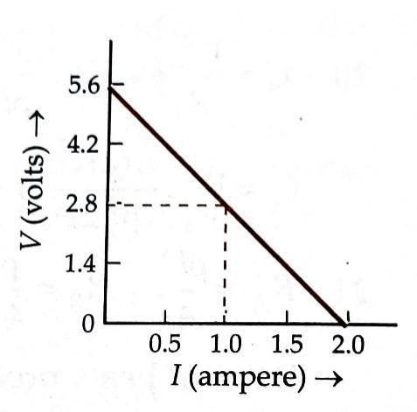

(a) 0.7 Ω (b) 2.8 Ω (c) 1.4 Ω (d)0 Ω
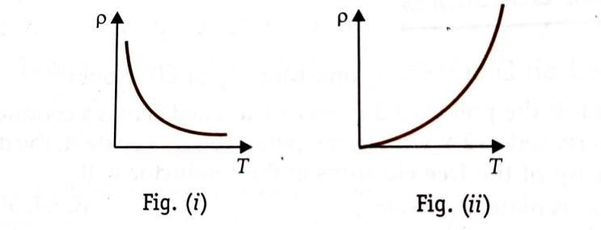
The temperature T dependence of resistivity of material A and material B is represented by Fig (i) and Fig (ii) respectively. Identify material A and material B.

(a) Material A is copper and material B is germanium.
(b) Material A is germanium. and material B is copper.
(c) Material A is nichrome and material B is germanium.
(d) Material A is copper and material B is nichrome.
A voltmeter reads 3 V at full-scale deflection and is graded as 6000 Ω/V. What resistance should be connected in series with it so that it reads 12 V at full-scale deflection?
(a) 1.8 x 10⁴ Ω (b) 3.6 x 10⁴ Ω (c) 5.4 x 10⁴ Ω (d) 7.2 x 10⁴ Ω
If the potential difference V applied across a conductor is increased to 2V with its temperature kept constant, the drift velocity of the free electrons in the conductor will
(a) remains the same.
(b) becomes half.
(c)be double of its initial value.
(d) becomes zero.
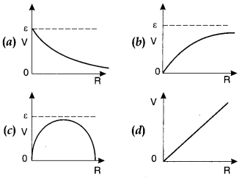
A cell having an emf E and internal resistance r is connected across a variable external resistance R. As the resistance R is increased, the plot of potential difference V across R is given by
A coil is embedded in a block of ice placed in an insulated box. If a current of 1.0 A is passed through the coil by applying a potential difference of 210 V across it, the amount of ice melted in one hour is
(a) 2.00 kg (b) 2.25 kg (c) 2.50 kg (d) 2.75 kg
An ammeter and a voltmeter are connected in series to a battery with an emf of 10V. When a certain resistance is connected in parallel with the voltmeter, the reading of the voltmeter decreases three times, whereas the reading of the ammeter increases two times. Find the voltmeter reading after the connection of the resistance.
(a) 1 V (b) 2 V (c) 3 V (d) 4 V

VSA 2 MARK EACH
A storage battery of emf 8.0 V and internal resistance 0.5 is being charged by a 120 V dc supply using a series resistor of 15.5 ohm. What is the current during charging?
For household electrical wiring, one uses Copper or Aluminum. What considerations are kept in mind?
Two wires one of manganin and the other of copper have equal length & equal resistance. Which one of these wires will be thicker? Justify your answer.
The emf of a cell is always greater than the terminal voltage of that cell. Why?
Two electric bulbs A and B are marked 220V, 40 W and 220V, 60 W respectively. Which one has greater resistance?
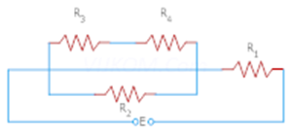
Whenever current flows through any electrical network, voltage drops across each electrical element. Arun found the voltage drop across the resistor R₁ in the circuit given below with
E= 60V, and as 40 volts? Is he correct? Justify
SA 3 MARKS EACH
i)Show on a plot, variation of resistivity of a) a conductor b) a typical semiconductor as a function of a temperature.
ii) Using the expression for the resistivity in terms of number density and relaxation time between the collisions explain how resistivity in case of a conductor increases while its decreases for semiconductor, with rise of temperature.
When a 60W, 220v bulb and 100W, 220v bulb are connected in series then which of the bulb will be brighter and why?
A variable resistor R is connected across a cell of emf E and internal resistance r.
a) Draw the circuit diagram.
b) Plot the graph showing variation of potential drop across R as a function of R.
c) At what value of R current in circuit will be maximum.
The following table gives the length of three copper wires, their diameter and the applied potential difference across their ends. Arrange the wires in increasing order of the following:
(i)The magnitude of the electric field within them,
(ii)the drift speed of electrons through them, and
(iii)the current density within them.

Wire no. | Length | Diameter | Potential difference
1 | l | 3d | V
2 | 2l | d | V
3 | 3l | 2d | 2V

Analyze the following statements and give reasons to justify them.
(i)The electron drift speed is very small still current is established almost instantly as circuit is closed?
(ii)The electron drift arises due to force experienced by electrons in the electric field which causes acceleration, still electrons acquire a steady average drift speed.
(iii)Even if electron drift speed and electronic charge is very small, still we obtain large amounts of current in a conductor.
Potential Difference V is applied across the ends of the copper wire of length l and diameter D. What is the effect on drift velocity of electrons if
a)V is doubled? b) l is doubled? c) Dis doubled?
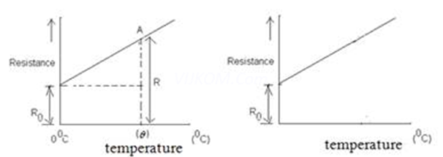
The variation of resistance of a metallic conductor with temperature is given in figure.
(a) Calculate the temperature coefficient of resistance from the graph.
(b) State why the resistance of the conductor increases with the rise in temperature.

At room temperature 27.0ºC the resistance of a heating element is 100 Ω. What is the temperature of the element if the resistance is found to be 117 Ω, given that the temperature coefficient of the material of the resistor is 1.70 x 10⁻⁴$℃$ .
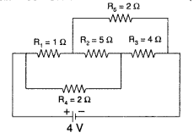
Calculate the current drawn from the battery in the given network.
A wire of 15 Ω resistance is gradually stretched to double its original length. It is then cut into two equal parts. These parts are then connected in parallel across a 3.0 volt battery. Find the current drawn from the battery.
A battery of emf 6 V and internal resistance 2Ω is connected to a resistor. If the current in the circuit is 0.25 A, find
(i) the resistance of the resistors;
(ii) the terminal voltage of the battery.
CASE BASED QUESTIONS 4 MARKS
Any source of emf has some internal resistance itself, called internal or source resistance. When we connect the terminals of a cell, a current flows in the wire from positive terminal of the cell towards the negative terminal. But inside the electrolyte of the cell, the positive ions flow from the lower to the higher potential (or negative ions from the higher to the lower potential) against the background of other ions and neutral atoms of the electrolyte. So the electrolyte offers some resistance to the flow of current inside the cell.

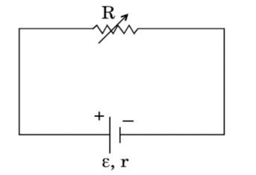
The resistance offered by the electrolyte to the flow of current between its electrodes is called the internal resistance of the cell. It depends on nature and concentration of electrolyte, separation and common area of the electrodes dipped in the electrolyte, and temperature of the electrolyte. Internal resistance causes energy loss which occurs inside a battery when a current is driven round an external circuit. The greater the current, the greater the energy loss and the small is the terminal p.d. of the battery. The internal resistance of a battery increases with age and so reduces the current it can drive. The knowledge of internal resistance becomes important when we consider how a source of emf can deliver maximum power to an appliance connected to it. According to maximum power theorem this occurs when the internal resistance of the source equals the resistance of the appliance.
- Define internal resistance
- Define emf of a cell
- A variable resistor R is connected across a cell of emf and internal resistance r as shown in the figure.
Draw a plot showing the variation of (i) terminal voltage V and (ii) the current I, as a function of R.
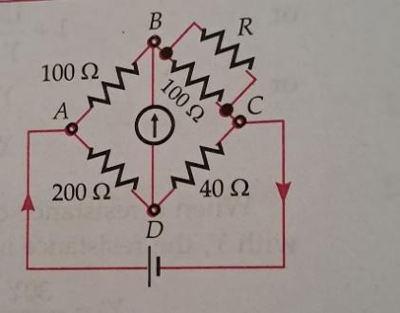
Wheatstone bridge. It is an arrangement of four resistances used to determine one of these resistances quickly and accurately in terms of the remaining three resistances. This method was first suggested by a British physicist Sir Charles F. Wheatstone in 1843.

A Wheatstone bridge consists of four resistances P, Q,R and S; connected to form the arms of a quadrilateral ABCD. A battery of emf & is connected between point A and C called cell arm and a sensitive galvanometer between Band D called galvanometer arm,

Let S be the resistance to be measured. The resistance R is so adjusted that there is no deflection in the galvanometer. The bridge is said to balanced when the potential difference across the galvanometer is zero so that there is no current through the galvanometer. In the balanced condition of the bridge,
- What will happen to null point if cell arm and galvanometer arm are interchanged?
- Name a device based on the principle of Wheatstone bridge
- The Wheatstone's bridge of fig is showing no deflection in the galvanometer joined between the points B and D. Compute the value of R.
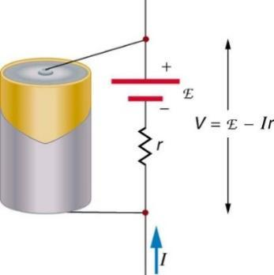
When the electric cell (source of EMF) is in a closed circuit, the current flows through the circuit. There is a fall of potential across the internal resistance of the cell. The terminal potential difference between the two electrodes of the cell becomes less than the EMF of the cell by an amount equal to potential drop across the internal resistance of the cell. Thus, in a closed circuit the terminal potential difference of a cell is always less than the EMF of the cell.

(i) EMF of a cell is independent of:
(a) size of the electrodes
(b) quantity of electrolyte presents in the cell
(c) distance between the electrodes
(d) all of these

(ii)Three cells of EMF, 2.0 V,2.5 V and 3.0 V are connected in series. Their internal resistances are 0.20 Ω, 0.20Ω and 0.15Ω respectively. The battery is connected to an external resistor of 6.5 Ω wire through a very low resistance ammeter, what would be the reading of ammeter?
(a) 1.06 Ω (b) 1Ω (c) 1.2 Ω (d) 2.1 Ω

(iii) A cell of emf E and internal resistance r is connected in series with an external resistance nr. Then ratio of terminal potential difference to emf is:
(a)1/n (b) 1/(n+1) (c) n/(n+1) (d) (n+1)/n

(iv) For a cell, the terminal potential difference is 3.6 V, when the circuit is open. If the potential difference reduces to 3V, when the cell is connected to 5 Ω resistance, the internal resistance of the cell is:
(a)1 Ω (b) 2 Ω (c) 4 Ω (d) 8 Ω
Consider a resistor connected to a source of emf. The energy gets dissipated entirely in the form of heat. This phenomenon of production of heat in a resistor by the flow of current through it is called heating effect of current.
When potential difference is applied across the ends of conductor, its free electrons get accelerated in the opposite direction of the applied field. The kinetic energy gained by the free electrons is transferred to the metal ions at the time of collisions. According to Joule’s law of heating, the amount of heat produced is H = I²Rt

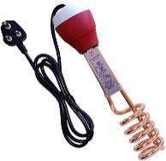
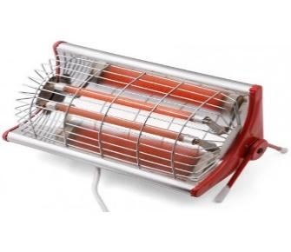
(i)If two identical heaters each rated as (1000W,220V) are connected in parallel to 220V, then power consumed is
(a) 200 W (b) 2500 W (c) 250 W (d) 2000 W

(ii)Two wires having resistances R and 2R are connected in parallel then ratio of heat generated is R and 2R is
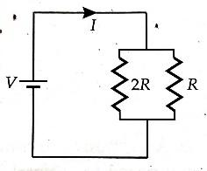

(a) 3:2 (b) 2:1 (c) 1:4 (d) 4:1

(iii)When 4 equal resistors are connected in series with a battery, they dissipate a power of 10W.What will be the power dissipated through any of them if it is individually connected across the same battery?
(a) 40 W (b) 10/3 W (c) 90 W (d) 10 W

(iv)Bulb B₁(100W-250V) and Bulb B₂(100W-200V) are connected across 250V.What is the potential drop across B₂ ?
(a) 200 V (b) 250 V (c) 98 V (d) 48 V

ANSWERS FOR MCQs
(b) 24 C
(d) current only
(c) 8:27
D
c) n/(n+1)
(a) T₁ > T₂
(c) $\frac{1}{3}$ A, 3V
(c) increasing S by 20Ω
(c) 5.4 x 10⁴ Ω
(b) Material A is germanium. and material B is copper.
(b)
(c) be double of its initial value.
(b)
(b) 2.25 kg
(b) 2 V
ANSWERS FOR VSA ( 2 MARKS)
net emf in the circuit will be
= 120-8.0=112 V
I= E' / R+r =112/ {15.5+0.5}. = 7A
i) Cost of metal.
ii)Good conductivity of metal.

Copper wire R=ρc​/Ac,

manganin wire R=ρm​l/Am​

ρc​/Ac​=ρm​/Am​

Ac​/Am​=ρc​/ρm​

we know ρm​>ρc​ (as manganin is an alloy) Ac​<Am​

The emf of a cell is greater than its terminal voltage because there is some potential drop across the cell due to its small internal resistance.
V=E-Ir
We know 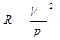
For Bulb A, 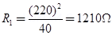
For Bulb B 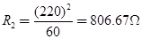Bulb A has higher resistance because its power is less.
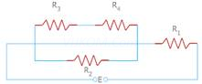
are in series
= = 15
Now are parallel
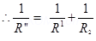
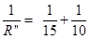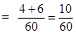
= = 6
Now are series
Rnet =
Rnet = 6+18 = 24
I= = 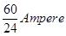Now voltage drop across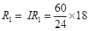
Arun is not correct.
ANSWERS FOR SA ( 3 MARKS)
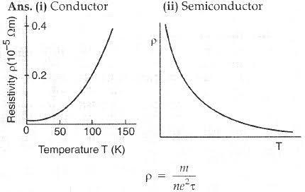
From the equation if we increase the temperature then relaxation time will decrease. So for conductor the resistivity will increase.
For semi-conductor the relaxation time will decrease as like conductors, but along with that the no. of conducting ions (electrons and holes) will also increase rapidly. So, the resistivity will decrease for semiconductors.
P=V²/R, Here in series connection V is constant
So, P is inversely proportional to R²
For P then R will be less and vice versa. For small value of R, more current will flow through that bulb. So, 100W bulb will glow brightly.

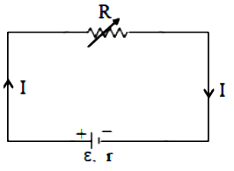
a)

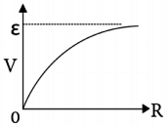
b)

c) We have, V = IR or, I = V/R When R = 0, Current will be maximum. Hence, Maximum current drawn will be at R =0
(i)E₁ =V/l, E₂ =V/2l, E₃ =2V/3l ∴ E₂ < E₃< E₁
- (ii)As v_{d} ∝ E,∴ vd2 < vd3< vd1
- (iii) j = ne vd, ∴ j2 < j₃< j₁
(i) As soon as the circuit is closed, electric field is set up throughout the circuit instantly. Electrons in every part begins to drift and current starts to flow instantly.
(ii) As the electron accelerates it collides with positive ion of the metal. It loses its drift speed after
collision but starts to accelerates and increase its speed again only to suffer a collision again and so on. On average, therefore an electron acquires a steady average drift speed.
(iii) As I = neAv_{d}, even if e and v_{d} are very small, we obtain a large current because the electron
density (n) is very large (of the order of 10²⁹ m⁻³).
Since
= 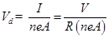
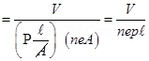
V is doubled, drift velocity gets doubled.
(2) If l is doubled, drift velocity gets halved.
(3) Since V of is independent of D, drift velocity remains unchanged.
(a) Temperature coefficient of Resistance
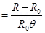
Where R is the resistance of the conductor and θ is the temperature corresponding to pt.A
(b) Since R = 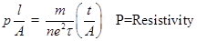
When temperature increases, no of collisions increases average relaxation time decreases, hence resistance Increases.
Room temperature, T=27
Resistance of the heating element at
Temperature co-efficient of the material of the filament,
is given by the relation,
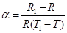
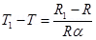
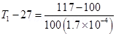
Therefore, at 1027 the resistance of the element is 117.
2 A
R = 15 Ω
On stretching to double its original length, the resistance becomes R1 = 60 Ω, as on stretching volume is constant and Rα l2.
The two cut parts will have a resistance of 30 Ω each as they are connected in parallel, then,
I= 0.2 A
i)R =22 Ohm ii)V= 5.5 V
ANSWERS FOR CBQ ( 4 MARKS)
- Definition 1mark
- Definition 1mark
- Graph 2 mark
- No change 1 mark
- Metre bridge 1 mark
- 25 ohm 2 mark
(i) (d) all of these
(ii) (a) 1.06 Ω
(iii) (c) n/(n+1)
(iv) (a)1 Ω
(i) (d) 2000 W
(ii) (d) 4:1
(iii) (a) 40 W
(iv) (c) 98 V

XII PHY CH-4 MOVING CHARGES AND MAGNETISM
Q. NO | QUESTION
MCQ s 1 MARK EACH
Two similar coils of radius R are lying concentrically with their planes at right angles to each other. The current flowing in them are I and 2I, respectively. The resultant magnetic field induction at the centre will be
a) $\sqrt{5}$µ₀I/2R b) 3µ₀I/2R c) µ₀I/2R d) µ₀I/R
In an ammeter 4% of the mains current is passing through galvanometer. If the galvanometer is shunted with a 5 Ω resistance, then resistance of galvanometer will be
(a) 116 Ω (b) 117 Ω (c) 118 Ω (d) 120Ω
A rectangular coil of length 0.12 m and width 0.1 m having 50 turns of wire is suspended vertically in a uniform magnetic field of strength 0.2 Weber/m². The coil carries a current of 2 A. If the plane of the coil is inclined at an angle of 30° with the direction of the field, the torque required to keep the coil in stable equilibrium will be
(a) 0.24 Nm (b) 0.12 Nm (c) 0.15 Nm (d) 0.20 Nm
The ratio of voltage sensitivity and current sensitivity of a moving coil galvanometer is

(a) 1/G (b) 1/G² (c) G (d) G²
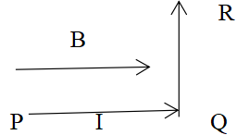
A wire PQR is bent as shown in the figure and is placed in a region of uniform magnetic field B. The length of PQ =QR =L. a current I ampere flows through the wire as shown. The magnitude of the force on PQ and QR will be

- BIL, 0 (b) 2 BIL, 0
(c) 0, BIL (d) 0 ,0
A charge of 1 C is moving in a magnetic field of 0.5 T with velocity of 30 m/s in a direction perpendicular to applied magnetic field. Force experienced is:
(a)0.5N (b)15N (c) 10 N (d) 0N
A student is using a micro-ammeter which is having a resistance of 100 Ω and a full-scale range of 50 m µA. The student wants to use it as a higher range ammeter or voltmeter by providing some resistance to it. Pick the correct range and resistance combinations that the student must use
(a) 50 V range and 10 kW resistance in series
(b) 10 V range and 200 kW resistance in series
(c) 5 mA range with 1 W resistance in parallel
(d) 10 mA range with 1 W resistance in parallel.
In a region of uniform magnetic field. An electron enters into the region with velocity making an angle of 45° with the direction of the magnetic field. In this region the proton will move on a path having the shape of a
(a) straight line (b) circle
(c) spiral (d) helix
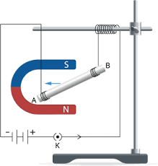
While performing an experiment to study the effect of magnetic field on a current carrying conductor placed inside magnetic field. A straight conducting wire of length l and mass m is suspended in a horizontal plane by a pair of flexible strings in a magnetic field of magnitude B. To remove the tension in the supporting strings, the magnitude of the current in the wire is

(a) $\frac{mgB}{l}$ (b)$\frac{mgl}{B}$ (c) $\frac{mg}{lB}$( d) $\frac{lB}{mg}$

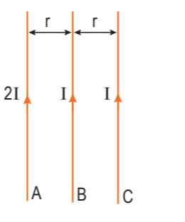
Three infinitely long parallel straight current carrying wires A, B and C are kept at equal distance from each other as shown in the figure. The wire C experiences net force F .The net force on wire C, when the current in wire A is reversed will
(a) Zero
(b) F/2
(c) F
(d) 2F

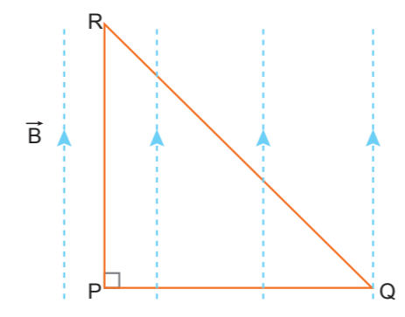
An isosceles right-angled current carrying loop PQR is placed in a uniform magnetic field B pointing along PR. If the magnetic force acting on the arm PQ is F, then the magnetic force which acts on the arm QR will be
(a) F
(b) F/√2
(c) √2F
(d) -F

In the following questions, a statement of Assertion (A) is followed by a statement of Reason (R). Choose the correct answer out of the following choices.
(a) Both A and R are true and R is the correct explanation of A.
(b) Both A and R are true but R is not the correct explanation of A.
(c) A is true but R is false.
(d) A is false and R is also false.

Assertion(A): To increase the range of an ammeter, we must connect a suitable high resistance in series to it.

Reason (R): The ammeter with increased range should have high resistance. ..
Assertion : If two long wires, hanging freely are connected to a battery in series, they come closer to each other.

Reason : Force of attraction acts between the two current carrying wire.
Assertion : In a shunted galvanometer only 10% current passes through the galvanometer. The resistance of the galvanometer is G. Then resistance of the shunt is G/9.

Reason : If S is the resistance of the shunt, then voltage across S and G is same.
Assertion(A): Galvanometer cannot as such be used as an ammeter to measure the value of the current in a given circuit.

Reason (R): It gives a full-scale deflection for a current of the order of micro ampere. .
Assertion (A): The resistance of an ideal voltmeter should be infinite.
Reason (R): The lower resistance of a voltmeter gives a reading lower than the actual potential difference across the terminals.
17 | The current sensitivity of a galvanometer increases by 20 %. If its resistance also increases by 25%, the voltage sensitivity will  - Decrease by 1 % (b) increase by 5 %  (c) increase by 10 % (d) decrease by 4%
18 | A long straight wire of circular cross section of radius a carries a steady current I. The current is uniformly distributed across its cross section. The ratio of magnitudes of magnetic field at a point distant a/2 from the surface of wire to that at a point distant a/2 from the axis of the wire is  - 4:1 (b) 1:1 (c) 4:3 (d) 3:4
VSA 2 MARKS EACH
 | Charge q is uniformly distributed on a disc of radius a.If the disc is rotated with a frequency ν/2,then find the magnetic field induction at the centre of the disc.
A long straight wire AB carries a current of 10 A. A proton P travels at 5× 10⁶ ms–1 parallel to the wire 0.4 m from it and in a direction opposite to the current as shown in the figure. Calculate the force which the magnetic field due to the current carrying wire exerts on the proton. Also specify its direction.

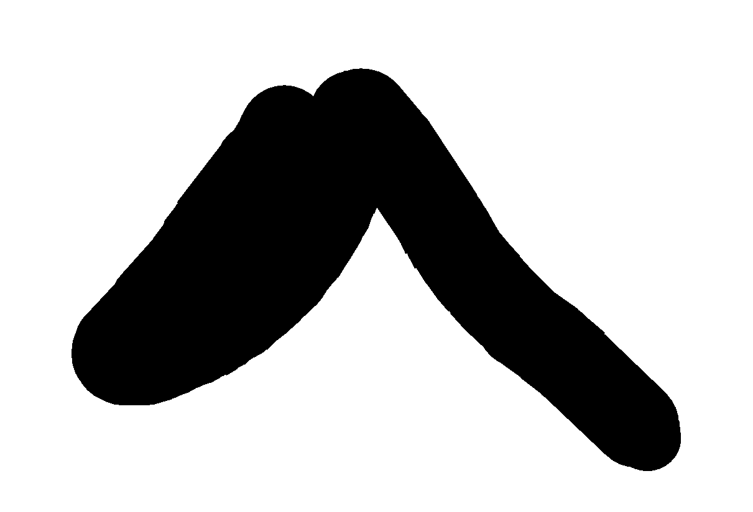
B
10A 0.4m
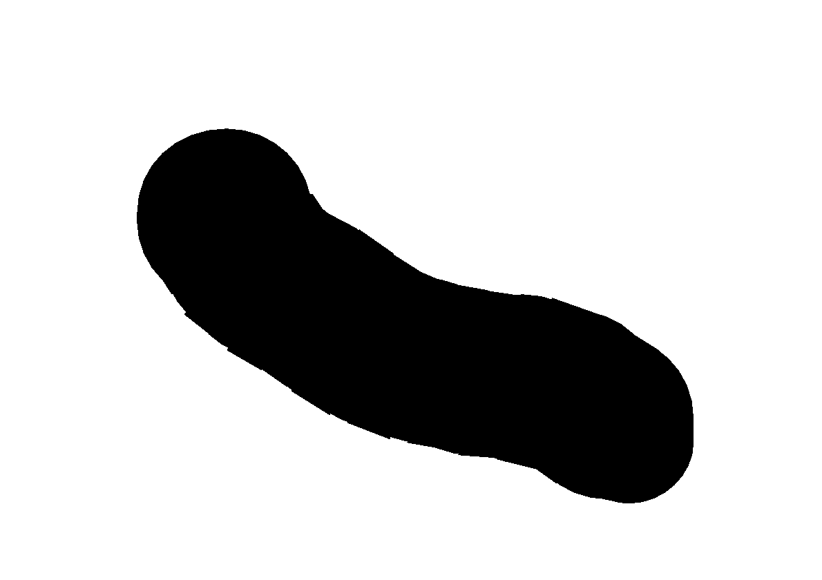

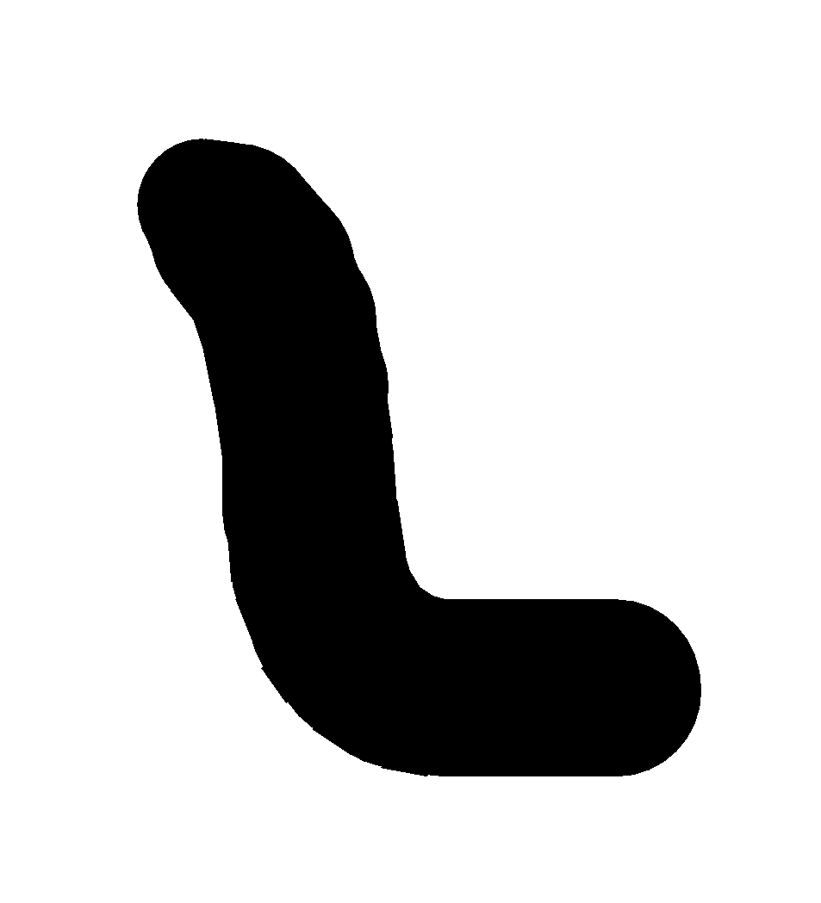
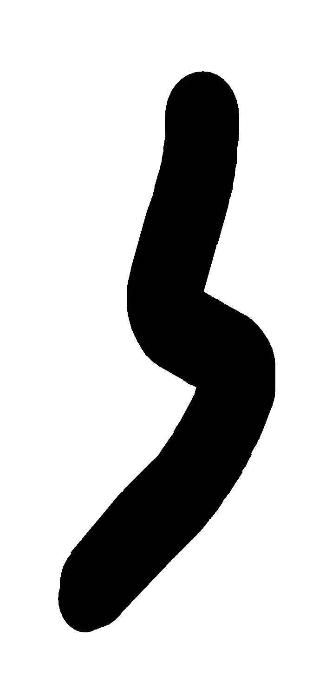
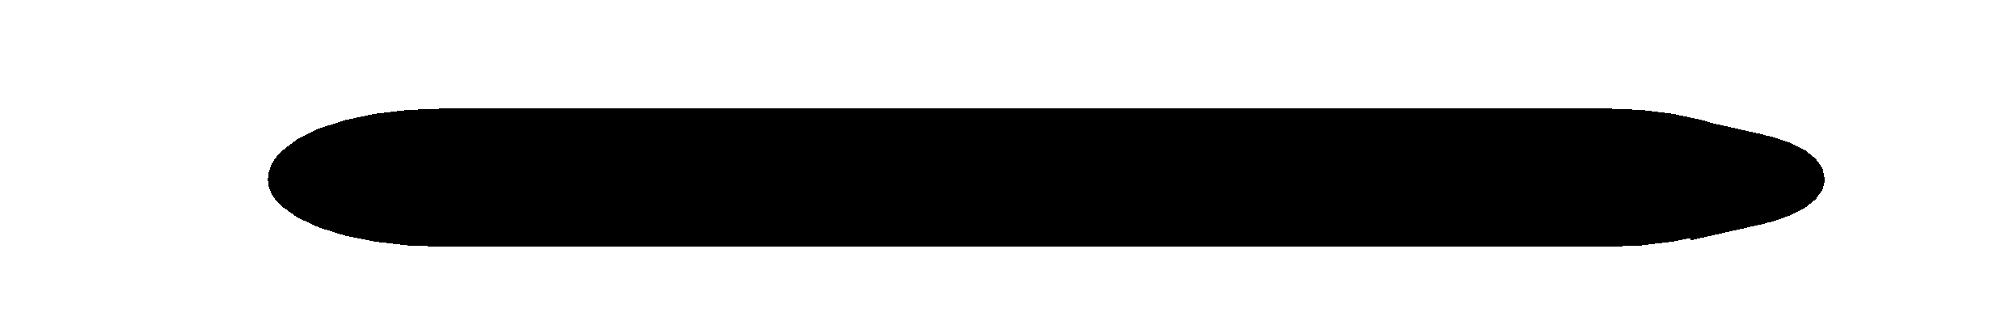
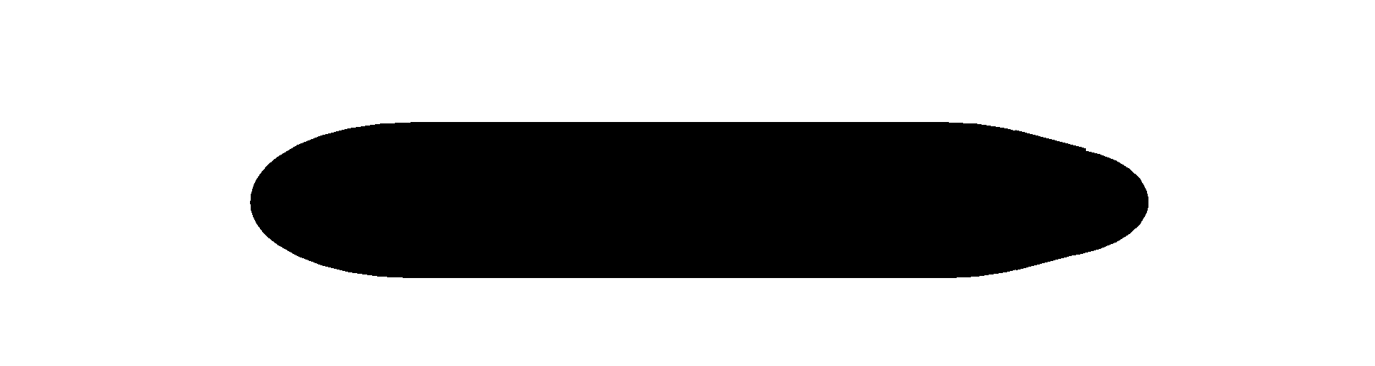
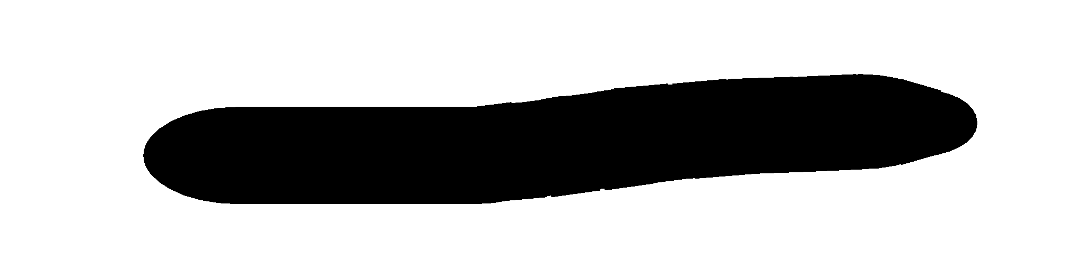
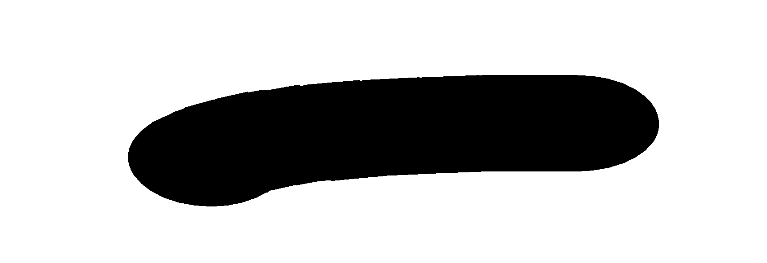
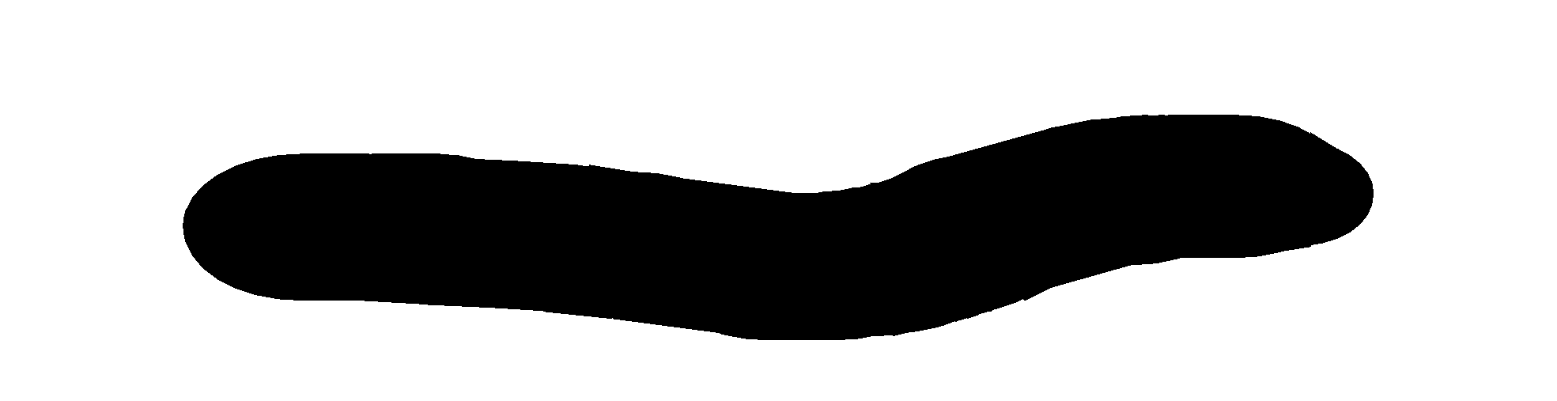
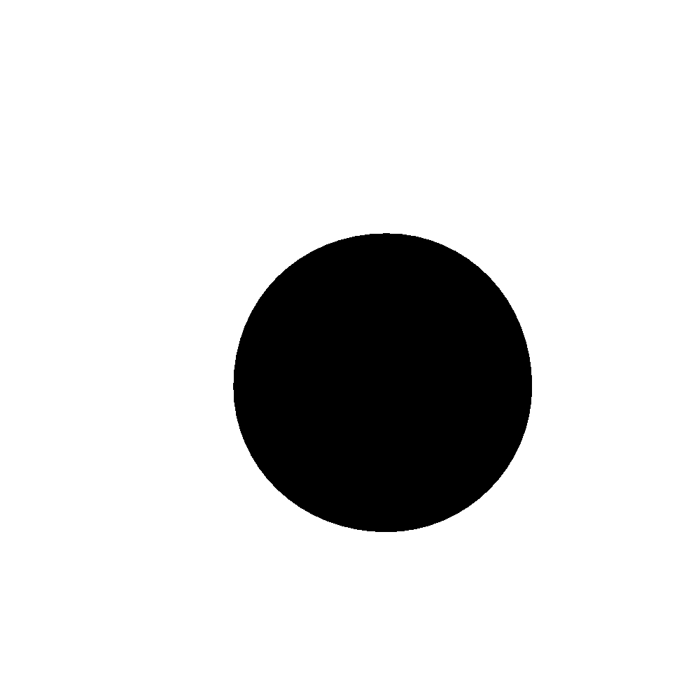
P
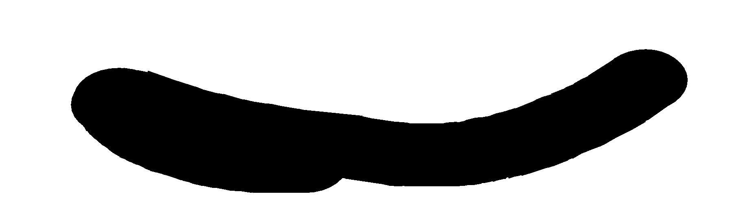
A 5ꓫ10⁶m/s
 | A circular coil of ‘N’ turns and diameter ‘d’ carries a current ‘I’. It is unwound and rewound to make another coil of diameter ‘2d’, current ‘I’ remaining the same. Calculate the ratio of the magnetic moments of the new coil and the original coil.
2r

I I
O
P Q

Two identical circular loops P and Q, each of radius r and carrying equal currents are kept in the parallel planes having a common axis passing through O. The direction of current in P is clockwise and Q is anti -clockwise as seen from O which is equidistant from the loops P and Q. Find the magnitude of net magnetic field at O.

A square loop of side 20 cm carrying current of 1 A kept near an infinite long straight wire carrying a current of 2 A in the same plane as shown in the figure.
2A
10 cm

1A 20 cm

20 cm
o

A straight wire carrying a current of 12 A is bent into a semi- circular arc of radius 2 cm as shown in figure. What is the magnetic field B at o due to
- Straight segments
- The semi-circular arc?
An ammeter of resistance 0.6 Ω can measure current upto 1.0 A. Calculate
(i) The shunt resistance required to enable the ammeter to measure current upto 5.0 A
(ii) The combined resistance of the ammeter and the shunt.
 | A circular loop of one turn carries a current of 5 A.If the magnetic field at the centre is 0.20 mT, find the radius of the loop.
 | A long solenoid consists of 20 turns per cm.What current is necessary to produce a magnetic field of 20 mT inside the solenoid?
A straight wire carrying a current of 10A is bent into a semi-circular arc of radius 2.0cm as shown in fig. Find the magnetic field at the centre of the semicircle.

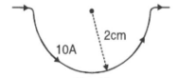

 | What is Lorenz force? An electron beam projected along +x –axis, experiences a force due to a magnetic field along the +y-axis. What is the direction of the magnetic field?
 | A wire of length 2 metre carrying a current 1 ampere is bent to form a circle. What is the magnetic moment of the coil?
 | What type of magnetic field is important in a moving coil galvanometer and why?
 | An electron of energy 15KeV moves in a magnetic field perpendicular to the direction of a uniform magnetic field of 0.5 x 10⁻³ T. Calculate the time period of rotation of the electron in the magnetic field.
 | Define current sensitivity and voltage sensitivity of a galvanometer.
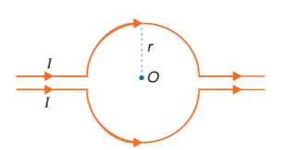
What is the value of magnetic field at point O due to current flowing in the wires as shown in figure?

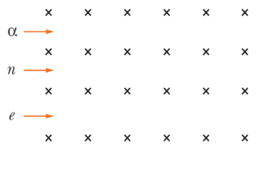
A neutron, an electron and an alpha particle moving with equal velocities, enter a uniform magnetic field going into the plane of the paper as shown. Trace their paths in the field and justify your answer.

 | A long straight wire in the horizontal plane carries a current of 50 A in north to south direction. Give the magnitude and direction of B at a point
SA 3 MARKS EACH
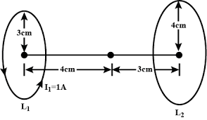
Two coaxial circular loops 𝐿1 and 𝐿2 of radii 3cm and 4cm are placed as shown. What should be the magnitude and direction of the current in the loop 𝐿2 so that the net magnetic field at the point O be zero?

- State the condition under which a charged particle moving with velocity v goes undeflected in a magnetic field B.

(b) An electron, after being accelerated through a potential difference of 10⁴ V, enter a uniform magnetic field of 0.04 T, perpendicular to its direction of motion. Calculate the radius of curvature of its trajectory.
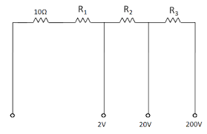
A multirange voltmeter can be constructed by using a galvanometer circuit as shown in the figure. We want to construct a voltmeter that can measure 2 V, 20 V and 200 V using a galvanometer of resistance 10 Ω and that produces maximum deflection for current of 1 mA. Find the value of R1, R2 and R3 that have to be used.

Figure shows a long straight wire of a circular cross section (radius a) carrying steady current I. The current I is uniformly distributed across this cross section. Calculate the magnetic field in the region r <a and r > a.
I aa
a

Also the variation of magnetic field(B) with distance(r).
Two identical loops P and Q each of radius 5 cm are lying perpendicular planes such that they have a common centre as shown in the figure. Find the magnitude and direction of the net magnetic field at the common centre of the two coils, if they carry currents equal to 3A and 4A, respectively.
Q

.0
P

 | A wire AB is carrying a steady current of 12 A and is lying on the table. Another wire CD carrying 5 A current is held directly above AB at a height of 1 mm. Find the mass per unit length of the wire CD, so that it remains suspended at its position when left free. Give the direction of the current flowing in CD with respect to that in AB. ( take g = 10 m/s²)
 | A wire AB is carrying a steady current of 12 A and is lying on the table. Another wire CD carrying 5 A is held directly above AB at a height of 1 mm. Find the mass per unit length of the wire CD so that it remains suspended at its position when left free. Give the direction of the current flowing in CD with respect to that in AB. [Take the value of g = 10 m/sec²
 | An electron, after being accelerated through a potential difference of 10⁴ V, enter a uniform magnetic field of 0.04 T, perpendicular to its direction of motion. Calculate the radius of curvature of its trajectory.
CASE BASED QUESTIONS 4 MARKS
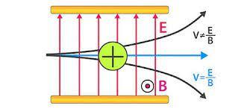
Velocity selector is an arrangement used to select charged particles of a specific velocity from a beam in which particles move with different speeds. It consists of a region of crossed electric and magnetic fields. These two fields are perpendicular to each other. In the figure, the electric field is upwards.

Magnetic field is perpendicular to the plane of the paper and coming outward. The positively charged particle is deflected upwards (towards the negative plate) with a force, 𝐹𝐸 = 𝑞𝐸.
This particle is deflected downwards with a force 𝐹𝐵 = 𝑞𝑣𝐵
When these two forces are equal the particle is not deflected in any direction. 𝑞𝑣𝐵 = 𝑞𝐸
𝑣 = 𝐸 /𝐵 Hence particles with velocity ‘v’ only will be coming out through the straight path. Velocity selector is used in accelerator mass spectroscopy to select particles of a particular velocity.
- If the direction of the initial velocity of the charged particle is perpendicular to the magnetic field, what will the path of the charged particle.
- Let the magnetic field direction is reversed in the above arrangement. Magnetic field is directed into the plane of the paper. In which direction the positive charge will deflect.
- You are requested to select only particles with velocity 10m/s in the selector. The magnetic field provided is 25T. What should be the surface charge density given to the parallel sheets to produce the required electric field.
When a conductor carrying a current is placed in an external magnetic field, it experiences a mechanical force. A current is an assembly of moving charges and a magnetic field exerts a force on a moving charge. That is why a current carrying conductor when placed in a magnetic field experiences a sideways force as the force experienced by the moving electrons is transmitted to the conductor as a whole. A conductor of length ′𝑙 ′ carrying a current ′𝐼 ′ held in a magnetic field 𝐵⃗ at an angle 𝜃 with it, experiences a force given by 𝐹 = 𝐼𝑙𝐵 𝑠𝑖𝑛𝜃 In vector form,𝐹⃗ = 𝐼(𝑙 ⃗ × 𝐵⃗)
The direction of 𝐹⃗ is perpendicular to both 𝑙 ⃗&𝐵⃗and is given by Fleming’s left -hand rule. A conducting bar with mass ′𝑚′ and length ′𝑙 ′ slides over horizontal rails that are connected to voltage source ′𝑉 ′ .the source maintains a constant current ′𝐼 ′ in the rails and bar, and a uniform magnetic field 𝐵⃗⃗ acts in the region between the rails vertically upwards.
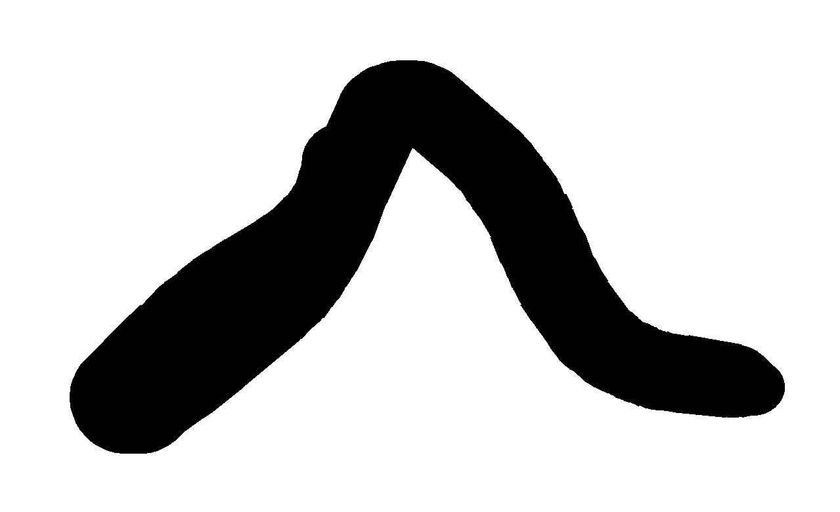
B
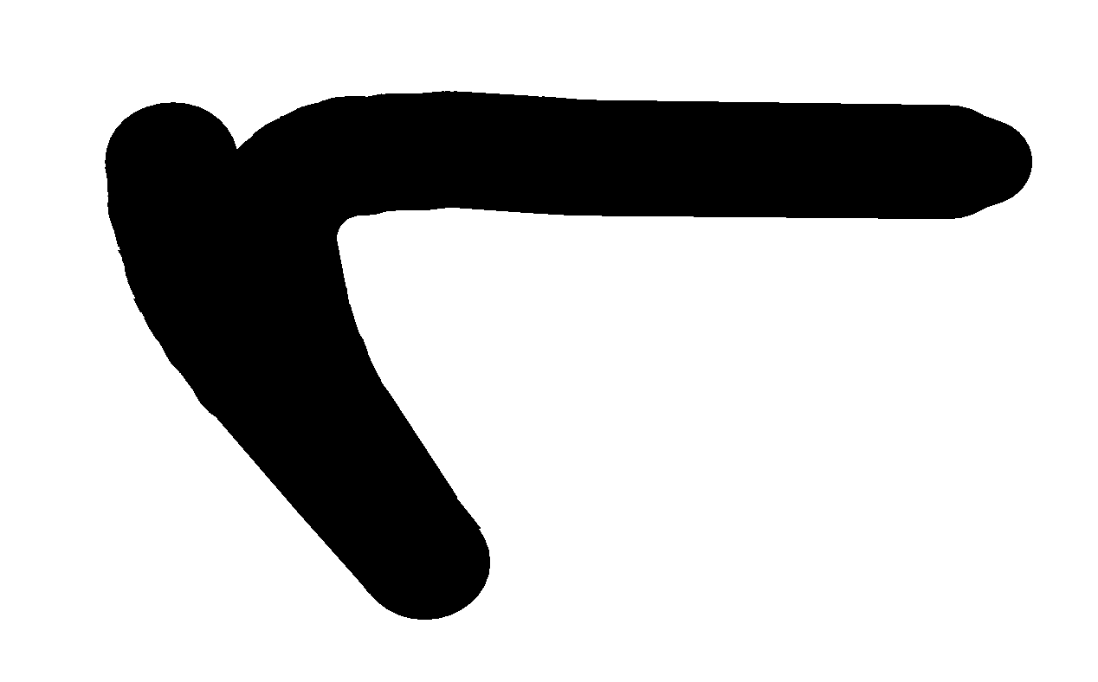
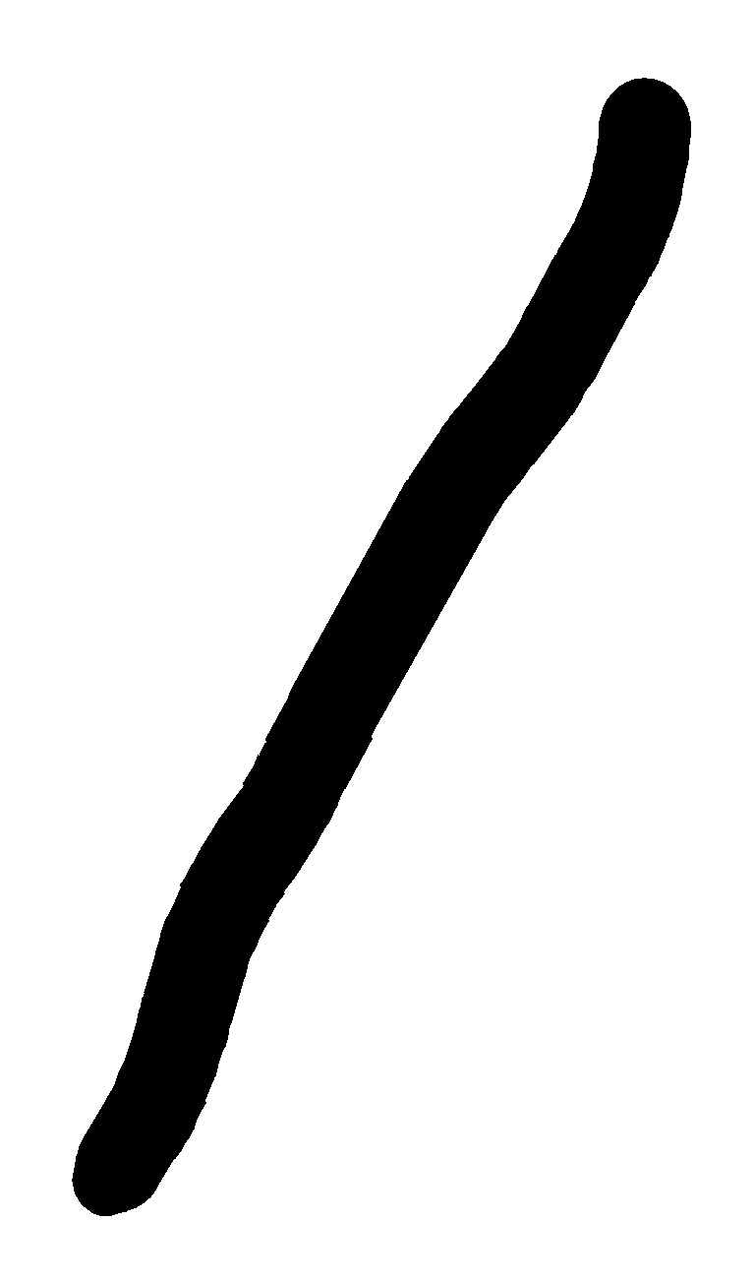
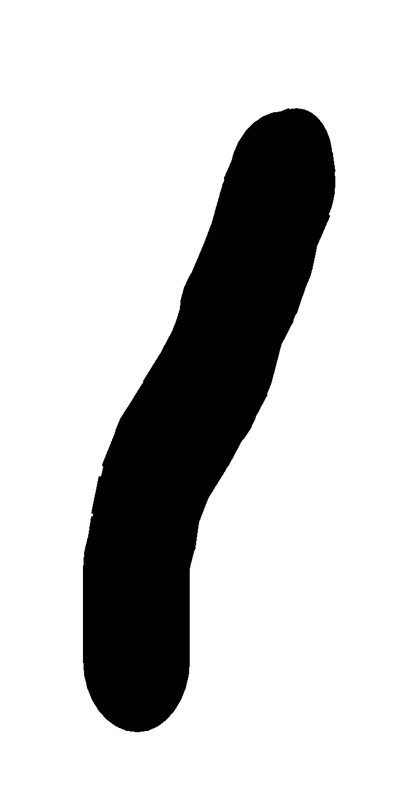
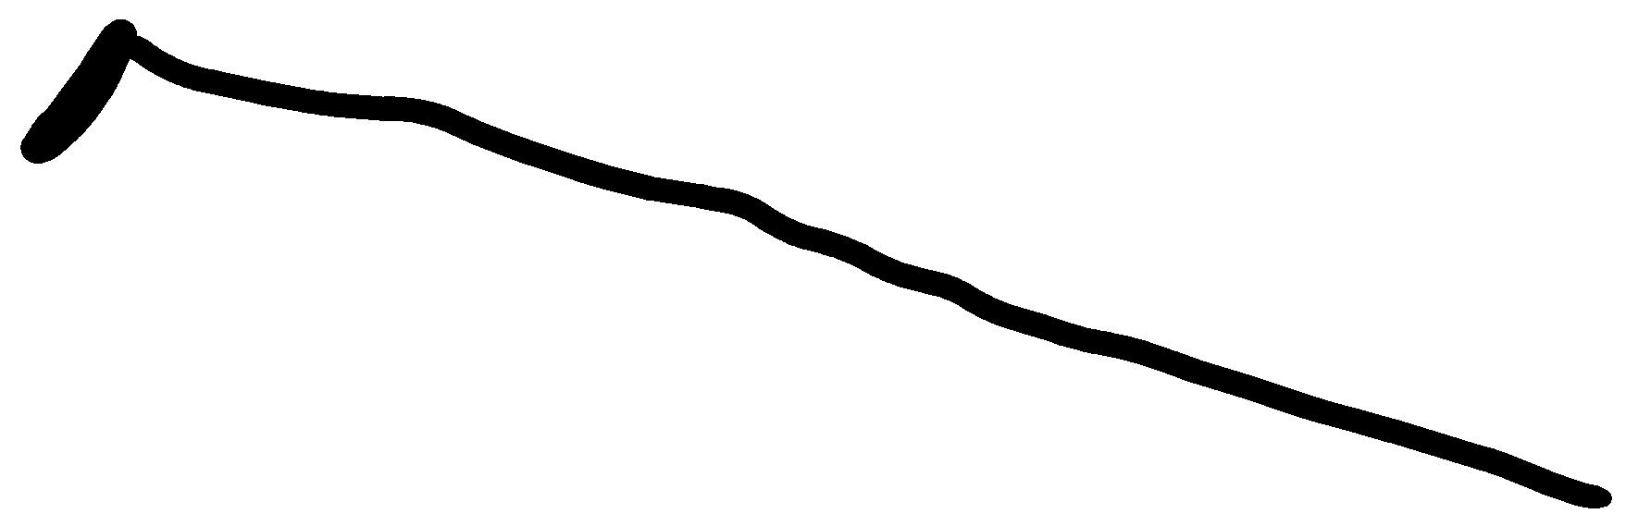
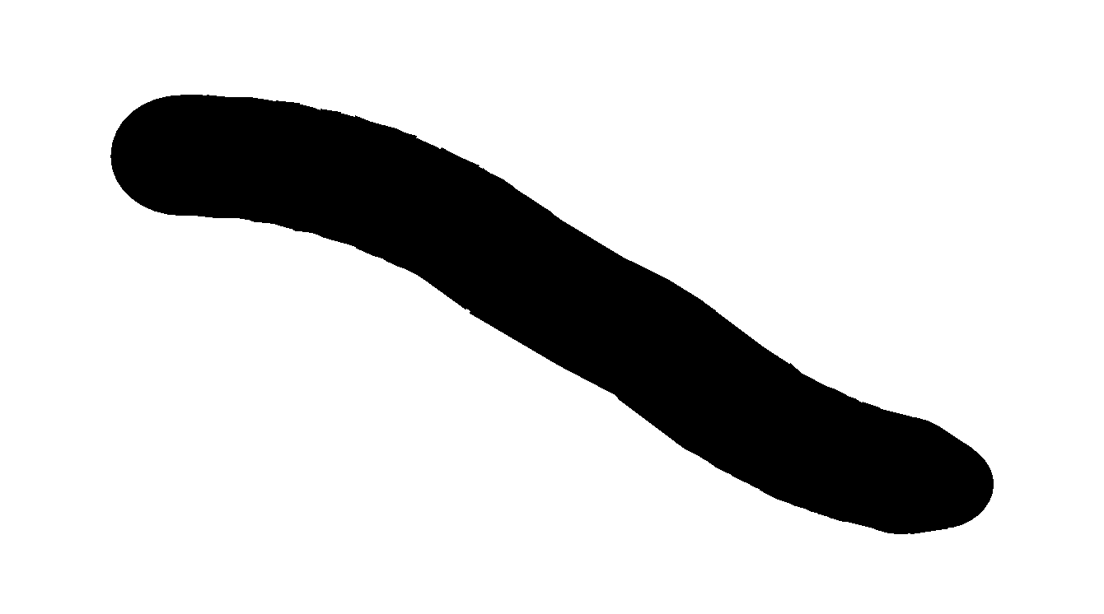
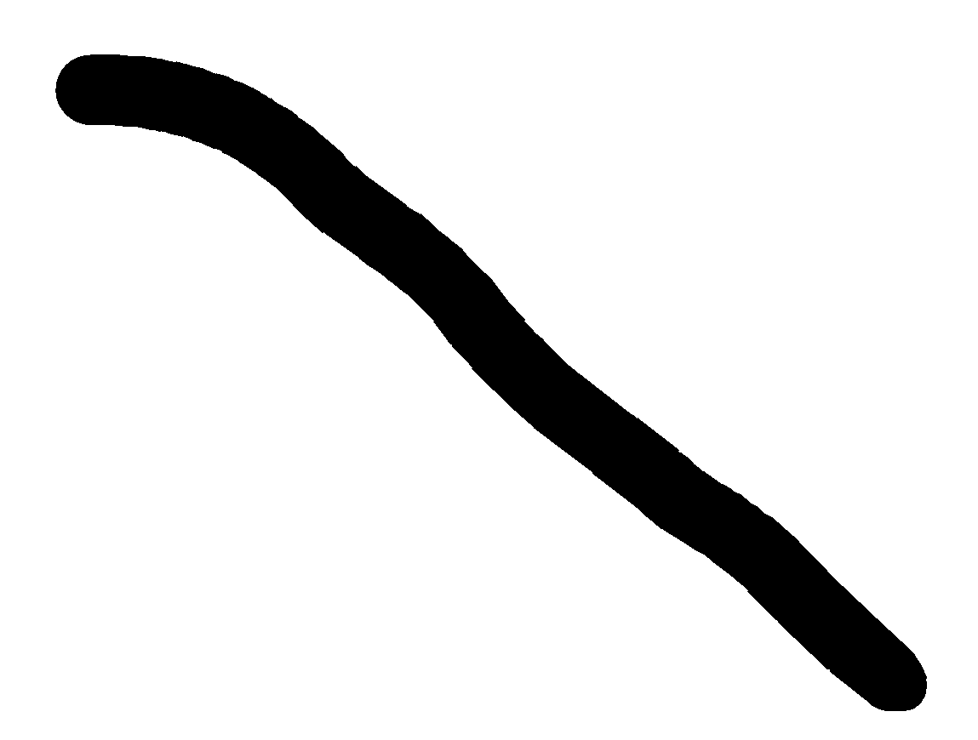
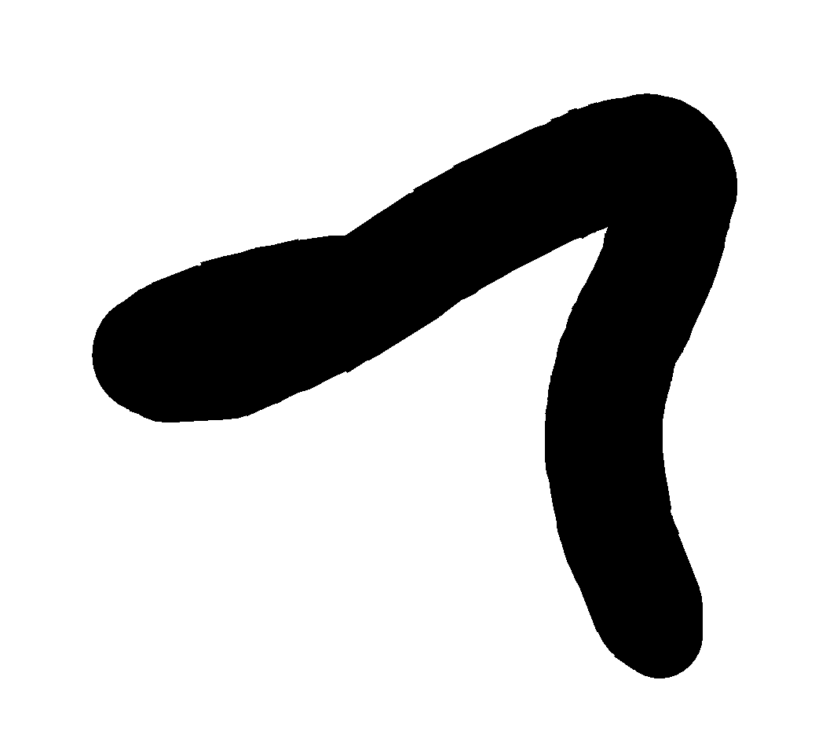
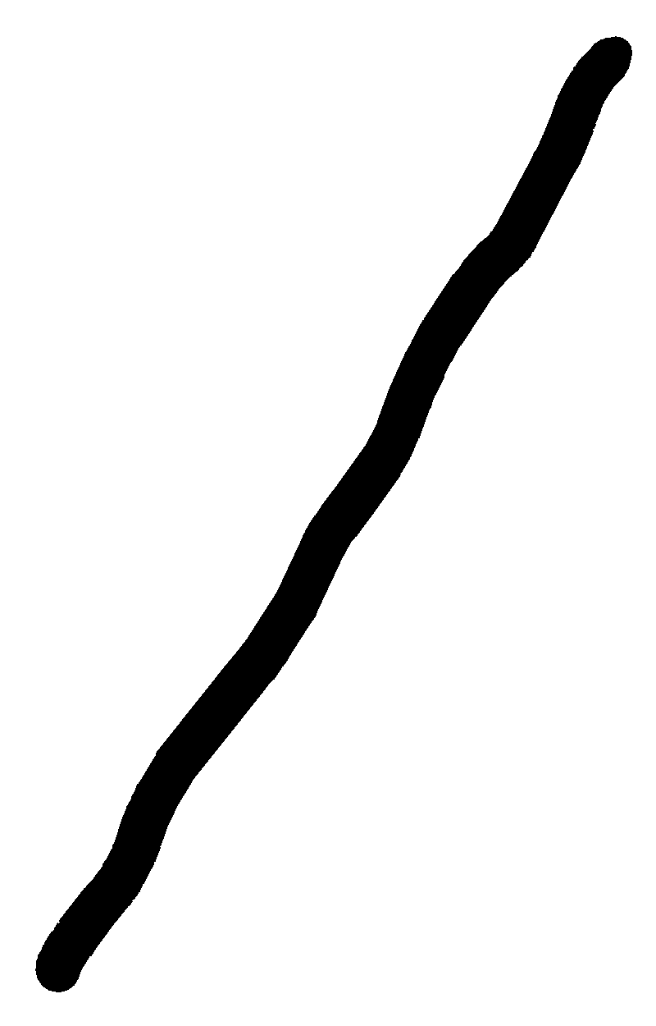
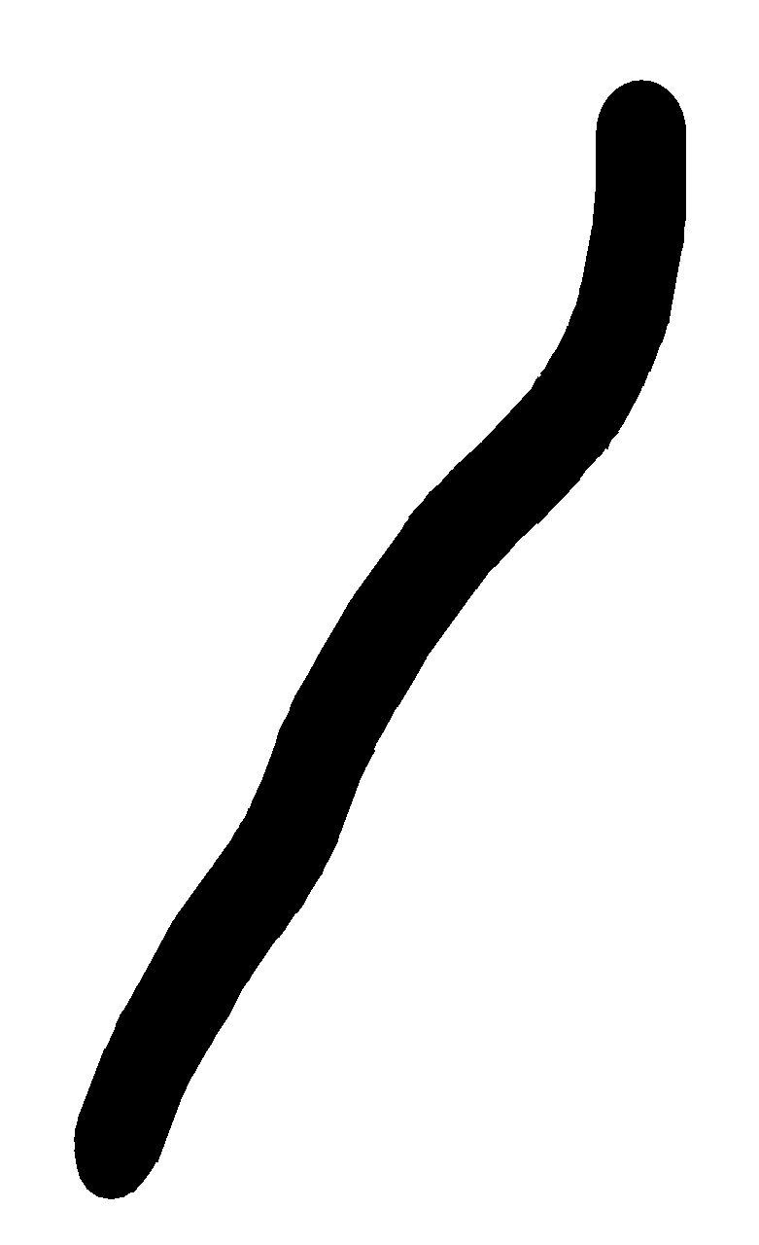
I
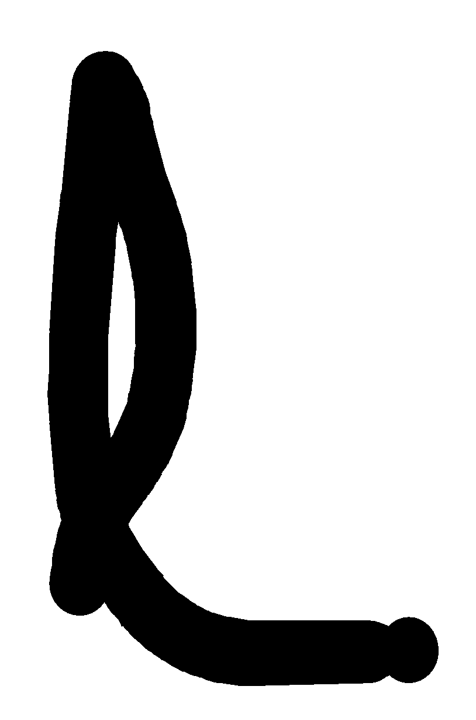
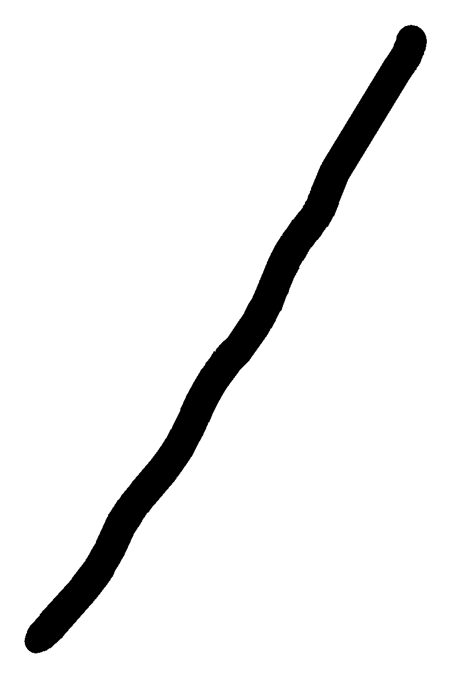
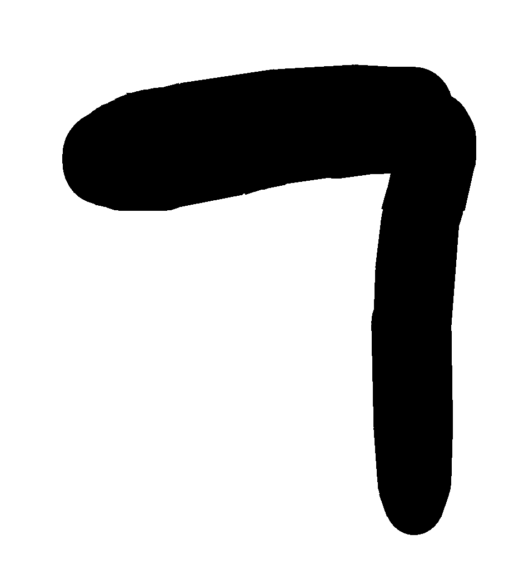
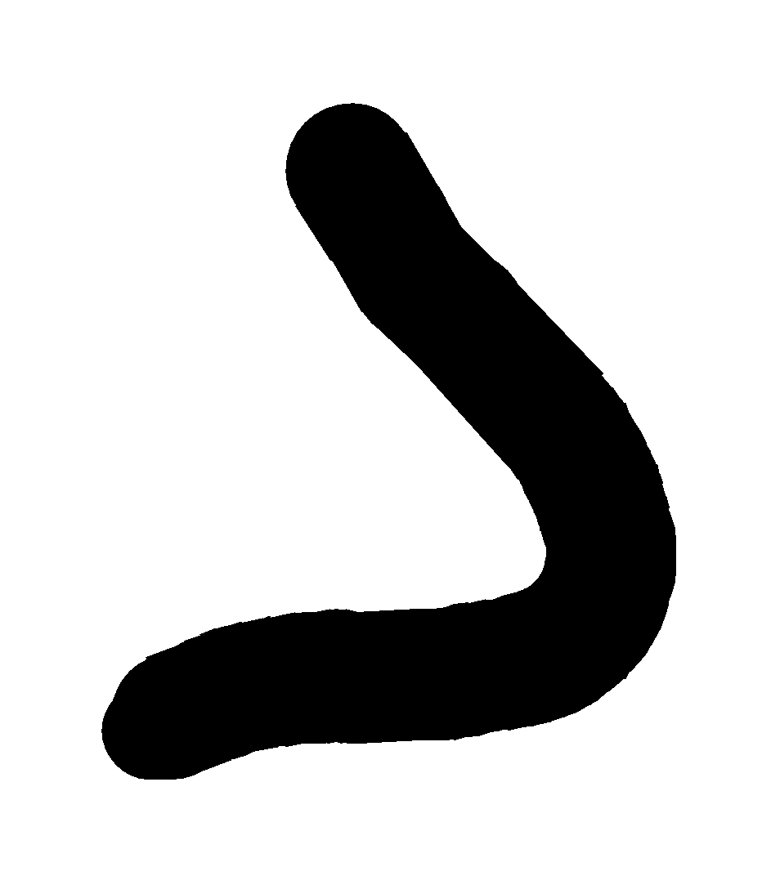
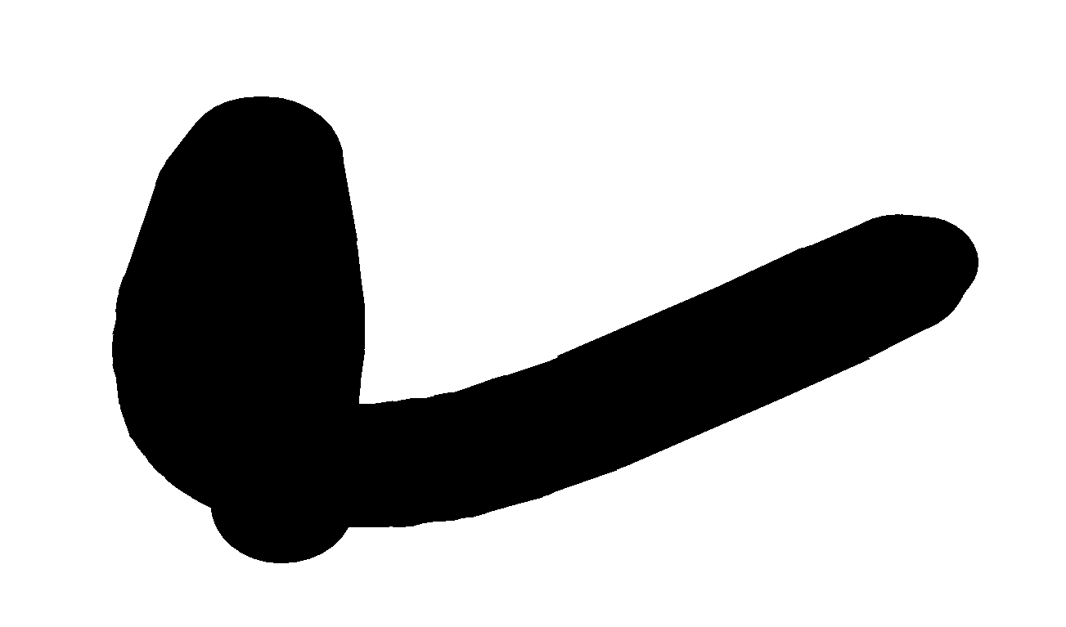
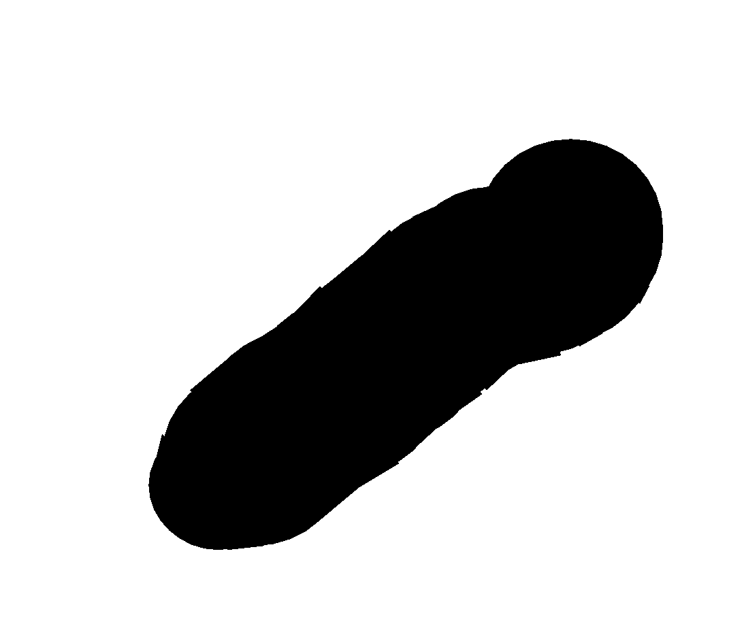
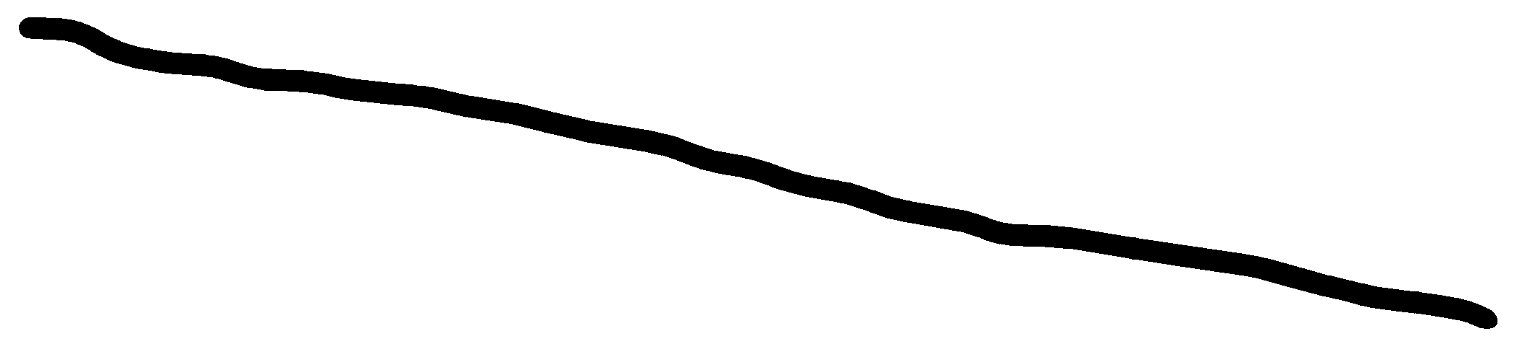
- A straight wire of mass 200g and length 1.5m carries a current of 2A. It is suspended in mid - air by a uniform horizontal magnetic field B. Find the magnitude of magnetic field induction.

- Find the force acting on a conductor of length 5m carrying a current of 8A kept perpendicular to the magnetic field of 1.5T

- If the bar has mass ‘𝑚’, find the distance ‘𝑑’ that the bar must move along the rails from rest to attain speed v.


AURORA BOREALIS
In certain polar regions, a splendid display of colors is seen in the sky. The appearance of dancing green pink lights is fascinating, and equally puzzling. Consider a charged particle of mass m and charge q, entering a region of magnetic field B with an initial velocity v. Let this velocity have a component v_{p} parallel to the magnetic field and a component v_{n} normal to it. There is no force on a charged particle in the direction of the field. Hence, the particle continues to travel with the velocity vp parallel to the field. The normal component v_{n} of the particle results in a Lorentz force q(vn×B) which is perpendicular to both v_{n} and B. The particle thus tends to perform a circular motion in a plane perpendicular to the magnetic field. When this is coupled with the velocity parallel to the field, the resulting trajectory will be a helix along the magnetic field line. Even if the field line bends, the helically moving particle is trapped and guided to move around the field line. Since the Lorentz force is normal to the velocity of each point, the field does no work on the particle and the magnitude of velocity remains the same.
During a solar flare, a large number of electrons and protons are ejected from the sun. Some of them get trapped in the earth’s magnetic field and move in helical paths along the field lines. The field lines come closer to each other near the magnetic poles. Hence the density of charges increases near the poles. These particles collide with atoms and molecules of the atmosphere. Excited oxygen atoms emit green light and excited nitrogen atoms emits pink light. This phenomenon is called Aurora Borealis in Physical Science.
(i) Which of the following defines the exact meaning of magnetic field?
(a) Magnetic field is a scalar field that describes the magnetic influence on moving electric charges, electric currents and magnetic materials.
(b) Magnetic field is a vector field that describes the magnetic influence on moving electric charges, electric currents, and magnetic materials.
(c) Both scalar and vector fields that describe the magnetic influence on moving electric charges, electric currents, and magnetic materials.
(d) Magnetic field is a vector field that describes the magnetic influence on static electric charges, electric currents, and magnetic materials.

(ii) Which of the following defines the exact meaning of Lorentz force?
(a) The Lorentz force is the combination of electric and magnetic force on a point charge due to electromagnetic fields
(b) The Lorentz force is the combination of electric and magnetic force on a point charge due to gravitational fields
(c) The Lorentz force is the combination of gravitational force and magnetic force on a point charge due to electromagnetic fields
(d) The Lorentz force is the combination of electric and centripetal force on a point charge due to electromagnetic fields

(iii) What does Aurora Borealis mean?
(a) The Aurora Borealis, otherwise known as the Northern Lights, is a physics phenomenon that can be magical to observe, striking onlookers to wonder about the cause of the whimsical lights that dance overhead.
(b) The Aurora Borealis, otherwise known as the Southern Lights, is a physics phenomenon that can be magical to observe, striking onlookers to wonder about the cause of the whimsical lights that dance overhead.
(c) The Aurora Borealis, otherwise known as the Eastern Lights, is a physics phenomenon that can be magical to observe, striking onlookers to wonder about the cause of the whimsical lights that dance overhead.
(d) The Aurora Borealis is a apparent outward force on a mass when it is rotated.

(iv) Consider a tightly wound 100 turn coil of radius 10 cm, carrying a current of 1 A. What is the magnitude of the magnetic field at the center of the coil?
(a) 2.28 × 10^{–4} T
(b) 6.28 × 10^{–4} T
(c) 3.28 × 10^{–4} T
(d) 5.28 × 10^{–4} T

The galvanometer can be used as a voltmeter to measure the voltage across a given section of the circuit. For this it must be connected in parallel with that section of the circuit. Further, it must draw a very small current, otherwise the voltage measurement will disturb the original set up by an amount which is very large. Usually we like to keep the disturbance due to the measuring device below one per cent. To ensure this, a large resistance R is connected in series with the galvanometer.
i) There are 3 voltmeter A, B, C having the same range but their resistance is 15,000Ω, 10,000Ω and 5,000Ω respectively. The best voltmeter amongst them is the one whose resistance is
a)5000 Ω b)10,000 Ω c)15000 Ω d) all are equally good
ii)A voltmeter of range 2 V and resistance 300 Ω cannot be converted into ammeter of range
a)1 A b)1 mA c)100 mA d)10 Ma
iii)The scale of a galvanometer of resistance 100 Ω contains 25 divisions. It gives a deflection of one division on passing a current of 4×10 -4 A. The resistance in ohm to be added to it so that it becomes a voltmeter of range 2.5 V is
a)150 b)170 c)110 d)220
iv)A voltmeter of resistance 2000 Ω,0.5 V/div is to be converted into a voltmeter to make it to read 2 V/div. The value of high resistance in ohm to be connected in series with it is
a) 6000 Ω b) 4000 Ω c) 5000 Ω d) 1000 Ω
ANSWERS FOR MCQs
 | (a)
 | (d)
 | (d)
 | (a)1/G
 | (c) 0 , BIL Fpq= ILBSin0 = 0 Fqr= BILSin 90 = BIL
 | b
 | b
 | d
 | c
 | a
 | d
 | d
 | a
 | b
 | A
 | a
 | (d) decrease by 4%
 | (c) 4:3
ANSWERS FOR VSA ( 2 MARKS)
Uniform charged disc
Surface charged density σ=q/∏a²
dq = σ2∏x dx= q/∏a² ꓫ 2∏x dx =2qxdx/a²
dI=dqꓫν=2q ν xdx/ a²
dB=µ₀/4∏ ꓫ 2∏ dI/x = µ₀/2x ꓫdI == µ₀/2x ꓫ 2 qν xdx/ a² = µ₀ qν dx/ a²
integrate dB we will get
B==µ₀ qν/a
Due to infinite wire B= µ₀ i/2∏ a
At a distance of 0.4 m from wire B = µ₀ i/2∏ a

B= 5× 10⁻⁶T
On a charged particle F=qvB sin ⱺ=4× 10⁻¹⁸ N
Since the total length of the wire used remains the same,
Nꓫ ∏ d =N’ꓫ ∏ 2d
N’=N/2
Hence the ratio of the magnetic moments=M’/M =IN’A’/INA=N’A’/NA=N’d²/Nd² =2
 | B = µ₀I/2^{3/2}r
 | 5.33 x 10 ⁻⁷ N (attractive and towards the wire)
 | Zero and 6.28 x 10⁻⁵T
i) shunt Resistance =0.15 ohm
ii) Total Resistance =0.12 ohm
 | B=µ₀NI/R=6.28×10⁻⁴ T
 | I=B/ µ₀n=8 A
 | B =1/2 (µ₀ I / 2r) 1.6 x 10⁻⁴ T
Force on a charged particle due to electric and magnetic field is called Lorenz force
F j = q [ V i x B (-k )]
For electron +k

 | M= IA= IπR² and 2πr = 2 r= 1/π
 | A uniform radial magnetic field is important in a moving coil galvanometer because it makes the torque on the coil same in all positions of the coil in the magnetic field.
B = 0.5 x 10⁻⁵ T
T = 2πM/ qB
= (2 x 3.14 x 9.1 x 10⁻³¹)/ (1.6 x 10⁻¹⁹ x 0.5 x 10⁻³)
= 7.14 x 10⁻⁹ sec
Current sensitivity- The deflection produced per unit current in the coil of a galvanometer is called current sensitivity.
I_{g} = φ/ I = NAB/ k

Voltage sensitivity- The deflection produced per unit voltage in the coil of galvanometer is called voltage sensitivity.

V_{g} = φ/V = (NAB/k) x 1/R
 | Zero, because the upper and lower current carrying conductors are identical and so the magnetic fields caused by them at the center O will be equal and opposite
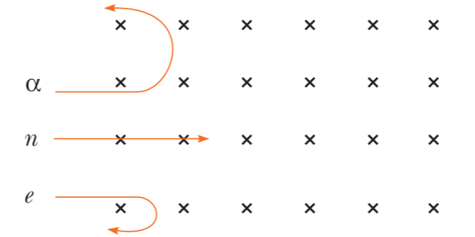
Force on alpha particle and electron are opposite to each other, magnitude of mass per charge ratio of alpha particle is more than electron (i. e. $r∝\frac{m}{q}$)? hence radius of alpha particle is more than radius of electron.

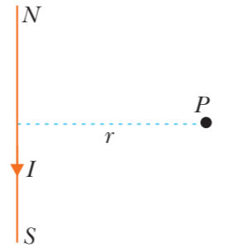
Given I = 50 A, r = 2.5 m

$$B=\frac{μ_{0}I}{2πR}$$

=$\frac{4π ×{10}^{-7}×50}{2π×2.5}$=$4×{10}^{-6}$ T
By right hand palm rule the magnetic field is directed vertically upward.
ANSWERS FOR SA ( 3 MARKS)
Magnetic field produced by both are equal in nature but in opposite direction
µ₀ I₁ a₁²/2(a₁² +x₁²)^{3/2} = µ₀ I ₂a ₂²/2(a ₂² +x ₂²)^{3/2}
I₂ =0.56 A
a)For F =0 sinⱺ=n∏
So.magnetic field will be parallel or antiparallel to the velocity of charged particle.

b)For a charged particle moving in a constant magnetic field and v perpendicular to magnetic field
mv²/r =qvB
r=p/qB …………..(i)
K.E of electron=ev
P²/2m=ev
P=√2mev ………(ii)
From (i) and (ii)
r =8.4ꓫ 10⁻³m
2=I_{G}G+R₁ I_{G}
R₁=19KΩ
20= I_{G}(10+R₁+R₂)
R₂=18 KΩ
200=I_{G}(10+R₁+R₂ +R₃)
R₃=180 KΩ
 | Calculation and graph NCERT Text Book page no. 149(old book)
 | B = 2π X 10⁻⁵T and tanθ = ¾
 | 1.2 x 10⁻³kg/m and current in CD should be opposite to that of AB
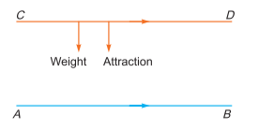
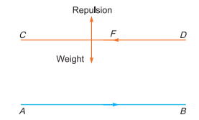
Current carrying conductors repel each other, if current flows in the opposite direction.

Current carrying conductors attract each other if current flows in the same direction. If wire CD remain suspended above AB then
F_{repulsion}= Weight

$\frac{μ_{0}I_{1}I_{2}l}{2πR}$= mg

$$\frac{μ_{0}I_{1}I_{2}}{2πRg}=\frac{m}{l}$$

$$\frac{2×{10}^{-7}×12×5}{1×{10}^{-3}×10}=\frac{m}{l}$$

$$= 1.2×{10}^{-3}kg/m$$

Current in CD should be in opposite direction to that in AB.
For a charged particle moving in a constant magnetic field and v is perpendicular to B
$$\frac{mv^{2}}{r}=qvB$$

$$r=\frac{mv}{qB}$$

$$r=\frac{p}{qB}………………………………………………………..(i)$$

If e is accelerated through a potential difference of 10⁴ V, then
K.E. of the electron = eV
Then $\frac{p^{2}}{2m} =eV$

$P=√2meV$ ……………………………………………(ii)

From (i) and (ii)

$$r=\frac{√2meV}{qB}$$
=$\frac{\sqrt{2}×9.1×{10}^{-31}×1.6×{10}^{-19}×{10}^{4}}{1.6×{10}^{-19}×0.04}$

r =$8.4×{10}^{-4}m$

ANSWERS FOR CBQ (4 MARKS)
- circular
- deflected upwards
c) 2.2ꓫ10⁻⁹ Cm⁻²
- 0.65
- v²m/2Ilm
- 60N
(i) b
(ii) a
(iii) a
(iv) b
- c
- a
- a
- a

XII PHY CH- 5 MAGNETISM AND MATTER
Q. NO | QUESTION
MCQ s 1 MARK EACH
The dipole moment of a circular loop carrying a current I, is m and the magnetic field at the centre of the loop is B ₁. When the dipole moment is doubled by keeping the current constant, the magnetic field at the centre of the loop is B ₂ . the ratio B ₁ / B ₂ is
(a) 2 (b) $\sqrt{3}$ (c) $\sqrt{2 }$ (d) 1/$\sqrt{2 }$
Needles N₁ , N₂ and N₃ are made of a ferromagnetic, a paramagnetic and a diamagnetic materials respectively. A magnet, when brought close to them, will
(a) attract N₁ strongly, but repel N₂ and N₃ weakly.
(b) attract all three of them.
(c) attract N₁ and N₂ strongly, but repel N₃ .
(d) attract N₁ strongly, N₂ weakly and repel N₃ weakly.
A bar magnet of magnetic moment 10⁴ J/T is free to rotate in a horizontal plane. The work done in rotating the magnet slowly from a direction parallel to a horizontal magnetic field of 4 x 10 ^{– 5} T to a direction of 60° from the field will be
(a) 0.2 J (b) 2 J (c) 4.18 J (d) 2 x 10² J
A magnetic needle suspended parallel to a magnetic field requires $\sqrt{3}$ J of work to turn it through 60°. The torque needed to maintain the needle in this position will be
(a) 2$\sqrt{3}$ J (b) 3 J (c) $\sqrt{3}$ J (d) 1.5 J
If the number of turns, area and current through a coil are given by N, A and I respectively, then its magnetic moment is given by
(a) NIA (b) NIA² (c) N²IA (d) N²IA²
Two wires of same length are shaped into a square and a circle. If they carry same current, ratio of their magnetic moment is
(a) 2 : π (b) π : 2 (c) π : 4 (d) 4 : π
If a bar magnet of pole strength m and magnetic moment M is cut perpendicular to its axis in two equal halves then its new pole strength m' and magnetic moment M' are respectively
a) m′= m and M′= M b) m′= m and M′= M/2
c) m′= m/2 and M′= 2M d) m′= 2m and M′= M/2
A short bar magnet of magnetic moment 0.4 JT⁻¹ is placed in a uniform magnetic field of 0.16 T. The magnet is in stable equilibrium when the potential energy is
a) − 0.64 J b) zero
c) − 0.082 J d) − 0.064 J
Which of the following statements are correct?
(A) Electric monopoles do not exist, whereas magnetic monopoles exist.
(B) Magnetic field lines due to a solenoid at its ends and outside cannot be completely straight and are confined.
(C) Magnetic field lines inside a bar magnet are not parallel.
(D) χ = −1 is the condition for a perfect diamagnetic material, where χ is its magnetic susceptibility
(a) (D) only (b) (B) only
(c) (A) and (B) only (d) (B) and (C)
The ratio of magnetic field induction due to short bar magnet on axial line and equatorial line for the same distance is
a.1:2 b.1:3
c.2:3 d. 2:1
A charged particle (charge q) is moving in a circle of radius R with uniform speed v. The associated magnetic moment μ is given by
a) qvR
b) qvR/2
c) qvR²
d) qvR² /2
Assertion: When radius of a circular loop carrying current is doubled, its magnetic moment becomes four times.
Reason: Magnetic moment depends on the area of the loop.

a) Assertion is True, Reason is True, Reason is a correct explanation for Assertion
b) Assertion is True, Reason is True, Reason is not a correct explanation for Assertion
c)Assertion is true, Reason is false
d) Assertion is False but, Reason is True
Assertion: Susceptibility is defined as the ratio of intensity of magnetization I to magnetic intensity H.
Reason: Greater the value of susceptibility, smaller the value of intensity of magnetization I.

a) Assertion is True, Reason is True, Reason is a correct explanation for Assertion
b) Assertion is True, Reason is True, Reason is not a correct explanation for Assertion
c)Assertion is true, Reason is false
d) Assertion is False but, Reason is True
VSA 2 MARKS EACH
The susceptibility of magnetic materials is – 4.2×10^{–6} . Name the type of magnetic materials it represents.
(b) State any two properties of the above type of materials
 | Draw magnetic field lines when a (i) diamagnetic (ii) paramagnetic substance is placed in an external magnetic field.
The susceptibility of a magnetic material is 2.6x10 ⁻⁵ . Identify the type of magnetic material.
(b) State any two properties of the above type of materials.
Explain the following:
Why do magnetic field lines form continuous closed loops?
Why are the field lines repelled (expelled) when a diamagnetic material is placed in an external uniform magnetic field?
A bar magnet of magnetic moment 1.5 JT–1 lies aligned with the direction of a uniform magnetic field of 0.22 T.
What is the amount of work required by an external torque to turn the magnet so as to align its magnetic moment
(i) normal to the field direction? And
(ii) opposite to the field direction?
(b) What is the torque on the magnet in cases (i) and (ii)?
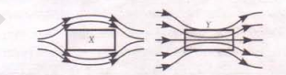
A uniform magnetic field gets modified as shown below when two specimens X and Y are placed in it. (i) Identify whether specimens X and Y are diamagnetic, paramagnetic or ferromagnetic.

﻿(ii) How is the magnetic permeability of specimen X different from that of specimen Y?
 | A coil of ‘N’ turns and radius ‘R’ carries a current ‘I’. It is unwound and rewound to make a square coil of side ‘a’ having same number of turns (N). Keeping the current ‘I’ same, find the ratio of the magnetic moments of the square coil and the circular coil.
 | In what way is the behaviour of a diamagnetic material different from that of a paramagnetic, when kept in an external magnetic field?
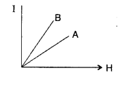
The figure shows the variation of intensity of magnetisation versus the applied magnetic field intensity, H, for two magnetic materials A and B :

(a) Identify the materials A and B.
(b) Why does the material B, has a larger susceptibility than A, for a given field at constant temperature?
 | Draw a graph showing variation between magnetizing field B and magnetic intensity H for a complete cycle of magnetization and demagnetization of ferromagnetic material and show the portion of retentivity and coercivity.
Magnetic field at an equatorial line at a distance of 10 cm from its centre due to a bar magnet is 0.48 x 10 ^{– 4} T. (i) find the magnitude and direction of magnetic field at the same distance from the centre of bar magnet at an axial line.
(ii) find the magnetic moment of the bar magnet.
Behaviour of magnetic field lines near two substance is shown by figures. Identify substance (a) and (b). Also write the effect of temperature on susceptibility of these substance.
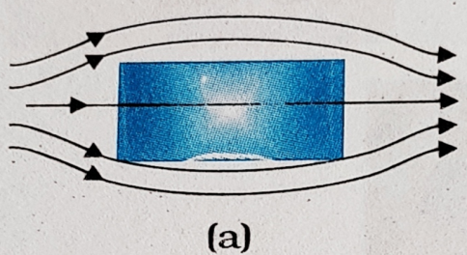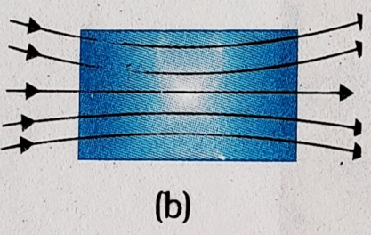
SA 3 MARKS EACH
Two similar bars, made from two different materials P and Q, are placed one by one, in a non-uniform magnetic field. It is observed that a) bar P tends to move from the strong to the weak field region.
b) bar Q tends to move from the weak to the strong field region. Identify the magnetic material used for making these two bars. Show with the help of diagrams, the behaviour of the field lines, due to an external magnetic field, near each of these two bars
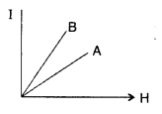
(a)Identify the materials A and B.
(b) Why does the material B, have a larger susceptibility than A, for a given field at constant temperature?
A bar magnet of magnetic moment 6 J/T is aligned at 60⁰ with a uniform external magnetic field of 0·44 T. Calculate (a) the work done in turning the magnet to align its magnetic moment (i) normal to the magnetic field,
(ii) opposite to the magnetic field,
and (b) the torque on the magnet in the final orientation in case (ii).

(a)Three curves are shown in figures. Indicate what magnetic substance they represent.
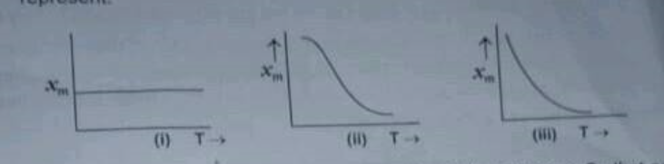
(b) Distinguish between diamagnetic and ferromagnetic substances in respect of (i) intensity of magnetization, (ii) susceptibility(iii)permeability.
A Solenoid has a core of material with relative permeability 400. The windings of the solenoid are insulated from the core and carry a current of 2 A. If the number of turns is 1000 per metre, calculate
(i) magnetic intensity H (ii) Field of magnetization M
(iii) the total magnetic field B
A closely wound solenoid of 2000 turns and area of cross-section 1.6 x 10 ^{– 4} m², carrying a current of 4 A , is suspended through its centre allowing it to turn in a horizontal plane.
(a) Calculate the magnetic moment associated with the solenoid.
(b) What is the force and torque on the solenoid if a uniform horizontal magnetic field of 7.5 x 10 ^{– 2} T is set up at an angle of 30° with the axis of solenoid.
CASE BASED QUESTIONS 4 MARKS
Read the following paragraph and answer the questions Magnetic materials:
All substances exhibit some type of magnetism. Magnetic materials are classified according to their bulk susceptibility. Ferromagnetism is responsible for most of the effects of magnetism encountered in everyday life, but there are actually several types of magnetism. Paramagnetic substances, such as aluminum and oxygen, are weakly attracted to an applied magnetic field; diamagnetic substances, such as copper and carbon, are weakly repelled; while antiferromagnetic materials, such as chromium and spin glasses, have a more complex relationship with a magnetic field.
i.The susceptibility of a magnetic material is −0.085. Identify the type of magnetic material . (1 mark )
ii. From the figure, identify the material suitable for making permanent magnet. (1 mark)

(iii) Why is soft iron preferred for making the core of electromagnet? (2marks)

OR
Suggest a method to move a device in Physics Lab without affecting the magnetic field. (2marks)

DOMAIN THEORY
The atom of a ferromagnetic material also possesses non-zero magnetic moment as in case of a paramagnetic substance. However, due to a quantum mechanical effect, called exchange interaction, an unpaired electron in one atom interacts strongly with the unpaired electron in the neighboring atom in such a way that they spontaneously align themselves in a common direction over a small volume of the material. These small volumes of uniform magnetization are called domains. Although domains are extremely small in size (~ 10⁻¹⁸ m³ in volume), yet each domain contains a large number of atoms (~ 10¹¹ atomic magnetic dipoles).

Q1. The domain formation is necessary feature of
a. Diamagnetic
b. Paramagnetic
c. Ferromagnetism
d. All of the above
Q2. Curie temperature is the temperature above which
a. A ferromagnetic material becomes paramagnetic
b. A paramagnetic material becomes diamagnetic
c. A ferromagnetic material becomes diamagnetic
d. A paramagnetic material becomes ferromagnetic.
Q3. What are domains?
Q4. What is the effect on orientation domains in ferromagnetic material when external magnetic field is applied?
a. Decrease in size and changes orientation.
b. May increase or decrease in size and change its orientation.
c. Have no relation with external magnetic field
d. Increase in size but no change in orientation.

Magnetic phenomena are universal in nature. The science of magnetism grew from the observation that a certain ore could attract small pieces of iron and point in a certain direction when kept on the floating cork. The ore was originally found in the district of Magnesia in Asia Minor (now in western Turkey) and therefore named magnetite. When iron filings are sprinkled on a sheet of glass placed over a short bar magnet, a particular pattern is formed and the following conclusions are drawn
The bar magnet has poles similar to the positive and negative charge of an electric dipole.
One pole is designated as the north pole and the other as the south pole.
When suspended freely, these poles point approximately towards the geographic north and south poles.
Like poles repel each other and unlike poles attract each other.
The poles of a magnet can never be separated.

Q1. State two important properties of magnetic field lines.
Q2. Draw magnetic field lines of a bar magnet.
Q3. Write the SI unit of (i) pole strength and (ii) magnetic moment of a bar magnet.
Q4. Define magnetic dipole moment. Give its SI unit.

As shown in figure a solenoid where the wire is coiled around a cylinder, each wire loop in this coil acts as if it was a separate circular wire carrying the same current I, the current in the coiled wire and the dense enough array of such loops may be approximated by a cylindrical current sheet with the current density K = I × (N/L) = I × L (loops) /solenoid length.
For simplicity, let’s assume a long solenoid (length ≫ diameter) which we approximate as infinitely long. For a long solenoid (compared to its diameter), the magnetic field inside the solenoid is approximately uniform and approximately parallel to the axis, except near the ends of the solenoid. Outside the solenoid, the magnetic field looks like the field of a physical dipole, with the North pole at one end of the solenoid and the South pole at the other end and is approximately negligible.
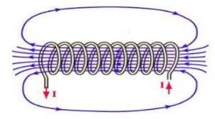
I. Which of the following material can be used to make loops around the cylinder?
(a)Plastic (b) Glass
(c) Quartz (d) copper

II. The magnetic field inside the solenoid is
(a) Non-Uniform and parallel to the axis
(b) Uniform and parallel to the axis
(c) Non-uniform and perpendicular to the axis
(d) Uniform and perpendicular to the axis

III. A proton is moving from left to right direction and outside the solenoid, then what is the direction of force on the proton?

(a) upwards (b) downwards
(c) proton will not deflect (d) inwards

IV. How the magnetic field inside the solenoid depends upon the number of turns?
(a) inversely proportional (b) directly proportional
(c) proportional to the number of turns (d) none of these

Every matter is formed of atoms, According to atomic model of magnetism, each atom is a complete magnetic dipole. Each atom, consist of a positively charged small nucleus at the center and electrons revolve around the nucleus in definite orbits. The motion of the electrons around the nucleus is identical to that of earth around the sun. The electrons revolve around the nucleus in a definite orbit and the motion is called orbital motion. The electron spins about its own axis and the motion is called spin motion, This spin motion may be clockwise or anticlockwise. The magnetic moment is produce due to both orbital motion and spin motion. However, most of the magnetic moment is produced due to spin motion and very small contribution due to orbital motion.
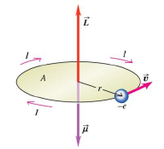
I. The orbital magnetic moment due to orbital motion of electron is
(a) evr
(b) evr/2
(c) evr/4
(d) none of these

II.The major part of magnetism is caused by
(a) spin motion
(b) orbital motion
(c) both (a) and (b)
(d) none of these

III. The primary origin(s) of magnetism is
(a) atomic currents
(b) Pauli exclusion principle
(c) intrinsic spin of electron
(d) both (a) and (c)

III. Bohr Magneton is defined as the magnetic moment associated with an electron due to its orbital motion in the ______ orbit of hydrogen atom.
(a) Last
(b) Second
(c) First
(d) Zeroth
ANSWERS FOR MCQs
 | (c)
 | (d)
 | (a)
 | (b)
 | (a)
 | (c)
 | b) m′= m and M′= M/2
 | d) − 0.064 J
 | (a) (D) only
 | d. 2:1
 | b) qvR/2
 | a) Assertion is True, Reason is True, Reason is a correct explanation
 | c) Assertion is true, Reason is false
ANSWERS FOR VSA ( 2 MARKS)
a) Diamagnetic
b) any two properties

 | a. Diamagnetic b. Paramagnetic
a) Paramagnetic
b) any two properties
Magnetic lines of force form continuous closed loops because a magnet is always a dipole and as a result, the net magnetic flux of a magnet is always zero.
When a diamagnetic substance is placed in an external magnetic field, a feeble magnetism is induced in opposite direction. So, magnetic lines of force are repelled
Here m=1.5J/T,
B=0.22T
(a) W=−m B(cosθ2​−cosθ1​)
(i) θ₁​=0° (along the field)
θ₂​=90° (perpendicular to the field)
W=−0.33(0−1)J =0.33 J
(ii) θ₁​=0°, θ_{2​}=180°
W=−1.5×0.22(cos180°−cos0°)=0.66 J
b)Torque =mBsinθ
(i) θ=90∘
⟹τ=0.33 Nm
(ii) τ=mBsin180∘
=0Nm

X is diamagnetic and
Y is ferromagnetic.
X is diamagnetic as it expels magnetic lines Y is paramagnetic or ferromagnetic as it pulls the magnetic lines into it.

 | Ms/Mc=π/4
The affinity of the paramagnetic material towards an external magnetic field is much higher than a diamagnetic material.
The magnetic field lines pass through the paramagnetic material while the magnetic field lines move away from the diamagnetic material
(a) Material A is Paramagnetic. Material B is Ferromagnetic.
(b) Since paramagnetic substances have a tendency to pull in magnetic field lines when placed in a magnetic field.
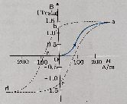
Value of B & H is not important only trend of curve should be emphasised.
Retentivity - Ob Coercivity - oc

(i) 0.96 x 10 ⁻⁴ T in the same direction of magnetic moment of the bar magnet
(ii) 0.48 J/T
(a) Diamagnetic susceptibility is independent of temperature.
(b) Paramagnetic susceptibility decreases as increase in temperature.
ANSWERS FOR SA ( 3 MARKS)
a. Diamagnetic
b. Paramagnetic

a.i)W=MB(cosƟ_{i}-cosƟ_{f}) =MB/2=1.32J
ii) W=MB(cosƟ_{i}-cosƟ_{f}) =3MB/2=3.96J
b. Torque=0
(a)(i) diamagnetic, (ii) Ferromagnetic, (iii) paramagnetic.

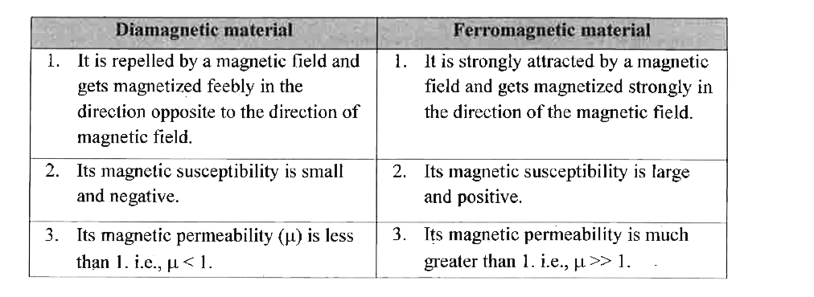
Magnetic Dipole in a Uniform Magnetic Field:
Consider a bar magnet of length 2l is placed in a uniform magnetic field B. Let m be the pole strength of its each pole and the angle made by the magnetic axis of a bar magnet with the magnetic field is θ
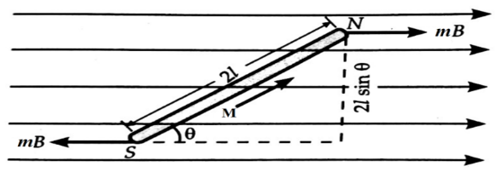
The force experienced by N-pole, =mB along B.
The force experienced by S-pole, = mB opposite to B
The force on two poles are equal and opposite. They form a couple and the moment of a couple(or torque) is given by
ζ=Force×perpendicular distance
= mB×2lsinθ=(m×2l)sinθ=MB sinθ
Where M=B×2l, is called the magnetic dipole moment of a bar magnet.
Expression for Potential Energy:
U=- m.B=m B cosθ
U=Magnetic potential energy
m =magnetic moment of the magnetic dipole
B = Magnetic field.

 | (i) 2 x 10³ A/m (ii) 8 x 10⁵ A/m (iii) 1.0 T
 | (a) 1.28 A m² (b) Net force = 0, torque = 0.048 Nm
ANSWERS FOR CBQ (4 MARKS)
ii) Diamagnetic material
(ii) Material A is ferromagnetic because here its slope is more. Hence material A is suitable for making permanent magnet.
(iii) The core of electromagnet should have high permeability, low retentively and low coercively. Hence soft iron used.
OR
Keep the device in an iron cavity and move. Iron has high permeability hence it converges all the magnetic field through it and the device will be safe
d.All the above
d. A paramagnetic material becomes ferromagnetic.
due to a quantum mechanical effect, called exchange interaction, an unpaired electron in one atom interacts strongly with the unpaired electron in the neighbouring atom in such a way that they spontaneously align themselves in a common direction over a small volume of the material. These small volumes of uniform magnetisation are called domains.
b. May increase or decrease in size and change its orientation.
i) A magnetic field line is an imaginary curve, the tangent to which at any point gives the direction of magnetic field B at that point.
The magnetic field lines of a magnet form a close-continuous loop.
Outside the body of the magnet, the direction of magnetic field lines are from the north pole to the south pole.
No two magnetic field lines can intersect each other. This is because, at the point of intersection, we can draw two tangents. This would mean two directions of the magnetic field at the same point, which is not possible. ( Any two)
(ii)
iii) 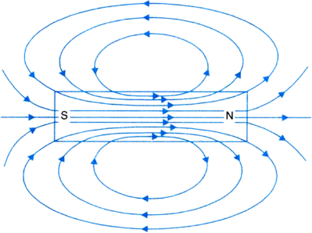
SI unit of pole strength is ampere-metre and SI unit of magnetic moment is ampere meter2.
The magnetic moment is the product of current and area.
Magnetic momemt, M = c u r r e n t × A r e a = [ A m p e r e ] × [ m 2]
The SI unit of magnetic moment is A m2 .
I. (d) copper
II. (b) Uniform and parallel to the axis
II. (c) proton will not deflect
IV. (b) directly proportional
I. (b) evr/2
II. (a) spin motion
II. (d) both (a) and (c)
IV. (c) First

XII PHY CH-6 ELECTROMAGNETIC INDUCTION
Q. NO | QUESTION
MCQ s 1 MARK EACH
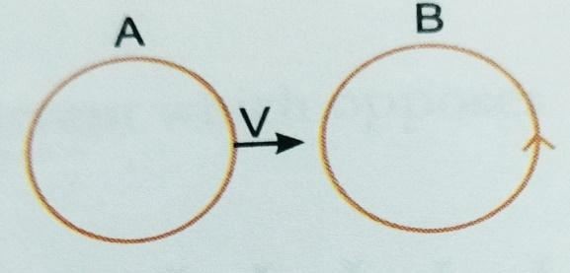
There are two coils A and B as shown in the figure. A current starts flowing in B as shown, when A is moved towards B and stops when A stops moving.We can infer that
- There is a constant current in the clockwise direction in A
- There is varying current in A
- There is no current in A
- There is a constant current in the counterclockwise direction in A
The magnetic flux linked with the coil (in webers) is given by the equation φ= 5t²+3t+16. The induced emf in the coil at time t=4 s is
- -27V (b) -43V (c) -108 V (d) 210 V
If both the number of turns and core length of an inductor is doubled keeping the other factors constant, then its self inductance will be
- Unaffected (b) doubled (c) halved
(d) quadrupled
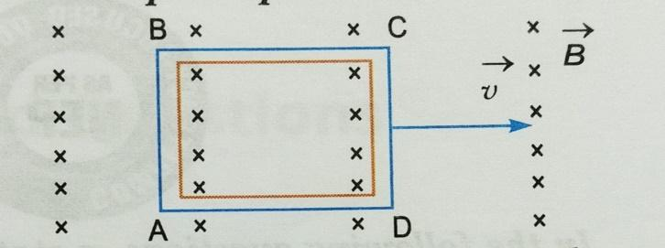
A conducting square loop of side L and resistance R moves in its plane with the uniform velocity v perpendicular to one of its sides.
A magnetic field B constant in time and space pointing perpendicular and into the plane of the loop exists everywhere as shown in the figure. The induced current in the loop is
- BLv/R clockwise (b) BLv/R anticlockwise
(c)2BLv/R anticlock wise (d) zero
A square shaped coil of side 10cm, having 100 turns is placed perpendicular to a magnetic field which is increasing at 1T/s. The induced emf in the coil is
- 0.1 V (b) 0.5 V (c) 0.75V (d) 1.0 V
A Circular loop of ‘r’,carrying a current I lies in Y-Z plane with its centre at the origin. The net magnetic flux through the loop is
(a) Directly proportional to r
(b) Zero (c) Inversely proportional to r (d) Directly proportional to I
The Self Inductance of a solenoid of 600 turns is 108 mH. The self-inductance of a coil having 500 turns with the same length ,the same radius and the same medium will be
- 95 mH (b) 90 mH (c) 85 mH (d) 75 mH
The Current in the Primary coil of a pair of coils changes from 7 A to 3 A in 0.04 s. The mutual inductance between the two coils is 0.5 H. The induced emf in the secondary coil is
- 50 V (b) 75 V (c) 100 V (d) 220 V
Two coils are placed close to each other . The mutual inductance of the pair of coils depends upon the
- Rate at which current change in the two coils
- Relative position and orientation of the coils
- Rate at which voltage induced across two coils
- Currents in the two coils
Of the following statements, mark the correct Answers as
A - if both Assertion and Reason -- are true and Reason -- is correct explanation of the Assertion.
B - if both Assertion and Reason -- are true but Reason -- is not correct explanation of Assertion.
C - if Assertion is true but Reason -- is false.
D - if both Assertion and Reason -- are false.

Assertion- Only a change in magnetic flux through a coil maintain a current in the coil if the current is continues.
Reason -- The presence of large magnetic flux through a coil maintain a current in the coil if the current is continues.
The Self inductance L of a solenoid of length l and area of cross section A,with a fixed number of turns N increases as
a) l and A increase (b) l decreases and A increases
c) l increases and A decreases (d) both l and A decrease
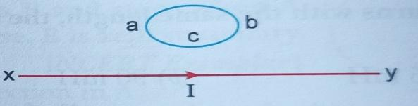
The direction of induced current in the loop abc is
- Along abc if I decreases
- Along acb if I increases
- Along abc if I constant
- Along abc if I increases
The Magnetic flux linked with the coil (in weber) is given by the equation, ϕ = 5t² +3t+16 . The induced EMF in the coil at time t = 4 will be
- -27 V b) -43 V c -108 V d) 210 V
Lenz’s law is essential for
- Conservation of Energy
- b) Conservation of mass
c) Conservation of momentum
d) Conservation of charge
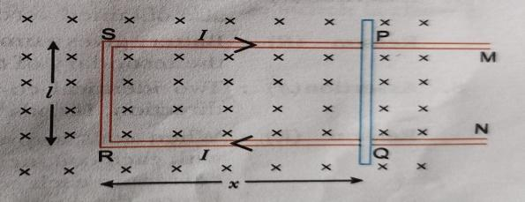
Figure shows a rectangular conductor PSRQ in which movable arm PQ has a resistance ‘r’ and resistance PSRQ is negligible. The magnitude of emf induced when PQ is moved with a velocity v does not depend on

- magnetic field B b) velocity field v
c)resistance d) length of PQ
VSA 2 MARKS EACH
A square loop MNPQ offside 20 cm is placed horizontally in a uniform magnetic field acting vertically downward as shown in the figure. The loop is pulled with a constant velocity of 20 m/s till it goes out of the field.
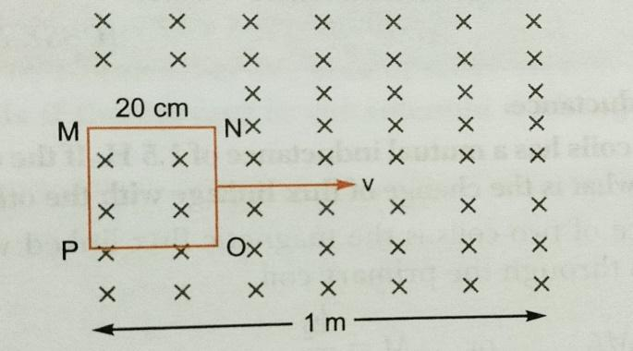
- Depict the direction of the induced current in the loop as it goes out of the field. For how long would the current in the loop persist?
- Plot a graph showing the variation of magnetic flux and induced emf as a function of time.
 | A metallic rod of length l is rotated at a constant angular speed ω, normal to a uniform magnetic field B. Derive an expression for the current induced in the rod, if the resistance of the rod is R.
A circular copper disc. 10 cm in radius rotates at a speed of 2 rad/s about an axis through its centre and perpendicular to the disc. A uniform magnetic field of 0.2T acts perpendicular to the disc.
1) Calculate the potential difference developed between the axis of the disc and the rim.
2) What is the induced current if the resistant of the disc is 2?
 | A pair of adjacent coils has a mutual inductance of 1.5 H. If the current in one coil changes from 0 to 20 A in 0.5 s, what is the change of flux linkage with the other coil?
 | A 0.5 m long solenoid of 10 turns/cm has area of cross-section 1 cm2. Calculate the voltage induced across its ends if the current in the solenoid is changed from 1A to 2A in 0.1s.
Two identical loops, one of copper and the other of Aluminium are rotated with the same angular speed in the same magnetic field. Compare
(a) the induces emf
(b) the current produced in the two coils.
 | A coil of wire of certain radius has 800 turns and a self inductance of 200mH,What will be the self inductance of another similar coil of 2500 turns?
 | Current in the circuit falls from 5.0 A to 0.0A in 0.1 sec. if an average emf of 200volt is induced calculate the self-induction of the current?
 | The magnetic flux through a coil is varying according to the relation ϕ = (4t3 + 5t2 + 8t-3 + 5) Wb. Calculate the induced current through the coil at t = 2s if resistance of coil is 3.1 ohm.
 | State Faraday’s law of electromagnetic induction. Give their mathematical form.
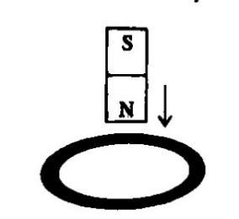
(a) A bar magnet falls from height h through a metal ring. Will its acceleration be equal to 'g’? Give reason for your answer.
(b) What happened if the ring in the above case is cut so as not to form a complete loop?

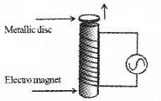
When AC is switched on the thin metallic disc is found to thrown up in air.
- Which makes the disc to thrown?
- How will you explain the mechanism behind the movement of disc
- Write the working principle of induction heater.
SA 3 MARKS EACH
(a) A rod of length l is moved horizontally with a uniform velocity 'v' in a direction perpendicular to its length through a region in which a uniform magnetic field is acting vertically downward. Derive the expression for the emf induced across the ends of the rod.
(b) How does one understand this motional emf by invoking the Lorentz force acting on the free charge carriers of the conductor? Explain.
 | Define mutual inductance between a pair of coils. Derive an expression for the mutual inductance of two long coaxial solenoids of same length wound one over the other.
- State Faraday’s law of electromagnetic induction
- Figure shows a rectangular conducting loop PQSR in which an RS of length ‘ ’ is movable. The loop is kept in a uniform magnetic field ‘B’ directed downward perpendicular to the plain of the loop. The arm RS is moved with a uniform speed ‘v’. 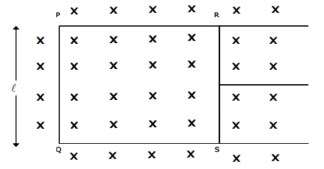
Deduce an expression for (a) The emf induced across the arm ‘RS’, (b) The external force required to move the arm, and (c) The power dissipated as heat.
A horizontal wire of 10m long extending from east to west is falling with a speed of 5 m/s at right angles to the horizontal component of earth’s magnetic field equal to 0.30x10⁻⁴Wb/m².
- What is the instantaneous value of the emf induced in the wire?
- What is the direction induced current?
- Which end of the wire is at the higher electric potential?
Use Lenz law to determine the direction of induced current in the situations described by the following two figures.
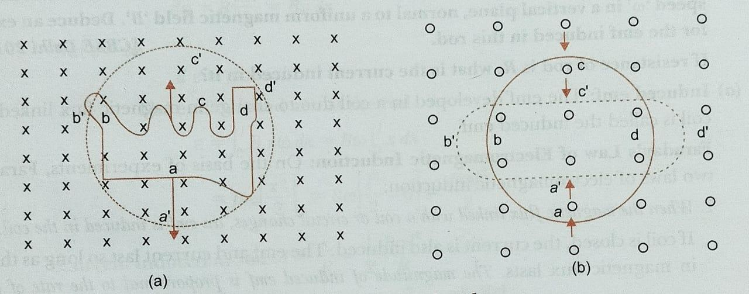
- A wire of irregular shape turning into a circular shape.
- A circular loop being deformed into a narrow straight wire.
 | Two concentric circular coils, one of radius R and the other of radius r are placed coaxially with their centres coinciding. For R>>r, obtain an expression for the mutual inductance of the arrangement.
CASE BASED QUESTIONS 4 MARKS
Elecromagnetic induction: Consider the experimental set up shown in the figure. This ring launcher set up is an outstanding demonstration of some simple laws of Physics. A conducting non-magnetic ring is placed over the vertical core of the solenoid. When current is passed through the solenoid, the ring is thrown off.

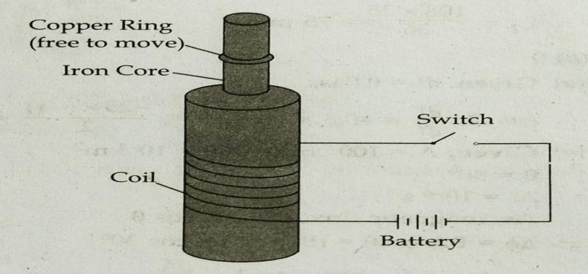
- Mention the reason of jumping of the ring when the switch is closed in the circuit.
- What will happen if the terminals of the battery are reversed and the switch is closed?
- Explain the two laws that help us understand this phenomenon.

Motional emf from Lorentz Force: The emf induced across the ends of a conductor due to its motion in a magnetic field is motional emf. It is produced due to the magnetic Lorentz force acting on the free electrons of the conductor. For a circuit shown in figure, if a conductor of length l moves with velocity v in a magnetic field B perpendicular to both its length and the direction of the magnetic field, then all the induced parameters are possible in the circuit.
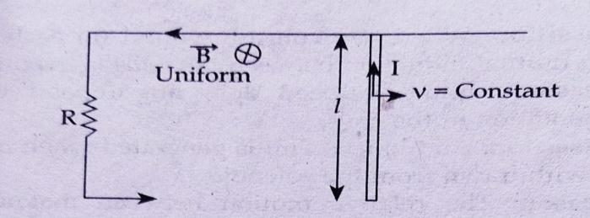

- Direction of current induced in a wire moving in a magnetic field is found using
- Fleming’s left hand rule
- Fleming’s right hand rule
- Ampere’s rule
- Right hand thumb rule
- A conducting rod of length l is moving in a transverse magnetic field strength B with velocity v. The resistance of the rod is R. The current in the rod is
- Blv/R (b) Blv (c) B²l²v²/R (d) zero
- A 0.1 m long conducting rod carrying a current of 50A is held perpendicular to a magnetic field of 1.25mT. The mechanical power required to move the conductor with a speed of 1m/s is
- 62.5mW (b) 625 mW (c) 6.25 mW (d) 12.5 mW
- A Bicycle generator creates 1.5 V at 15 km/h. The emf generated at 10 km/h is
- 1.5 V (b) 2 V (c) 0.5 V (d) 1.0 V
(a)A closed loop is held stationary in the magnetic field between the north and south poles of two permanent magnets held fixed. Can we hope to generate current in the loop by using very strong magnets?
(b)A closed loop moves normal to the constant electric field between the plates of a large capacitor. Is a current induced in the loop
(i) when it is wholly inside the region between the capacitor plates
(ii) when it is partially outside the plates of the capacitor? The electric field is normal to the plane of the loop.

(c)A rectangular loop and a circular loop are moving out of a uniform magnetic field region to a field free region with a constant velocity. In which loop do you the induced emf to be a constant during the passage out of the field region? The field to the loop.

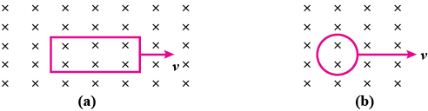
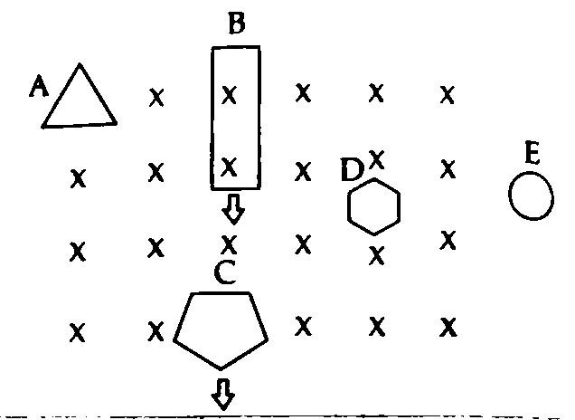
Figure shows planar loops A, B, C, D and E of different shapes moving out of or into a region of a magnetic field which is directed normal to the plane of the loop away from the reader.

(i) Name the Law/Rule preferably used to find the direction of induced emf/current in such cases?
(ii) What is the direction of induced current in loop A?
(iii) Determine the direction of induced current in loop B and C?
OR
(iii) Determine the direction of induced current in loop D and E?
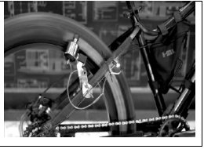
Bottle Dynamo: A bottle dynamo is a small generator to generate electricity to power the bicycle light. It is not a dynamo. Dynamo generates DC but a bottle dynamo generates AC. Newer models are now available with a rectifier. The available DC can power the light and small electronic gadgets. This is also known as a sidewall generator since it operates using a roller placed on the sidewall of bicycle tyre. When the bicycle is in motion, the dynamo roller is engaged and electricity is generated as the tyre spins the roller. When engaged, a dynamo requires the bicycle rider to exert more effort to maintain a given speed than would otherwise be necessary when the dynamo is not present or disengaged Bottle dynamos can be completely disengaged during day time when cycle light is not in use. In wet conditions, the roller on a bottle dynamo can slip against the surface of the tyre, which interrupts the electricity generated. This cause the lights to go out intermittently
i. Why is a bottle dynamo not a dynamo?
(A) It generates AC only
(B) It generates DC only
(C) It looks like a bottle
(D) It requires no fuel to operate
ii. Can you recharge the battery of your mobile phone with the help of a bottle dynamo?
- Yes (B) No (C) Yes, when a rectifier is used
(D) Yes, when a transformer is used
iii. Bottle generator generates electricity:
(A) when fuel is poured in the bottle.
(B) when the cycle is in motion.
(C) when it is mounted properly.
(D) when the wind blows.
iv. Bulb of bicycle light glows
(A) with AC supply only. (B) with DC supply only.
(C) with both AC and DC supply. (D) only when AC supply is rectified.
ANSWERS FOR MCQs
 | (d)
 | (b)
 | (b)
 | (d)
 | (d)
 | b) Zero
 | d) 75 mH
 | - 50 V
 | b)
 | C)
 | b)
 | d)
 | b)
 | a)
 | c)
ANSWERS FOR VSA ( 2 MARKS)
Direction of current- clockwise, time(t)= d/v= 1 sec,
Graph:
 | Derive emf induced e= $\frac{1}{2}$Bl²ω, induced current i= = $\frac{1}{2R}$ Bl²ω
(1) Radius = 10cm, B = 0.2T w = 2 rad/s
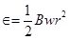
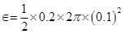
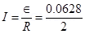
I = 0.0314 A
Mutual inductance of a pair of coils, µ = 1.5 H
Initial current, = 0 A
Final current = 20 A
Change in current,
Time taken for the change, t = 0.5 s
Induced emf, 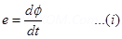
Where is the change in the flux linkages with the coil.
Emf is related with mutual inductance as:
Equating equations (1) and (2), we get
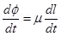
Hence, the change in the flux linkage is 30 Wb.
 | V= $µ_{0}n^{2}la\frac{dI}{dt}$ = 0.628 Mv
 | (a) emf same (area and time period same) (b) Current in copper is more as copper has less resistance.
 | 1.9 Henry
 | 50 Amp/s, 4H
ϕ = (4t³ + 5t² + 8t-3 + 5) Wb.
Rate of change of flux, dϕ/dt = 12 t2 + 10 t – 24 t-4
According to Faraday's law of electromagnetic induction,
Induced e.m.f. |ε| = |- dϕ/dt| at t = 2s
ε = | 48 + 20 – 24/16 |= | 68 – 1.5 |= 66.5 V
so, induced current = ε/R = 66.5/3.1 = 21.45 A
The magnitude of induced emf in a circuit is equal to the time rate of change of magnetic flux through the circuit.
Mathematically, ε = - dϕ/dt
(a)The acceleration of the falling magnet will be less than 'g'. As the magnet falls the magnetic flux linked with the ring increases. The current induced in the ring opposes the downward motion of magnet.
(b) When the ring is cut, the e.m.f. is induced across the ends but no induced current flows through it. Thus the motion of magnet will not opposed. The magnet falls with acceleration equal to acceleration due to gravity.
Eddy current produced in the coil thrown disc into air.
Whenever the magnetic flux linked with a metal block changes, induced currents are produced due to this current, disc becomes a magnet. Hence disc thrown up in to air.
The change in flux produces eddy current in a metal. The heat produced by eddy current is used for cooking in induction heater.

ANSWERS FOR SA ( 3 MARKS)
ε = − dϕ_{B}/dt = -d(Blx)/dt = Blv.
The Lorentz force on this charge is qvB in magnitude,
The work done in moving the charge W= qvBl
Now, e.m.f. is the work done per unit charge. Hence, we have ε =W/q =Blv.
This is the equation of motional e.m.f.
φ₁ = M₁₂ (I2) ……… (Equation 1)
where M₁₂ = Coefficient of mutual inductance of solenoid S₁ wrt solenoid S₂
Magnetic field due to the current I₂ in S₂ is B₂ = μ₀n₂ I₂
∴Magnetic flux through S₁ is ∴ φ₁ = B₂A₁ N₁ where N₁ = n1 and l = total number of turns in S1
φ1 = (μ₀n₂ I₂ ) (πr1² ) (n₁ l) → φ1 = μ₀ n₁n₂π r₁² l I₂ ……… (Equation 2)
From Equations 1 and 2, we get → M₁₂ = μ₀ n₁n₂π r₁² l ……… (Equation 3)
- Faraday’s law of electromagnetic induction states that the induced emf is proportional to the rate of change of magnetic flux.
- (a) Blv (b) F = ilB
(c) and here i = Blv / R where R is resistance of RS. F = B²l²v/R,
Power = P =F.v = B²l²v²/R
(a) Emf induced (e)= Blv= 1.5 mV
(b) west to east
(c) eastern end
(a) anti clockwise; reason: for a given length of the wire area of a circle is maximum. Thus the flux with the coil increases. The current induced in the coil will tend to decrease the flux and so will produce a field upward.
(b) anticlockwise: reason: similar as above
Let the current through the outer circular loop be I, so B (at centre)= µ₀I/2R
Flux φ(linked with inner loop)= B Πr² hence find L= φ/I
ANSWERS FOR CBQ (4 MARKS)
i)Elecromagnetic induction
ii)jumps
 | (i)- (b) (ii)-(a) (iii)- (c) (iv)-(d)
(a) no flux is not changing
(b) No current is induced in either case. Current can not be induced by changing the electric flux
(c)In rectangular coil the induced emf will remain constant because in this the case rate of change of area in the magnetic field region remains constant, while in circular coil the rate of change of area in the magnetic field region is not constant

(i) Lenz’s Law
(ii) anticlockwise
(iii) in loop B- anticlockwise & in loop C- Clockwise
OR
(iii) in loop D- no induced current since the loop is completely inside the region of magnetic field & in loop E- no induced current since the loop is completely outside the region of magnetic field.
5. | (i) A (ii) C (iii) B (iv) C

XII PHY CH-7 ALTERNATING CURRENT
Q. NO | QUESTION
MCQ s 1 MARK EACH
Why AC is preferred over DC for house hold supply?
- AC is easier to generate and in long range supply energy loss is low
- AC can be stored easily
- DC possesses lower energy loss
- DC is used for household uses
Two identical circular loops A and B of metal wires are lying on a table without touching each other. Loop A carries a current which increases with time. In response the loop B
- Remains stationary
- is repelled by loop A
- is attracted by loop A
- Rotates about its center of mass fixed.

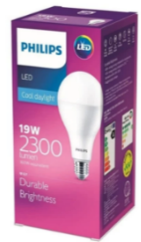
How much electric current will a new electric bulb consume on which 19w 220v is mentioned?
- 86A
- 86mA
- 0.00086A
- None of this
 | If fans and lights of train runs only on AC? Explain what is the voltage of train light and fans?
Why transformers are installed in our locality during electric supply?
- To provide more current
- To reduce current supply
- To stabilize street lights
- To step down the voltage
Why birds don't feel electric shock while sitting on high voltage wires?
- Birds have insulating legs
- Birds sit on both the wires at same time
- Birds usually stand on single live wire
- Birds have high current absorbing capacity
Why high voltage wires are kept at higher distance from ground level?
- Easier to repair
- Closed loops will be formed with foreign particles and damage will be minimum.
- To be visible from long distances
- Closed loops won’t be formed with foreign particles and damage will be minimum.
A person felt an electric shock when he touched an electrical appliance even though it was switched off. What could be the reason?
- Excess current was flowing in the circuit
- Switch is connected to live wire
- Switch was connected to the neutral wire
- Fuse had blown off
Alternating current cannot be measured by D.C. ammeter, because
(a) A. C. is virtual
(b) A. C. changes its direction
(c) A. C. cannot pass through D.C. ammeter
(d) average value of A. C for complete cycle is zero
A.C. power is transmitted from a power house at a high voltage as
(a) the rate of transmission is faster at high voltages
(b) it is more economical due to less power loss
(c) power cannot be transmitted at low voltages
(d) a precaution against theft of transmission lines
The frequency of A.C. mains in India is
(a) 30 c/s
(b) 50 c/s
(c) 60 c/s
(d) 120 c/s
A capacitor acts as an infinite resistance for
(a) DC
(b) AC
(c) DC as well as AC
(d) neither AC nor DC
A bulb connected in series with a solenoid is lit by an AC source. If a soft iron core is introduced in the solenoid then,
(a) the bulb will glow brighter
(b) the bulb will glow dimmer
(c) there will be no effect on the light produced by the bulb
(d) bulb may glow more brighter or dimmer
Assertion: If Xc > XL, Φ is positive and the circuit is predominantly capacitive. The current in the circuit leads the source voltage.

Reason: If Xc< XL, Φ is negative and the circuit is predominantly inductive, the current in the circuit lags the source voltage.

15 | Assertion: An inductor and a capacitor are called low pass filter and high pass filter respectively  Reason: Reactance of an inductor is low for low frequency signals and that of a capacitor is high for high frequency signals.
16 | Assertion: The ammeters and voltmeters used for measuring alternating current and voltage have non – uniform divisions on their scales.  Reason: The instruments used for measuring alternating current and voltage are based on heating effect of current
VSA 2 MARKS EACH
 | In a series LR circuit, X_{L} = R and the power factor of the circuit is P₁. When a capacitor with capacitance C such that X_{C} = X_{L} is put in series, the power factor becomes P₂. Find out P₁ /P₂.
 | Why is the use of AC voltage preferred over DC voltage? Give reasons.
 | A step-up transformer converts a low input voltage into a high output voltage. Does it violate law of conservation of energy? Explain.
 | A variable frequency AC source is connected to a capacitor. Will the displacement current change if the frequency of the AC source is decreased?
The circuit arrangement as shown in the diagram shows that when an a.c. passes through the coil A, the current starts flowing in the coil B .(i) State the underlying principle involved.
(ii) Mention the factors on which the current produced in the coil B depends.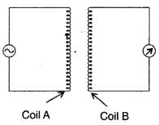
An alternating voltage given by V = 140 sin 314 t is connected across a pure resistor of 50 Ω. Find
(i) the frequency of the source.
(ii) the rms current through the resistor.
 | Magnet is moved in the direction indicated by an arrow between two coils AB and CD as shown in the figure. Suggest the direction of current in each coil.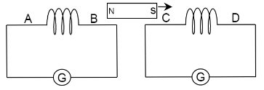
 | The peak voltage of an ac supply is 300V. What is the rms voltage?
 | The rms value of current in an ac circuit is 10A. What is the peak current?
An inductor and a resistor connected in parallel to a battery through a switch. The resistance is same as that of coil that makes . Two identical bulbs are put in each arm of the circuit.
- Which of the bulbs lights up earlier when S is closed ?
(ii) Will the two bulbs be equally bright after some time ?
A reactive element in an ac circuit causes the current flowing
i) to lead in phase by π/2
ii) lag in phase by π/2 w.r .t applied voltage. Identify the element in each case.
 | Calculate the Quality factor of a series LCR circuit with L = 2 H, C = 2 and R = 10 . Mention the significance of Q factor in the LCR circuit.
SA 3 MARKS EACH
The figure shows a series LCR circuit with L = 5.0 H, C = 80 µF, R = 40 ꭥ connected to a variable frequency 240V source. Calculate.
(i) The angular frequency of the source which drives the circuit at resonance.
(ii) The current at the resonating frequency.
(iii) The rms potential drop across the capacitor at resonance.
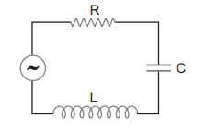

(a) Plot a graph showing variation of current with the frequency of the applied voltage.
(b) Explain briefly how the phenomenon of resonance in the circuit can be used in the tuning mechanism of a radio or a TV set.
(a)State the underlying principle of a transformer.
(b)How is the large scale transmission of electric energy over long distances done with the use of transformers?
 | Derive an expression for the impedance of an a.c. circuit consisting of an inductor and a resistor.
 | An inductor 20 mH, a capacitor 50 μF and a resistor 40 Ω are connected in series across a source of emf V=10sin340t. Thencalculate the power loss in A.C. circuit .

Fig. show three alternating circuits with equal currents. If frequency of alt. e.m.f be increased, what will be the effect on currents in the three cases? Explain.
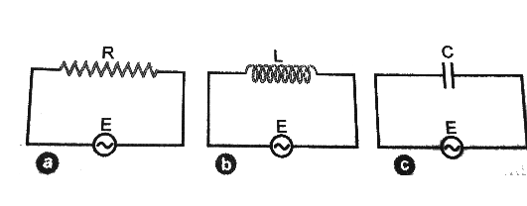

Give below are the two circuit A and B .Calculate the ratio of power factors of the circuit A to that of B
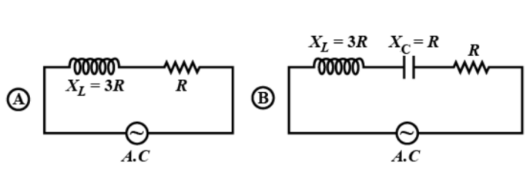
 | A variable frequency 230V alternating voltage source is connected across a series combination of L=5H, C=80μF and R=40Ω. Calculate Angular frequency of the source which drives the circuit in resonance
A horizontal straight wire 10m long is extending along east and west and is falling with a speed of 5.0m/s at right angles to the horizontal component of the earth’s magnetic field of strength 0.30×10⁻⁴wb/m².
What is the instantaneous value of the emf induced in the wire?
What is the direction of the emf?
Which end of the wire is at the higher potential?
 | Distinguish between resistance, reactance and impedance of an ac circuit
 | A sinusoidal emf is applied to a circuit containing an inductor only. Show that the current lags behind the voltage by π/2
 | Describe briefly any two energy losses, giving the reason of their occurrence in actual transformer. How are these reduced?
CASE BASED QUESTIONS 4 MARKS
Read the following text and answer the following questions on the basis of the same :
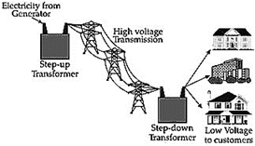
At substations, transformers lower the voltage of incoming power to make it acceptable for high- volume delivery to nearby end-users. Electricity is sent at extremely high voltage because it limits so-called line losses. Very good conductors of electricity also offer some resistance and this resistance becomes considerable over long distances causing considerable loss.
At generating station, normally voltage is stepped up to around thousands of volts. Power losses increase with the square of current. Therefore, keeping voltage high current becomes low and the loss is minimized. Another option of minimizing loss is the use of wires of super-conducting material. Super-conducting materials are capable of conducting without resistance, they must be kept extremely cold, nearly absolute zero, and this requirement makes standard super-conducting materials impractical to use. However, recent advances in super-conducting materials have decreased cooling requirement. In Germany recently 1 km super-conducting cables have been installed connecting the generating station and the destination. It has eliminated the line loss and the cable is capable of sending five times more electricity than conventional cable.
- Which of the following statement is true for long distance transmission of electricity?
- Step-down transformer is used at generating station and step-up transformer is used at destination substation
- Step-down transformers are used at generating station and destination substation
- Step-up transformers are used at generating station and destination substation
- None of the above
- Super conducting transmission line has the following advantages:
- Resistance being zero, there is no loss.
- There is no requirement of costly step-up and step-down transformers.
- Cable is capable of sending more electricity
- All of the above.
- Why does stepping up voltages reduce power loss?
- Since resistance of conductor decreases with increase of voltage
- Since current decreases with increase of voltage
- Both of the above
- None of the above
- Oil transfer heat from transformer winding by the process of
- Convection
- Conduction
- Radiation
- All of the above
A transformer is essentially an AC device. It cannot work on DC. It changes alternating voltages or currents. It does not affect the frequency of AC. It is based on the phenomenon of mutual induction. A transformer essentially consists of two coils of insulated copper wire having different number of turns and wound on the same soft iron core. (i) The number of turns in the primary and secondary coils of an ideal transformer are 2000 and 50 respectively. The primary coil is connected to a main supply of 120 V and secondary coil is connected to a bulb of resistance 0.6Ω.
(i)The voltage across the secondary coil is
(a) 5V (b) 2V (c) 3 V (d) 10 V
(ii) The value of current in the bulb is
(a) 7 A (b) 15 A (c) 3 A (d) 5 A
(iii) The value of current in primary coil is
(a) 0.125 A (b) 2.52 A (c) 1.51 A (d) 3.52 A
(iv) Power in primary coil is
(a) 20W (b) 5W (c) 10W (d) 15W

When a pure resistance R, pure inductor L and an ideal capacitor of capacitance C is connected in series to a source of alternating e.m.f., then current at any instant through the three elements has the same amplitude and is represented as I = I0sinωt. However, voltage across each element has a different phase relationship with the current . The effective resistance of RLC circuit is called impedance (Z) of the circuit and the voltage leads the current by a phase angle Φ

A resistor of 12Ω a capacitor of reactance 14Ω and a pure inductor of inductance 0.1 H are joined in series and placed across 200 V, 50 Hz AC supply.
(i)The value of inductive reactance is
(a) 15Ω (b) 31.4Ω (c) 20Ω (d) 30Ω
(ii) The value of impedance is
- 20Ω (b) 15Ω (c) 30Ω (d) 21.13Ω
( iii) What is the value of current in the circuit?
- 5 A (b) 15 A (c) 10 A (d) 9.46 A
iv) What is the value of the phase angle between current and voltage?
(a) 53°9′ (b) 63°9′ (c) 55°4′ (d) 50°
ANSWERS FOR MCQs
 | A
 | B
b) 86mA

Given P = 19w
V = 220v
We know, Power (P) = VI
So, I = $\frac{P}{V}$
I = 19/220 = 0.086A
So the New bulb will consume 86mA current.
 | - Lights and fans of trains are specially designed so that it works at 110V DC which is installed beneath every coach. It gives better illumination and is being provided in the coaches in place of TL lamps or self-generating trains. On non AC BG coaches 400 mm sweep carriage fans are used where system voltage is 110 DC.
D) To step down the voltage

When electricity is supplied from substation to locality it is always at high voltage that can damage our electric equipment if supplied directly to our home. Hence a step down transformer is used in our locality to lower the voltage to a range of 220-240V which is suitable for home use.
C) Birds usually stand on single live wire

Birds usually stand on single live wire and so electric current doesn't flow through the bird. When a bird stands on a high voltage wire, there is no potential difference between the legs of the bird as it stands in a single wire and hence no current passes through it.
d) Closed loops won’t be formed with foreign particles and damage will be minimum.

As overhead lines are normally not insulated, it's important to make them as high as possible to ensure no foreign particles (like Tree, Truck, etc.) get too close to them else it will form a closed loop which may damage both property and life.
- Excess current was flowing in the circuit
[As the live wire is directly connected to the appliance, as soon as the person touches it, the circuit gets completed through ground and hence he gets a shock.]
 | (d) average value of A. C for complete cycle is zero
 | (b) it is more economical due to less power loss
 | (b) 50 c/s
 | (a) DC
 | (b)The bulb will glow dimmer because when a soft iron core is introduced in the solenoid then, its inductive reactance (XL = ωL) will increase, as a result of which the current through the bulb decreases.
 | B Both Assertion and Reason are true but Reason is not the correct explanation of Assertion
 | C Assertion is true but Reason is false.
 | A Both Assertion and Reason are true and Reason is the correct explanation of Assertion
ANSWERS FOR VSA ( 2 MARKS)
 | 1 /$\sqrt{2}$
(i) The generation of AC is more economical than DC.
(ii) Alternating voltage can be stepped up or stepped down as per requirement during transmission from power generating station to the consumer.
(iii) Alternating current in a circuit can be controlled by using wattless devices like the choke coil.
(iv) Alternating voltages can be transmitted from one place to another, with much lower energy loss in the transmission line.
 | When output voltage increases, the output current automatically decreases to keep the power same. Thus, there is no violation of conservation of energy in a step up transformer.
On decreasing the frequency of AC source, reactance, xc=1/ωC will increase, which will lead to decrease in conduction current. In this case
ID = IC
Hence, displacement current will decrease.
(i) It is based on the principle of “mutual induction”.
(ii) Two factors are:
- distance between the coils.
- orientation of the coils.
- Number of turns in the coil.

f= 50 Hz
I_{rms} =1.98=2 A
When a magnet is moved in the given direction, the north pole of the magnet is moved away from the coil AB. Therefore, from Lenz law, the face of coil AB nearest to the North-pole will act like a south pole.

So, the current in coil AB will flow in a clockwise direction when seen from the B-side of the coil. Therefore, the direction of current in coil AB is from A to B.

When the magnet is moved, the south pole of the magnet is moved towards the coil CD. Therefore, to oppose the induced emf, the face of the coil near the South-pole will act as South-pole.

So, the current in the coil CD will flow in anti-clockwise direction when seen from the D-side of the coil. Therefore, the direction of current in coil CD is D to C.
It is given that,

Peak voltage of the ac supply, V₀=300V

It is known that,

Vrms=V₀2√

⇒Vrms=3002√

⇒Vrms=212.1V

Therefore, the rms voltage is 212.1V.

It is given that,

Rms value of current in an ac circuit, Irms=10A

It is known that,

I₀=√2 Irms

⇒I₀=1.414×10

⇒I₀=14.14A

Therefore, the peak current is 14.14A.
- Bulb lights up earlier
Reason : induced emf across opposes growth of current in
ii) yes, after some time both bulbs will be equally bright Reason : after some time current reached its maximum value in and self-induction plays no role
 | i) Capacitor ii) Inductor.
 | Q =1/R√L/C = 1 /10 √2 / 2X10⁻⁶ = 100. It signifies sharpness of resonance.
ANSWERS FOR SA ( 3 MARKS)
 | (i) 50 rad/s (ii) 6 A (iii) 1500 V
(a)
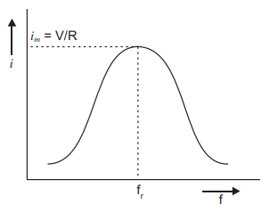
(b) A radio or a TV set has a L-C circuit with capacitor of variable capacitance C. The circuit remains connected with an aerial coil through the phenomenon of mutual inductance. Suppose a radio or TV station is transmitted a programme at frequency f, then waves produce alternating voltage of frequency f, in areal, due to which an emf of same frequency is induced in LC circuit, when capacitor C in circuit is varied then for a particular value of capacitance C, f = 1 /2π$\sqrt{LC}$ , the resonance occurs and maximum current flows in the circuit; so, the radio or TV gets tunned.

(a) Principle of mutual induction
(b) At the power generating station, the step-up transformers step up the output voltage which reduces the current through the cables and hence reduce resistive power loss. Then, at the consumer end, a step-down transformer step down the voltage. Hence, the largescale transmission of electric energy over long distances done with the use of transformers is taken place.
From the phasor diagram, we get R
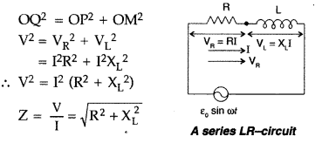
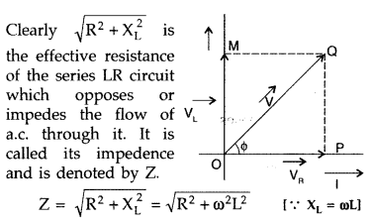

X C = 1/wc=
1/340×50×10-6 = 58.8 Ω

XL​=ωL=340×20×10−3=6.8 Ω

Z=(R2+(XC​−XL​)2 )1/2

=(4304​) )^{1/2}

Power, P=irms²R=(Vrms​​)/Z​​)²R =≈0.51 W

(i) ω0 = 1/√LC

= 1/√(50 × 10-3) (80 × 10-6)

= 1/√4000 × 10-9 = 1/√4 × 10-6= 103/2= 1000/2 = 500 rad S-1

f = ω0/2r = 500/2r = 80 hertz

(ii) Q = ω0L/R = (500 × (50 × 10-3))/40 = 0.625
 | P₁/P₂=1/$√2$
Inductance of the inductor,L=5H
Capacitance of the capacitor, C=80μF=80×10−6F
Resistance of the resistor=40Ω
Potential of the variable voltage source,V_{eff}=230V
Vpeak=230√2V
Angular frequency at resonance, ωr=1/√(LC)=1/√(5×80×10⁻⁶)
⇒ωr=50rad/s
It is given that,
Length of the wire, l=10m
Speed, ν=5.0m/s
BH=0.30×10⁻⁴wb/m²
Induced emf, E=B_{H}lν
⇒E=0.30×10⁻⁴×10×5
⇒E=1.5×10⁻³V
Therefore, the instantaneous value of the emf induced in the wire is 1.5mV.
The direction of the induced emf is from west to east.
The eastern end of the wire is at higher potential
Resistance-It is the opposition offered by a pure resistor to the flow of current .SI unit: ohm
Reactance- It is the opposition offered by a pure inductor or a pure capacitor to the flow of current .SI unit: ohm. XL=WL and Xc = 1/wc
Impedance Z: It is the effective resistance of an ac circuit containing any two or all 3 elements, L, C and R.
Z=√R²+(XL−XC)² SI Unit is Ω
E =E₀Sinwt.
As the alternating current flows through the inductor a back emf - L dI/dt is set up which opposes the applied emf. Net instantaneous emf = E – L dI/dT =0
E = L dI/d
∴E₀Sinwt = L dI/dt ,
dI= ( E₀/L) Sinwtdt ,
I = (E₀/L) )∫ Sinwtdt
= - (E0/wL) Coswt
I = - I₀Coswt
I = I₀ Sin(wt- π/2)
Energy losses in a transformer :
- Copper loss : Energy loss as heat due to resistance of primary and secondary is called copper loss and can be minimized by using thick copper wires
- Iron loss : Energy loss as heat due to eddy currents in the iron core is called Iron loss and can be reduced by using a laminated iron core
- Hysteresis loss: Magnetization of iron core is repeatedly reversed by the alternating magnetic field and energy is lost in the form of heat in the core. This is called hysteresis loss and can be minimized by using a core of a material having low hysteresis loop.
- Flux leakage : There is always some flux leakage; i,e, all of the flux due to primary does not passes through the secondary. It can be minimized by winding primary and secondary coils one over the other
ANSWERS FOR CBQ (4 MARKS)
- d) none of the above
[At power plant/ a step-up transformer increases the voltage of generated power by thousands of volts, so that it can be sent of long distance through high-voltage transmission power line. At substations, step-down transformers lower the voltage of incoming power to make it acceptable for high volume delivery to nearby end- users.]
- d) All of the above
[Super-conducting materials are capable of conducting without resistance. So, this eliminates the line loss and the cable is capable of sending more electricity than conventional cable. Using super-conducting cables, one can get rid of the need of costly transformers]
- b) since current decreases with increase with voltage
[At generating station, normally voltage is stepped up to around thousands of volts. Power losses increase with the square of current. Therefore, keeping voltage high, current becomes low and the loss is minimized]
- a) convection
[Transformers generate waste heat when they are in operation and oil is the coolant of choice. It transfers the heat through convection to the transformer housing.]
 | (i)C (ii) D (iii)A (iv) D
 | (i)B (ii) D (iii)D (iv) C

XII PHY CHP-8-ELECTROMAGNETIC WAVES
Q. NO | QUESTION
MCQ s 1 MARK EACH
Which of the following statement is false for the properties of electromagnetic waves?
- Both electric and magnetic field vectors attain the maxima and minima at the same place and same time.
- The energy in electromagnetic waves is divided equally between electric and magnetic field vectors.
- Both electric and magnetic field vectors are parallel to each other and perpendicular to the direction of propagation of wave.
- These waves do not require any material medium for propagation.
The waves used by artificial satellites for communication is
- Microwaves
- infrared waves
- radio waves
- X-rays
Light with an energy flux of 20 W/cm2 falls on a non-reflecting surface at normal incidence. If the surface has an area of 30 cm2, the total momentum delivered (for complete absorption) during 30 minutes is
- 36 × 10-5 kg m/s.
- 36 × 10-4 kg m/s.
- 108 × 104 kgm/s.
- 1.08 × 107 kg m/s.
The source of electromagnetic waves can be a charge
- moving with a constant velocity.
- moving in a circular orbit.
- at rest.
- falling in a magnetic field.
In electromagnetic spectrum, the frequencies γ-rays, X-rays and ultraviolet rays are denoted by n1, n2 and n3 respectively then
- n1 > n2 > n3
- n1 < n2 < n3
- n1 > n2 < n3
- n1 < n2 > n3
When electromagnetic waves enter the ionised layer of ionosphere, then the relative permittivity i.e. dielectric constant of the ionised layer
- does not change
- appears to increase
- appears to decrease
- sometimes appears to increase and sometimes to decrease
A person from India talking to one of his friend of America in whatsapp call feels no time lag during their conversation. Such smooth conversation is possible because
- Light travels in a straight line.
- Electromagnetic wave travels with the speed of light.
- Electromagnetic wave travels faster than light.
- Audio wave travels very fast.

Hot towels are used to relax back pain and muscles stiffness.

Which part of electromagnetic wave used here.
- UV ray
- Infrared Radiation
- Visible light
- Radiowave.
An electron gun is targets to a metal surface. Which radiation is expected to be emitted?
- UV radiation
- X-Rays
- Infrared rays
- Visible light
The most technological importance of electromagnetic waves is that they are having strong capacity to take energy from one place to another place. The best examples are radio waves, TV signals which also carry energy from their broadcasting stations. Also, life is possible on the earth only because of the sunlight coming from the sun to the earth which also carry energy and it is nothing but the electromagnetic waves.
Which of the electromagnetic waves are emitted by the sun?
- Visible light
- Infrared Wave
- UV rays
- All of the above

Figure below represents propagation of electromagnetic
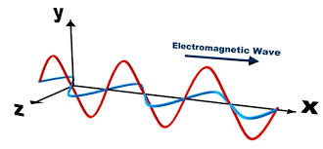
Wave along x-axis. The component of electric and magnetic field along x-axis are respectively
- Zero and Non-zero
- Zero and Zero
- Non zero and Non zero
- Non zero and zero

The electromagnetic waves used in this machine is…………………
- Microwaves
- infrared waves
- radio waves
- X-rays
Assertion: Electromagnetic waves with longer wavelengths have higher energy.
Reason: The energy of an electromagnetic wave is directly proportional to its wavelength.

a) Assertion and Reason both are correct and R is the correct explanation of A.
b) Assertion and Reason both are correct but R is not the correct explanation of A.
c) Assertion is true but Reason is false.
d) Assertion and Reason both are incorrect.
Assertion: Electromagnetic waves do not require a medium for propagation.
Reason: Electromagnetic waves consist of oscillating electric and magnetic fields.

a) Assertion and Reason both are correct and R is the correct explanation of A.
b) Assertion and Reason both are correct but R is not the correct explanation of A.
c) Assertion is true but Reason is false.
d) Assertion and Reason both are incorrect.
VSA 2 MARKS EACH
Optical fibre communication involves the transmission of data using light in the form of electromagnetic waves. Her is how it works
- Light Source: An optical transmitter, typically a laser diode or light-emitting diode (LED), generates light signals.
- Modulation: The light signal is modulated to encode data. On-off keying (OOK) and phase modulation are common techniques.
- Transmission: The modulated light is sent into an optical fibre, which consists of a core surrounded by a cladding layer. Total internal reflection within the core keeps the light within the fibre.
- Reception: At the receiving end, a photo detector converts the received light signals back into electrical signals.
Is the modulation compulsory? What is the reason?

Microwave ovens use electromagnetic waves in the microwave frequency range, typically around 2.45 gigahertz (GHz). The oven contains a magnetron, a device that generates these microwaves. When you set the cooking time and power level, the magnetron emits microwaves into the cooking chamber.
Microwaves are absorbed by water molecules within the food. The absorbed energy causes the water molecules to vibrate, generating heat throughout the food. This even heating is a characteristic feature of microwave cooking.
Which wave are more energetic, Micro waves or infrared rays?
From the data given find the wavelength of a typical microwave.
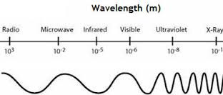
From the given data draw a bar graph to show the order of different electromagnetic waves.
SA 3 MARKS EACH
Answer the following questions.
Assume that the earth doesn't have an atmosphere. Will it affect the average surface temperature of the earth?
For the survival of human beings, the presence of the ozone layer on the top of the stratosphere is very significant. Substantiate this statement.
It is said that X-ray astronomy is possible only from satellites orbiting the earth. Why?
Answer the following
- Name the EM waves which are suitable for radar systems used in aircraft navigation. Write the range of frequency of these waves.
- If the earth did not have an atmosphere, would its average surface temperature be higher or lower than what it is now? Explain.
- An EM wave exerts pressure on the surface on which it is incident. Justify.

Name the following parts of the electromagnetic spectrums.
- used in radar systems for aircraft navigation
- used to treat muscular strain
- used in hospitals for diagnosing diseases
Also, briefly describe how these waves can be produced.

The radio station generates electromagnetic waves through an electronic circuit. The station's transmitter modulates an electrical signal, such as an audio signal, onto a carrier wave. This modulation process varies the amplitude, frequency, or phase of the carrier wave in accordance with the audio signal. Once modulated, the transmitter amplifies the signal and sends it to an antenna. The antenna is crucial for emitting the modulated electromagnetic waves into space.
What do you mean by amplification? How is it different from modulation? What is the meaning of FM wave?
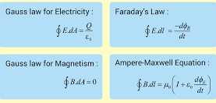
What are these equations collectively called?
Which term represents displacement current?
Who introduced the term displacement current?

 | A tech company is developing a wireless charging solution for smartphones and electric vehicles. Describe the principles of electromagnetic induction and resonance that underlie wireless charging technology.
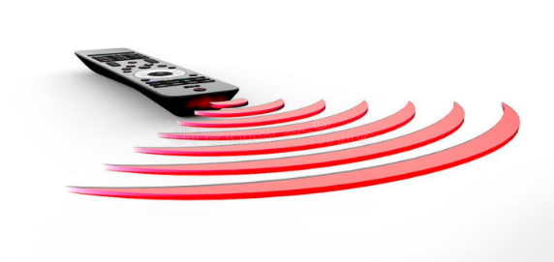
- Name the electromagnetic wave used by the TV remote. Give another two instances where the same wave is used.
- What is the speed of such wave in vacuum?
- Give the wave length range of the wave.
CASE BASED QUESTIONS 4 MARKS
GAMMA RAYS IN TREATMENT OF CANCER
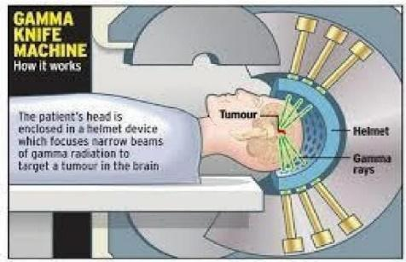
Gamma rays are used in radiotherapy to treat cancer. They are used to spot tumors. They kill the living cells and damage malignant tumor.

- What is the source of gamma rays?
  - radioactive decay of nucleus
  - accelerated motion of charges in conducting wire
  - hot bodies and molecule
  - klystron valve

2. Which E M Waves are used to study nuclear structure?
- X-ray
- Gamma Ray
- UV Ray
- Microwave
3. Which EM Wave is used in the treatment of tumor?
- X rays
- X rays and Gamma rays
- UV rays
- IR rays
4. Which E M Waves are used to study Molecular structure?
- X rays
- UV rays
- Gamma rays
- Microwave
OR
5. Which EM Waves has Highest penetrating Power?
- X ray
- Gamma ray
- UV ray
- Visible light
All the known radiations from a big family of electromagnetic waves which stretch over a huge range of wavelengths. The orderly distribution of electromagnetic waves in accordance with their wavelength or frequency into distinct groups having widely differing properties is called electromagnetic spectrum. The main parts of the electromagnetic spectrum are Gamma rays , X- rays ,ultraviolet rays , visible light , infrared waves , microwaves and radio waves in the order of increasing wavelength from 10⁻²Å or 10⁻¹²𝑚 to 10⁶𝑚 .The wavelength of the e.m. wave is correlated with the characteristic size of the system that radiates. Thus, Gamma rays having a wavelength of 10⁻¹⁴𝑚 to 10⁻¹⁵𝑚 , typically originate from an atomic nucleus. X-rays are emitted from heavy atoms. Radio waves are produced by accelerating electrons in a circuit. A transmitting antenna can most efficiently radiate waves having λ of about the same size as the antenna. Visible radiation emitted by atom is, however much longer in wavelength than atomic size.
Q1.The correct option, if speeds of Gamma rays , X rays and microwaves are𝑣_{g} , 𝑣_{𝑥} 𝑎𝑛𝑑 𝑣_{𝑚}respectively will be
a) 𝑣_{g} > 𝑣_{𝑥} > 𝑣_{𝑚}
b) 𝑣_{g} < 𝑣_{𝑥} < 𝑣_{𝑚}
c) 𝑣_{g} > 𝑣_{𝑚} > 𝑣_{𝑥}
d) 𝑣_{g} = 𝑣_{𝑥} = 𝑣_{𝑚}
Q2. In the order of increasing frequency, the electromagnetic spectrum may be arranged as
- Gamma rays ,X rays, visible light ,radio waves
- X rays, Gamma rays ,visible light, radio waves
- Radio waves ,visible light, X rays, gamma rays
- Radio waves, visible light ,Gamma rays, X-rays Q3. Microwave oven acts on the principle of
- Giving rotational energy to water molecules
- Giving vibrational energy to water molecules
- Giving translational energy to water molecules
- Transferring electrons from lower to higher energy levels in water molecule

Q4. The condition under which a microwave oven heats up a food item containing water molecules most efficiently is
- The frequency of the microwaves must match the resonant frequency of the water molecules
- The frequency of the microwaves has no relation with natural frequency of water molecules
- Microwaves are heat webs so always produce heating
- Infrared waves produce heating in a microwave oven
OR
Q5. The structure of solids is investigated by using
- Cosmic rays
- X-rays
- Gamma rays
- Infrared radiation
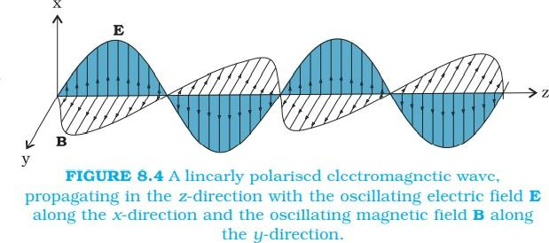
A typical example of a plane electromagnetic wave propagating along the z direction (the fields are shown as a function of the z coordinate, at a given time t). The electric field Ex is along the x-axis,
and varies sinusoidally with z, at a given time. The magnetic field By is along the y-axis, and againvaries sinusoidally with z. The electric and magnetic fields Ex and By are perpendicular to each other, and to the direction z of propagation. We can write Ex and By as follows:
Ex= E₀ sin (kz–ωt)
By= B₀ sin (kz–ωt)
i)The electric field 'E' and magnetic field 'B' in electromagnetic waves are:
- parallel to each other
- inclined at an angle of 45°
- perpendicular to each other
- opposite to each other
- The energy of photon of electromagnetic radiation of wavelength = 2000 Armstrong is : (A) 1.76 x 10⁻¹⁸ J
(B) 0.99 x 10⁻¹⁸ J
(C) 0.54 x 10⁻¹⁸ J
(D) 0.63 x 10⁻¹⁸ J
- The speed of light in air, if an electromagnetic wave is travelling in air whose dielectric constant is k = 1.006, will be :
(A) 3 x 10⁸ m/s
(B) 3.88 x 10⁸ m/s
(C) 2.5 x 10⁸ m/s
(D) 4.6 xl0⁸ m/s
iv)An object is placed at some distance from a radio station. If the interval between transmission and reception of pulses is 2.66 x 10⁻² sec, then the distance is :
- 4000 km
- 2000 km
- 3000 km
- 2500 km
ANSWERS FOR MCQs
 | (c)Both electric and magnetic field vectors are parallel to each other and perpendicular to the direction of propagation of wave.
 | (a) microwaves
 | (b)
 | (b)
 | (a) From electromagnetic spectrum, frequencies of γ-rays is greater than frequency of X-rays. Frequency of Xrays is greater than frequency of ultraviolet rays.
 | (c)
 | (b) Electromagnetic wave travels with the speed of light.
 | (b) Infrared Radiation
 | (b) X-Rays
 | (d) All of the above
 | (b) Zero and Zero
 | C) radio waves
 | (d) Assertion and Reason both are incorrect.
 | (a) Assertion and Reason both are correct and R is the correct explanation of A.
ANSWERS FOR VSA ( 2 MARKS)
- Yes
- To get use of carrier wave.
- Encoding of data
 | IR,Correct answer
 | Use the relation V = nλ
ANSWERS FOR SA ( 3 MARKS)
The phenomenon of the greenhouse effect is only possible due to the presence of the atmosphere. If the atmosphere is not there, the greenhouse effect will not be there. Because of this, there would be a decrease in the temperature of the earth.
It is the ozone layer that prevents the entry of harmful ultraviolet rays from the sun. It protects the life forms on earth from the detrimental effects of UV rays.
It is because when X-rays pass through the atmosphere, it will absorb the X-rays.

- The waves which are used in radar systems are microwaves. Its frequency ranges between 10¹⁰ and 10¹² Hz
- If there is no atmosphere, there would be no ozone layer to prevent ultraviolet radiations reaching the earth. The temperature on earth’s surface would have been lower because there would be no greenhouse effect, and it would make human survival difficult.
- Since an electromagnetic wave carries both energy and momentum, it exerts pressure on the surface on which it is incident. But the pressure will be negligibly small. It is because of the extremely small momentum of the photon which can be calculated by the de-Broglie relation,(λ=h / p)(p=ℎ/$λ$)or
p=h/λ=6.63×10−34/10−9=6.63×10−25 kg ms

- Microwaves are used in radar systems that are used in aircraft navigation. These rays can be produced by making use of special vacuum tubes, such as Klystrons, magnetrons and Gunn diodes etc.
- Infrared waves are used in the treatment of muscular strain. These rays can be produced by hot bodies and molecules.
- X rays are used as a very significant diagnostic tool in medicine. These rays are produced when high energy electrons hit any metal of a greater atomic number.

- Increasing amplitude
- Modulation means modification of character.
- Maxwell’s equations
- Correct term
- Maxwell
 | Correct explanation.
- Infra red. Head light of vehicles in foggy area they also used to Reduce stiffness of muscles
- 3X10⁸ m/s
- 10⁻⁴ to 10⁻⁵ m
ANSWERS FOR CBQ (4 MARKS)
- D
- B
- B
- C
- A
- A
- C
- B
- D
- B
- C
- B
- B
- D

XII PHY CH_9_RAY OPTICS AND OPTICAL INSTRUMENTS
Q. NO | QUESTION
MCQ s 1 MARK EACH
Absolute refractive indices of glass and water are 6/4 and 4/3. The ratio of velocity of light of glass and water will be
(i) 4:3 (ii) 8:7 (iii) 8:9 (iv) 3:4
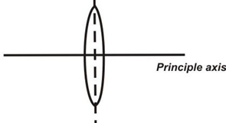
An equiconvex lens of focal length 15 cm is cut into two halves as shown in figure. Find the focal length of each part?
(a) -30cm (b)-20c m
(c) 30cm (d) -15cm
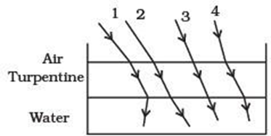
The optical density of turpentine is higher than that of water while its mass density is lower shows a layer of turpentine floating over water in a container. For which one of the four rays incident on turpentine in the path shown is correct?
(a) 1 (b) 2
(c) 3 (d) 4
The diameter of the telescope is doubled, the magnifying power becomes
a. twice
b. halved
c. remains constant
d. zero
To a fish under water, viewing obliquely a fisherman standing on the bank of a lake, the man looks
a. taller than what he actually is
b. shorter than what he actually is
c. the same height as he actually is
d. depends on the obliquity
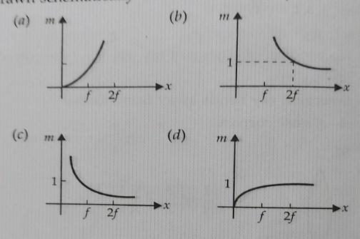
An object is gradually moving away from the focal point of a concave mirror along the axis of the mirror. The graphical representation of the magnitude of linear magnification (m) verses distance of the object from the mirror is correctly given by

Which of the following is used in optical fibres?
(a ) Total internal Reflection (b) Scattering (c) Diffraction (d) Refraction
A convex lens of focal length 20cm produces image of the same magnification 2 when object placed at two distances x₁ and x₂ (x₁>x₂) from the lens. The ratio of x₁ and x₂ is
3:1 (b) 2:1 (c)4:3 (d) 5:3
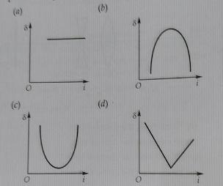
The graph between the angle of deviation (δ) and angle of prism (i) represented by

Two lenses of power -15D and +5D are placed in contact with each other. The focal length of the combination is
(a ) +10cm (b) -20cm (c )-10cm (d) +20cm.
An equiconvex lens is cut into two halves along (i) XOX’ and (ii) YOY’ as shown in figure. Let f, f’ , f” be the focal length of complete lens, of each half in case (i) and of each half in case (ii) respectively. Choose the correct statement from the following.

A) F’=2f and f”=f ( b) f’=f and f”=f (c) f’=2f and f”=2f (d) f’=f and f”=2f.
 | A thin prism of angle A = 6° produces a deviation d = 3°. The refractive index of the material of prism is a)1 (b) 2 (c) 1.5 (d) 3
Assertion: A convex lens maybe diverging
Reason: The nature of lens depends upon refractive index of the lens and surrounding medium.
a) Both A and R are true, and R is the correct explanation for A.
b) Both A and R are true, and R is not the correct explanation for A.
c)A is true but R is false.
d)A is false and R is false
Assertion: If a convex lens is kept in water, its convergence power decreases.
Reason: The refractive Index of convex lens relative to water is less than that relative to air.
a) Both A and R are true, and R is the correct explanation for A.
b) Both A and R are true, and R is not the correct explanation for A.
c)A is true but R is false.
d)A is False but R is true.
Assertion: Propagation of light through an optical fiber is due to total internal reflection taking place at the core-clade interface.
Reason: Refractive index of the material of the core of the optical fiber is greater than that of cladding.
Two thin lenses of focal lengths 20 cm and 25 cm are placed in contact. The effective power of the combination is:
(A) 45 D
(B) 9 D
(C) 19 D
(D) 6 D

17 | The air bubble inside water shine due to  (A) Reflection  (B) Refraction  (C) Total internal reflection  (D) None of these
18 | 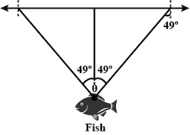  A fish is little away below the surface of a table if the critical angle is 49°,the fish could see some things above the water surface within an angle of Ꝋ°,where  (a) Ꝋ= 49°  (b) Ꝋ= 98°  (c) Ꝋ= 90°  (d) Ꝋ= 24.5°
VSA 2 MARKS EACH
Which two of the following lenses L1, L2,and L3 will you select as objective and eyepiece for constructing best possible (i) telescope(ii) microscope? Give reason to support your answer.
Lens Power (P) Aperture (A)
L1 6 D 1 cm
L2 3 D 8 cm
L3 10 D 1 cm
 | Draw a ray diagram to show the image formation by a combination of two thin convex lenses in contact. Obtain the expression for the power of this combination.
 | An optical instrument uses eye-lens of power 20 D and objective lens of power 50 D and has a tube length of 15 cm. Name the optical instrument and calculate its magnifying power if it forms the final image at infinity.
 | For the same value of angle of incidence, the angles of refraction in three media A, B and C are 15°, 25° and 35° respectively. In which medium would the velocity of light be minimum?
 | An object of size 3.0 cm is placed 14 cm in front of a concave lens of focal length 21 cm. Describe the image produced by the lens. What happens if the object is moved further away from the lens?
 | A biconvex lens made of a transparent material of refractive index 1.25 is immersed in water of refractive index 1.33. Will the lens behave as a converging or a diverging lens? Give reason.
 | Write the essential conditions for total internal reflections to occur.
 | Draw a schematic diagram of a single optical fibre structure. On what principle does such a device work? Explain the mechanism of propagation of light signal through an optical fibre.
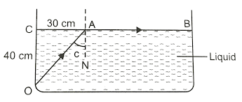
(i) Define refractive index of a medium.
(ii) In the given ray diagram , calculate the speed of light in the liquid of unknown refractive index

You are given following three lenses , which two lenses will you use as an objective to construct an astronomical telescope and why?
LENSES | POWER (P) | Aperture
L1 | 3D | 8cm
L2 | 6D | 1cm
L3 | 10D | 1cm

 | Suppose the lower half of the concave mirror’s reflecting surface is covered with an opaque material. What effect will this have on the thickness of the object
 | A convex lens of focal length 20cm is placed co axially in contact with a concave lens of focal length 25cm. Determine the power of combination, will the system be converging or diverging in nature.
SA 3 MARKS EACH
An optical instrument uses a lens of power 100 D for objective lens and 50 D for its eyepiece. When the tube length is kept at 25 cm, the final image is formed at infinity.
(a) Identify the optical instrument.
(b) Calculate the magnification produced by the instrument
 | Draw a graph showing the variation of linear magnification with image distance for a thin convex lens. How can this graph be used for finding the focal length of the lens?
Three rays of light red (R), green (G) and blue (B) fall normally on one of the sides of an isosceles right angled prism as shown. The refractive index of prism for these rays is 1.39,1.44 and 1.47 respectively. Find which of these rays get internally reflected and which get only refracted from AC. Trace the paths of rays. Justify your answer with the help of necessary calculations.
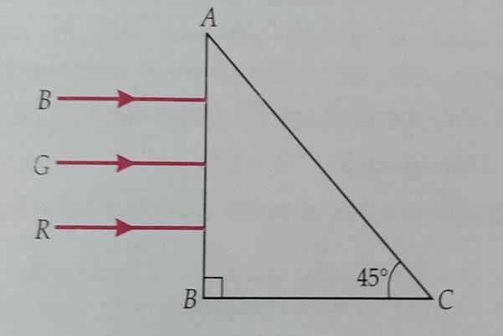
 | (a) A small telescope has an objective lens of focal length 140 cm and an eyepiece of focal length 5.0 cm. Find the magnifying power of the telescope for viewing distant objects when(i) the telescope is in normal adjustment,(ii) the final image is formed at the least distance of distinct vision.(b) Also find the separation between the objective lens and the eyepiece in normal adjustment.
 | With the help of ray diagram derive the expression of lens makers formula for a biconvex lens.
 | A ray of monochromatic light passes through an equilateral glass prism in a way that angle of incidence is equal to the angle of emergence and each of these angles is3/4 times the angle of prism. Determine angle of deviation and refractive index of the glass prism.
 | The radii of curvature of the faces of a double convex lens are 10 cm and 15 cm. If focal length of the lens is 12 cm, find the refractive index of the material of the lens.
 | Drive the expression for the angle of deviation for a ray of light passing through an equilateral prism of refracting angle A?
(i) Out of blue and red light which is deviated more by a prism? Give reason.
(ii) Give the formula that can be used to determine refractive index of materials of a prism in minimum deviation condition
 | Draw a labelled ray diagram of an astronomical telescope in the near point position. Write the expression
An equiconvex lens of refractive index ‘µ1’ , focal length ‘f’ and radius of curvature ‘R’ is immersed in a liquid of refractive index ‘µ2’
(i) µ2 > µ1 (ii) ) µ2 < µ1
Draw the ray diagram in the two cases when a beam of light coming parallel to principal axis is incident on the lens. Also find the focal length of the lens in terms of the original focal length of the refractive index of the glass of the lens and that of the medium.
 | A convex lens of focal length 20cm is placed co axially in contact with a concave lens of focal length 25cm. Determine the power of combination , will the system be converging or diverging in nature
 | A mobile phone lies along the principal axis of a concave mirror . Show with the help of a suitable diagram the formation of its image . Explain why magnification is not uniform.
CASE BASED QUESTIONS 4 MARKS
Sparking brilliance of diamond
The total internal reflection of light is used in polishing diamonds to create a sparking brilliance. By polishing the diamond with specific cuts, it is adjusted so that most of the light rays approaching the surface are incident with an angle of incidence more than critical angle. Hence, they suffer multiple reflections and ultimately come out of diamond from the top. This gives the diamond a sparkling brilliance.
- Light cannot easily escape a diamond without multiple internal reflections. This is because:
(a) Its critical angle with reference to air is too large
(b) Its critical angle with reference to air is too small
(c) The diamond is transparent
(d) Rays always enter at angle greater than critical angle
(ii) The critical angle for diamond is 24.4⁰. Its refractive index is
(a) 2.42
(b) 0.413
(c) 1
(d) 1.413
(iii) The basic reason for the extraordinary sparkle of suitably cut diamond is that
(a) It has low refractive index
(b) It has high transparency
(c) It has high refractive index
(d) It is very hard
(iv) A diamond is immersed in a liquid with a refractive index greater than water. Then the critical angle for total internal reflection will
(a) Will depend on the nature of the liquid
(b) decrease
(c)remains the same
(d) increase
(v) The following diagram shows the same diamond cut in two different shapes. The brilliance of diamond in the second diamond will be:
(a) less than the first
(b)greater than the first
(c) same as first
(d) will depend on the intensity of light

Telescope:An instrument used to view distant objects clearly. It consists of:- (a) Objective lens (b) Eyepiece
The telescope is used to provide angular magnification of distant objects. The objective has a large focal length and a much larger aperture than the eyepiece because object is very far away.
Light from a distant object enters the objective and a real and inverted image is formed at its second focal point.
This image acts as an object for the eyepiece; it magnifies this image producing a final inverted image.
Magnification
The magnifying power m is the ratio of the angle β subtended at the eye by the final image to the angle α which the object subtends at the lens or the eye.
Therefore, m≈ (β / α) ≈ (h/f_{e}) x (f_{o}/h) = (f_{o}/fe).
In this case, the length of the telescope tube is (f_{o} + f_{e}).
In addition, a pair of inverting lenses to make the final image erect.
Refracting telescopes can be used both for terrestrial and astronomical observations.
- A small telescope has an objective lens of focal length 144cm and an eyepiece of focal length 6 cm.What is the magnifying power of the telescope?

A)240 B)24 C)2.4 D)0.042
- What is the separation between the objective and eye piece

  - 144cm B)6cm C)150cm D)138cm iii)What is the nature of the final image formed in an astronomical telescope
- virtual,magnified and erect w.r.t the object
- virtual,magnified and inverted w.r.t the object
- Real,magnified and inverted w.r.t the object
- virtual,diminishedand inverted w.r.t the object
- Three lenses of focal length 5cm ,50cm and 60cm are to be used for making a telescope ,which lens will you use for objective
  - 5cm B)50cm c)either one of these D)60cm v)What do you mean by normal adjustment of telescope?
- when image is formed at least distance of distinct vision
- when image is formed at a distance less than least distance of distinct vision C)) when image is formed a infinite.
D)Both B and C
- Nowadays optical fibres are extensively used for transmitting audio and video signals through long distances. Optical fibres too make use of the phenomenon of total internal reflection. Optical fibres are fabricated with high quality composite glass/quartz fibres. Each fibre consists of a core ( Inner) and cladding (outer).
When a signal in the form of light is directed at one end of the fibre at a suitable
angle, it undergoes repeated total internal reflections along the length of the fibre and finally comes out at the other end

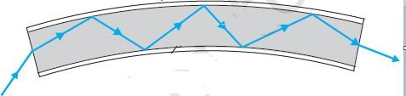.
Since light undergoes total internal reflection at each stage, there is no appreciable loss in the intensity of the light signal. Optical fibres are fabricated such that light reflected at one side of inner surface strikes the other at an angle larger than the critical angle. Even if the fibre is bent, light can easily travel along its length. Thus, an optical fibre can be used to act as an optical pipe.
- Light cannot escape an optical fibre due to refraction. This is because:
- Critical angle for core with reference to cladding is too large
- Its critical angle for core with reference to cladding is too small
- The core is transparent
- Rays always enter at angle greater than critical angle.

- For total internal reflection to take place
- the ray must go from rarer to denser medium.
- angle of incidence should be less than critical angle.
- the ray must go from denser to rarer medium.
- angle of incidence should be zero.

- In optical fibre
- refractive index of core is kept less than that of cladding
- refractive index of core is kept more than that of cladding
- refractive index of core is equal to that of cladding
- refractive index of core is 1

- If critical angle for core with reference to cladding is 60°. The refractive index of core with respect to cladding will be.
- 23
- 32
- 2
- 12

- If angle of incidence is greater than critical angle than
- very small amount of light refract to cladding.
- small amount of light gets reflected in core.
- total light is refracted into cladding
- total light gets reflected in core.
Power (P) of a lens is given by reciprocal of the focal length (f) of the lens i.e., P= 1/f, where f is in meter and power is in diopter. Power a convex lens, power is positive and for a concave lens, power is negative. When a number of thin lenses of power P₁, P₂,P₃,……. are held in contact with each other, the power of the combination is given by the algebraic sum of the power of all the lenses (P = P₁+ P₂+P₃+…….).
Two convex lenses are separated by distance d and kept co-axially and then kept in contact co-axially with each other. The focal length of the combination
remains the same b) different c) decreases d) none
If two lens of power +1.5D and +1.0D are place in contact, then the effective power of combination will be 2.5 D b) 1.5 D c) 0.5 d) 3.25 D
If the power of a lens is + 5D diopter, what is the focal length of the lens? 10 cm b) 20 cm c) 15 cm d) 5 cm
Two thin lenses of focal +10 cm and -5 cm are kept in contact. The power of the combination is
-10D b) -20D c) 10 D d) 15 D
A convex lens of focal length 25 cm is place co-axially in contact with a concave lens of focal length 20 cm. The system will be
Converging in nature b) diverging in nature c) a or b d) none

ANSWERS FOR MCQs
 | C
 | C
 | b
 | c. remains constant
 | a. taller than what he actually is
 | (b)
 | (a)
 | (a)
 | ( c)
 | ( c)
 | (d)
 | ( c)
The Correct option is a
The nature of a lens depends upon the refractive index of the lens and that of the surrounding medium.
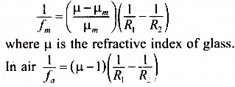
The correct option is a
The focal length of a lens in a medium of refractive index µ_{m} is given by

From these two expressions it is clear that fm > fa, that is the focal length of the convex lens in water increases thereby reducing its convergent power.
The Correct option is A
Propagation of light through an optical fiber is due to total internal reflection taking place at the core-clade interface. Reason: Refractive index of the material of the core of the optical fiber is greater than that of cladding.
 | B
 | C
 | b
ANSWERS FOR VSA ( 2 MARKS)
 | An astronomical telescope should have an objective of larger aperture and longer focal length while an eyepiece of small aperture and small focal length. Therefore, we will use L2 as an objective and L3 as an eyepiece. For constructing microscope, L3 should be used as objective and L1 as eyepiece because both the lenses of microscope should have short focal lengths and the focal length of objective should be smaller than the eyepiece.
 | Correct diagram and correct derivation.
The optical instrument is the Compound Microscope.
Given, P_{e} = 16D, L= 16.25 cm, P_{o}= 50D
We know f=$\frac{1}{p}$
F_{e}=$\frac{100}{16}$cm, f₀=$\frac{100}{50}$= 2cm
Hence D =25 cm
The magnifying power of a compound microscope is
M=$\frac{1}{f_{o}}×\frac{D}{f_{e}}=\frac{16.25}{2.0}×\frac{25}{6.67}=30.45$

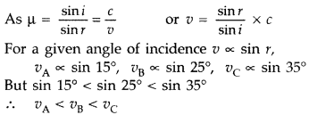
Hence, velocity of light is minimum in medium A
Size of the object, h₁ = 3 cm
Object distance, u = −14 cm
Focal length of the concave lens, f = −21 cm
Image distance = v
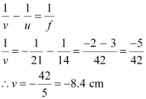
According to the lens formula, we have the relation:

Hence, the image is formed on the other side of the lens, 8.4 cm away from it. The negative sign shows that the image is erect and virtual.
The magnification of the image is given as:

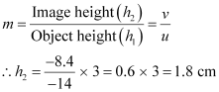
Hence, the height of the image is 1.8 cm.
If the object is moved further away from the lens, then the virtual image will move toward the focus of the lens, but not beyond it. The size of the image will decrease with the increase in the object distance.

 | Concave lens
(i) Light must travel from denser medium to rarer medium.
(ii) Angle of incidence must be greater than critical angle

Schematic diagram
A single optical fibre works on the principle of total internal reflection. An optical fibre consists of a core with higher refractive index and a cladding with a lower refractive index. When light enters the fibre at a suitable angle, it undergoes successive total internal reflections along the length of the fibre. This is how a light signal travels through the optical fibre.

(i) The refractive index of a medium is defined as the ratio of the speed of light in vacuum or air to speed of the light in the given medium.
µ = C/V

(ii)
As shown, OA shows TIR at A and going along AB
∴ ∠OAN =c, the critical angle
µ = 1/sin c = OA/CA

√302+402 = 50/30 = 5/3 µ
30

As, µ = C/V
5/3 = 3x10⁸
^{V}
V = 9 x10⁸ = 1.8x10⁸m/s
5

In an astronomical telescope, the eyepiece has greater power while a smaller aperture and the objective has lower power with a longer aperture. So we use
L3 as eyepiece and L1 as objective
 | If the lower half of the concave mirror is covered with an opaque material , the size of the image will not vary but, since the reflecting surface has been reduced the intensity of the image will be less. i.e, brightness of the image will decrease
ANSWERS FOR SA ( 3 MARKS)
(i) f_{e} = $\frac{1}{Pe}$= $\frac{1}{100}$ m = 1 cm
f_{o} = $\frac{1}{Po}$= $\frac{1}{50}$ m = 2 cm
As both the objective and the eyepiece are convex lenses of short focal lengths, so the given optical instrument is a compound microscope.
(ii) L = 25 cm, D = 25 cm, fe = 1 cm, f_{o} = 2 cm
When the final image is formed at infinity, the magnification produced is
m = $\frac{L}{ fe}$ $×$ $\frac{D}{fo}$ = $\frac{25}{1}$ $×$ $\frac{25}{2}$ = 312.5
m= $\frac{h2}{h1}$ = $\frac{v}{u}$

m
v

Critical angle for (i) Red light is sin c₁= 1/1 39 = = 0. 7194 or c1 = 46°
(ii) Green light is sin c2 =1/1 44 = = 0. 6944 or c2 = 44°
(iii) Blue light is sin c3 = 1/1 4. 7= 0.6802 or c3 = 43°
As angle of incidence i = 45° of red light ray on face AC is less that its critical angle of 46°, so red light ray will emerge out of face AC. A
(a) (i) Given f0 = 140 cm, fe = 5 cm, When final image is at infinity, magnifying power, m=fo/fe = –28
Negative sign shows that the image is inverted.
(ii) When final image is at the least distance of distinct vision, magnifying power, m= –33.6
(b) Separation between objective and eye piece when final image is formed at infinity, L = f0 + fe or, L = 140 cm + 5.0 cm o r, L = 145 cm
 | Correct diagram and correct
Given,$<A=60°, <e=<r,<e=<r=\frac{3}{4}×60°=45°$
We know that δ + A = I + e
δ = I + e – A
∴ δ = 45° + 45° – 60° = 30°
angle of deviation = 30°

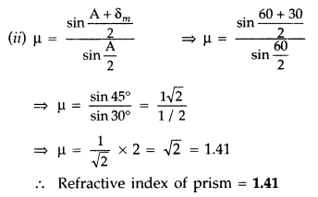
Hence, Refractive index of prism =1.41
Given: R₁ = 10 cm,
R₂ = -15 cm,
f = 12 cm
Using lens maker’s formula, we have
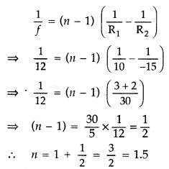
Refractive index of the material of the lens is 1.5
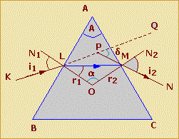
In the above figure, ABC represents the principal section of a glass-prism having ∠A as its refracting angle.
A ray KL is an incident on the face AB at the point F where N1LO is the normal and ∠i1 is the angle of incidence. Since the refraction takes place from air to glass, therefore, the refracted ray LM bends toward the normal such that ∠r1 is the angle of refraction. If µ be the refractive index of glass with respect to air, then
By Snell's law,
$$μ=\frac{sinsin i}{sinsin r }$$
∠QPN gives the angle of deviation ‘δ
Thus, δ=i₁–r₂+i₂−r₂….... (1)
δ=i₁+i₂–(r₁+r₂)
Again, in quadrilateral ALOM,
∠ALO + ∠AMO = 2 right angles [Since, ∠ALO = ∠AMO = 90º]
So, ∠LAM +∠LOM = 2 right angles [Since, Sum of four angles of a quadrilateral = 4 right angles] ….... (2)
Also, in △ LOM,
∠r1+∠r2+ ∠LOM = 2 right angles …... (3)
Comparing (2) and (3), we get
∠LAM =∠r1+∠r2
A = ∠r1+∠r2
Using this value of ∠A, equation (1) becomes,
δ=i₁+i₂−A

 | (i).Out of blue and red light which is deviated more by a prism? Give reason. (ii). Prism formula
 | Ray diagram
1st case
$\frac{1}{f}$ = (µ-1) [$\frac{1}{R1}-\frac{1}{R2}$] --------(i)
When lens is immersed in a liquid of refractive index µ2 then,
$\frac{1}{f'}$ = ($\frac{µ1}{µ2}-1$) [$\frac{1}{R1}-\frac{1}{R2}$] ---------(ii)

Dividing equation (i) by (ii)

$\frac{f^{'}}{f}$ = (µ₁-1) /$\frac{µ1-µ2}{µ2}$ = $\frac{µ2(µ1-1)}{(µ1-µ2)}$

f’ = f ($\frac{µ2(µ1-1)}{µ1-µ2}$)

(i) for µ2 > µ1, lens will as a diverging lens
(ii) for µ2 < µ1, lens will as a converging lens

We have,
Focal length of concave lens, f1= +20cm =+0.20m
Focal length of concave lens f2= −25cm =−0.25m
Power of convex lens, P1=1 f1=1/0.20
Power of concave lens, P2=1 f2=1/−0.25
Power of the combination lens,
P=P1+P2
=1/0.20+1/−0.25
=100/20+100/−25
=500/100−400/100
=100/100=1D
As the power is positive, the system will be converging in nature.

The formation of image of the mobile phone by the concave mirror is as shown in above figure.
Magnification is not a uniform because:
(i) The part of mobile at the center of the curvature will form image of the same size.
(ii) The part that lies between F and C will form an enlarged image beyond C .
(iii) The image of the mobile phone is highly magnified.
Thus the different parts of the mobile phone are magnified in different proportions because of their different locations from the concave mirror. That is why the image is distorted.
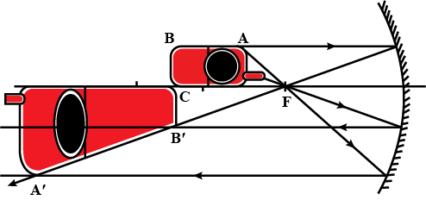
ANSWERS FOR CBQ (4 MARKS)
 | (i) b (ii) 2.42 (iii) c (iv) d (v) a
- B
- C
- B
- D
- c
- D
- C
- B
- A
- D

- B
- A
- B
- C
- b

XII PHY CH_10_WAVE OPTICS
Q. NO | QUESTION
MCQ s 1 MARK EACH
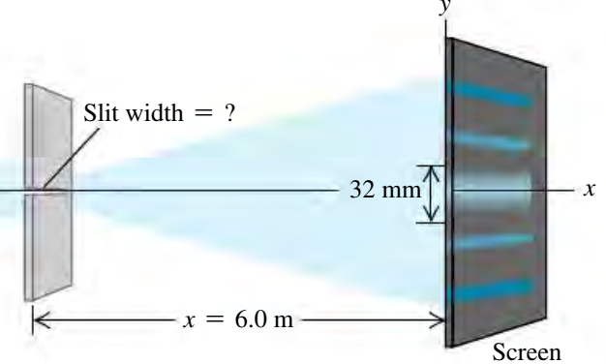
You pass 633-nm laser light through a narrow slit and observe the diffraction pattern on a screen 6.0 m away. The distance on the screen between the centers of the first minima on either side of the central bright fringe is 32 mm. How wide is the slit?
- 2.4 mm
- 0.24 mm
- 24 nm
- 2.4 nm
In Young’s double slit experiment the correct curve between the fringe width β and distance d between the slits is
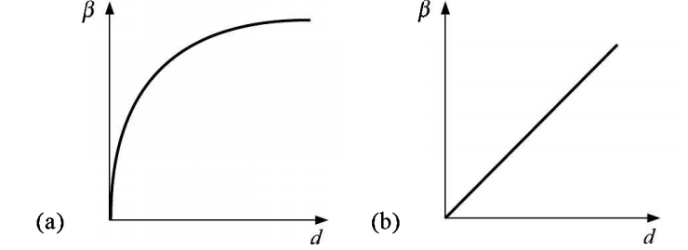
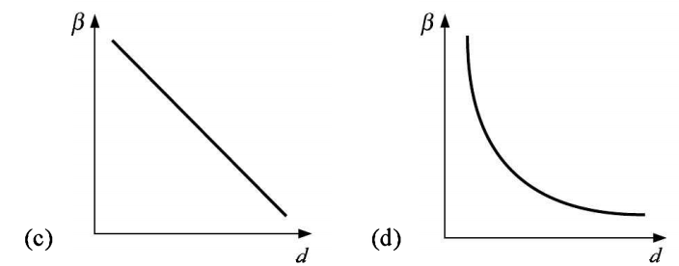
A diffraction pattern is obtained by using beam of red light what will happen, if red light is replaced by the blue light?
(a) Bands disappear.
(b) Bands become broader and farther apart.
(c) No change will take place.
(d) Diffraction bands become narrow and crowded together.
Radio waves diffract around buildings, although light waves do not. The reason is that radio waves
(a) travel with speed larger than c
(b) have much larger wavelength than light
(c) are not electromagnetic waves
(d) none of these
For question number 5 & 6, two statements are given-one labelled Assertion (A) and the other labelled Reason (R).
Select the correct answer to these questions from the codes (a), (b), (c) and (d) as given below.
(a) Both A and R are true and R is the correct explanation of A
(b) Both A and R are true but R is NOT the correct explanation of A
(c) A is true but R is false
(d) A is false and R is also false
Assertion (A): X-rays in vacuum travel faster than light waves in vacuum.
Reason (R): The energy of X-rays photons is less than that of light photons.
Assertion (A) : We cannot get a diffraction pattern from a wide slit illuminated by monochromatic light.
Reason (R) : In diffraction pattern, all the bright
bands are not of the same intensity.
 | Welders wear special goggles or face masks with glass windows to protect their eyes from electromagnetic radiations. Name the radiations and write the range of their frequency.
Consider the following statements in case of Young’s double slit experiment.
(1) A slit S is necessary if we use an ordinary
extended source of light.
(2) A slit S is not needed if we use an ordinary
but well collimated beam of light.
(3) A slit S is not needed if we use a spatially
coherent source of light.
Which of the above statements are correct?
(a) (1), (2) and (3) (b) (1) and (2) only
(c) (2) and (3) only (d) (1) and (3) only
The ratio of the intensities of two light waves is given by 9:1. The ratio of the amplitudes of the waves is
(a)3:1 (b) 1:3 (c) 9:1 (d) 1:9
In Young's double slit experiment, the separation between the slits is 0.1 mm, the wavelength of light used is 600 nm and the interference pattern is observed on a screen 1m away. Find the separation between bright fringes.
(a)6.6 (b)6.0 mm (c)6 m (d)60 cm

Two slits in young’s double slit experiment have widths in the ratio $81 :1$. The ratio of the amplitudes of light waves is
(a) 3 : 1
(b) 3 : 2
(c) 9 : 1
(d) 6 : 1

In Young’s double slit experiment, the minimum amplitude is obtained when the phase difference of super-imposing waves is (where n = 1, 2, 3, …)
(a) zero
(b) (2 n – 1) π
(c) n π
(d) (n + 1) π
Fig. Shows a standard two slits arrangement with slits S₁,S₂,P₁,P₂ are the two minima points on either side of P.
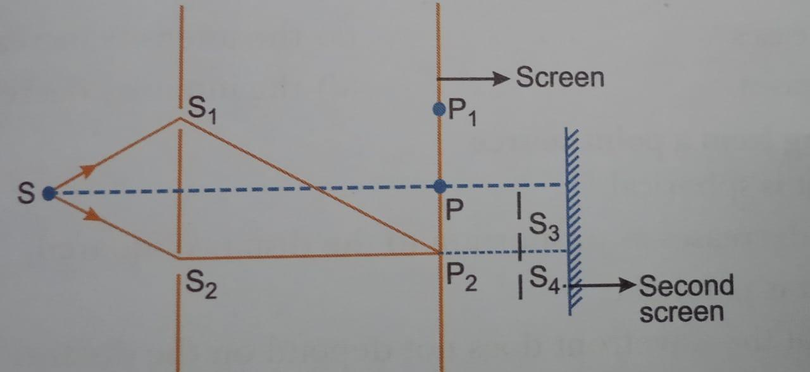
At P₂ on the screen,there is a hole and behind P₂IS A second 2-slit arrangement with slits S_{3,}S₄ AND A second screen behind them
- There would be no interference pattern on the second screen but it would be lighted
- THE second screen would be totally dark
- There Would Be A Single Bright Point On The Second Screen
- There would be a regular slit pattern
TWO WAVES having intensities in the ratio of 9:1 produce interference. The ratio of maximum to minimum intensities is
- 10:8
- 9:1
- 4:1
- 2:1
Consider diffraction pattern for a small pinhole . As the size of the hole increased, the size of the diffraction
- Decreases
- The intensities increases
- Increases
- The intensities decreases
VSA 2 MARKS EACH
(a) Is it possible to have a purely electric wave propagate through empty space—that is, a wave made up of an electric field but no magnetic field?
(b) What about a purely magnetic wave, with a
magnetic field but no electric field?
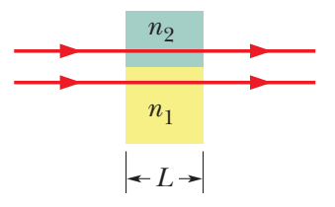
In figure, the two light waves that are represented by the rays have wavelength 550.0 nm before entering media 1 and 2. They also have equal amplitudes and are in phase. Medium 1 is now just air, and medium 2 is a transparent plastic layer of
index of refraction 1.600 and thickness 2.600 μm. Find the phase difference of the emerging waves in wavelengths.
 | Two wavelengths of sodium light of 590 nm and 596 nm are used in turn to study the diffraction taking place at a single slit of aperture 2 × 10^{–6} m. The distance between the slit and the screen is 1.5 m. Calculate the separation between the positions of first maxima of the diffraction pattern obtained in the two cases.
 | A parallel beam of light of wavelength 500 nm falls on a narrow slit and the resulting diffraction pattern is observed on a screen 1 m away. It is observed that the first minimum is a distance of 2.5 mm away from the centre. Find the width of the slit.
 | How will the angular separation and visibility of fringes in Young’s double slit experiment change when (i) screen is moved away from the plane of the slits, and (ii) width of the source slit is increased?
 | What is the diffraction of light? Draw a graph showing the variation of the intensity with angle in a single slit diffraction experiment.
 | In the double slit experiment using light of wavelength 600 nm, the angular width of the fringe formed on a distant screen is 0.1. Find the spacing between the two slits.
 | In a single slit diffraction experiment, the first minima for the red light (660 nm) coincide with the first maxima of some other wavelength $λ.$Find the value of $λ.$
Monochromatic light wavelength 589 nm is incident from air on a water surface. What are the wavelength, frequency and speed of
- Reflected light
- Refracted light
(Refractive index of water is 1.33)
What type of wavefront will emerge from a
(i) point source, and
(ii) distant light source?
Draw a diagram to show refraction of a plane wave front incident in a convex lens and hence draw the refracted wave front.
In a single slit diffraction experiment, the width of the slit is reduced to half its original width. How would this affect the size and intensity of the central maximum?
How does the angular separation between fringes in single-slit diffraction experiment change when the distance of separation between the slit and screen is doubled?
State one feature by which the phenomenon of interference can be distinguished from that of diffraction.
A parallel beam of light of wavelength 600 nm is incident normally on a slit of width ‘a’. If the distance between the slits and the screen is 0.8 m and the distance of 2nd order maximum from the centre of the screen is. 15 mm, calculate the width of the slit.
SA 3 MARKS EACH
 | A carbon dioxide laser emits a sinusoidal electromagnetic wave that travels in vacuum in the negative x-direction. The wavelength is 10.6 μm (in the infrared) and the field is parallel to the z-axis, with E_{max}=1.5MV/m. Write vector equations for and as functions of time and position.
 | Light of wavelength 6 × 10^{–5} cm falls on a screen at a distance of 100 cm from a narrow slit. Find the width of the slit if the first minima lie 1 mm on either side of the central maximum.
 | A soap film of thickness 0.3 mm appears dark when seen by the reflected light of wavelength 580 nm. What is the index of refraction of the soap solution, if it is known to be between 1.3 and 1.5?
 | The ratio of the intensities at minima to the maxima in Young's double slit experiment is 9 : 25. Find the ratio of the widths of the two slits
a) State two differences between interference pattern and diffraction pattern
b) Draw the diagram to show the refraction of the plane wave front when it travels from rarer to denser medium.
Define wave front
Using the Huygens principle prove the laws of refraction of light waves.
Two coherent light wave of intensity 5 x 10⁻² Wm⁻² each super-impose and produce the interference pattern on a screen . At a point where the path difference between the waves is $\frac{λ}{6}.$ Where is wave length of wave, find the
- Phase difference between the waves
- Resultant intensities at the point
- Resultant intensities in terms of the intensities at the maximum
 | In the diffraction due to single slit experiment, the aperture of the slit is 3mm.If the monochromatic light of wave length 620nm is incident normally on the slit, calculate the separation between the first order minima and the third order maxima on the one side of the screen. The distance between the slit and the screen is 1.5 m
 | In Young’s double slit experiment using mono-chromatic light of wavelength X, the intensity of light at a point on the screen where path difference is X, is K units. Find out the intensity of light at a point where path difference is 2λ/3 ?
Laser light of wavelength 640 nm incident on a pair of slits produces an interference pattern in which the bright fringes are separated by 7.2 mm. Calculate the wavelength of another source of light which produces interference fringes separated by 8.1 mm using same arrangement.
Also find the minimum value of the order ‘n’ of bright fringe of shorter wavelength which coincides with that of the longer wavelength.
Yellow light (λ = 6000Å) illuminates a single slit of width 1 x 10-4 m.
Calculate (a) the distance between the two dark lines on either side of the central maximum, when the diffraction pattern is viewed on a screen kept 1.5 m away from the slit;
(b) the angular spread of the first diffraction minimum.
CASE BASED QUESTIONS 4 MARKS
Case-based question
According to superposition principle, the resultant displacement produced due the number of waves at a particular point is the vector sum of displacement produced by each vector at that point. The two sources of light are said to be coherent only when the phase difference between the light waves produced by them is zero or constant. The point at which two waves are in phase or if trough of one wave coincides with the trough of other or crest of one wave coincides with the crest of other then the resultant intensity produced at that point will be larger and amplitude also maximum. Such points are the points where constructive interference takes place. While there are some points where two light waves are not in phase with each other and crest of one wave coincides with the trough of other and vice versa due to which resultant intensity at that point is minimum and amplitude also get decreased. Such points are the points where destructive interference takes place
Q 1.) For coherent sources of light, the phase difference must be___

a) one
b) zero
c) either zero or constant
d) 90°

Q 2.) If the phase difference between two waves is 0, +2π, 4π then,

a) constructive interference will take place
b) destructive interference will take place
c) both a and b
d) interference is not possible

Q 3.) For destructive interference

a) path difference is (n +1/2) times wavelength
b) phase difference is π, -3π, +5π
c) path difference is integral multiple of wavelengths
d) both a and b

Q4) What is the phase difference between consecutive crest and trough in a transverse wave
- π b)0 c) 2π d)4π

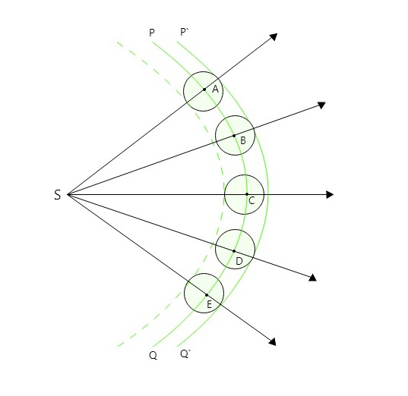
Huygen’s principle is the basis of wave theory of light. It
tells how a wave front propagates through a medium.
According to the Huygen’s principle, each point on a wave front is a source of secondary waves, which add up
to give a wave front at any later time
Figure bellow shows the construction of secondary wave fronts in a medium all the particles which are same phase constitute a wave front a line perpendicular to wave front is called a ray.

- Select the correct option among the following:

a. Christian Huygens, a contemporary of Newton's established the wave theory of light by assuming that light waves were transverse.
b. Maxwell provided the theoretical evidence that light is transverse wave.
c. Thomas Young experimentally proved the wave behavior of light and Huygens' assumption
d. All the statements given above, correctly answer the question "What is light?"

2. The phases of the light wave at c, d, e are Φc, Φd, Φe respectively. It is given that Φc = Φe .
a. Φc cannot be equal to Φd
b. Φd cannot be equal to Φe
c. Φd – Φe) is equal to (Φc – Φe)
d) (Φd – Φe) is not equal to (Φc – Φe)

3. Light waves travelling through air strike the surface of water at an angle. Which of the following statements about the light's wave properties upon entering the water is correct?
a. The light's speed, frequency and wavelength all stay the same
b. The light's speed, frequency and wavelength all change
c. The light's speed and frequency change, but the wavelength stays the same
d. The light's wavelength and speed change, but the frequency stays the same.
4.What is the angle between wave front and ray.
a) 0-degree b) 90-degree c)180-degree d)45-degree

Case-based question

A narrow tube is bent in the form of a circle of radius R, as shown in figure. Two small holes S and D are made in the tube at the positions at right angle to each other. A source placed at S generates a wave of intensity I₀ which is equally divided into two parts: one-part travels along the longer path, while the other travels along the shorter path. Both the waves meet at point D where a detector is placed.
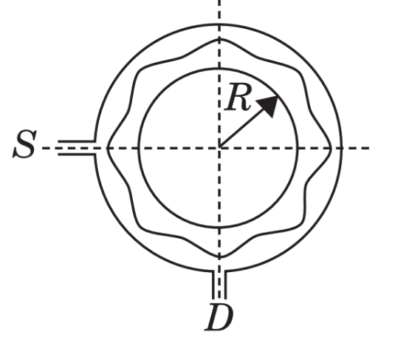

- If a maximum is formed at a detector, then the magnitude of wavelength λ of the wave produced is given by
- ⇨R (b) ⇨R/2 (c) ⇨R/4 (d) All of these
- The maximum intensity produced at D is given by
- 4I₀ (b) 2 I₀ (c) I₀ (d) 3 I₀
- In a Young’s double slit experiment, the intensity at a point where the path difference
is λ/6 (λ – wavelength of the light) is I. If I₀ denotes the maximum intensity, then I/I₀ is equal to
- ½ (b) $\sqrt{3}$/2 (c) 1/ $\sqrt{2}$ (d) ¾
- Two identical light waves, propagating in the same direction, have a phase difference δ. After they superpose the intensity of the resulting wave will be proportional to
- Cos δ (b) cos (δ/2) (c) cos² (δ/2) (d) cos²δ
Read the paragraph carefully and answer the following question.
In our daily life we observe various optical phenomenon but do not realize what is occurring to produce this phenomenon. Light reflected from a film of oil floating on water or soap bubble that reflects a variety of beautiful colour when illuminated by the natural or artificial light sources are the example of one of the important optical phenomenon exhibits by the light wave.
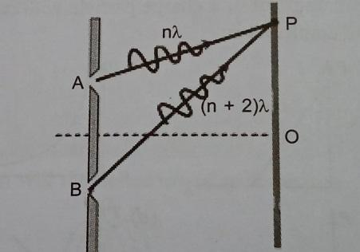
- Which optical phenomenon is exhibiting by the light wave in the paragraph?
- Reflection
- Refraction
- Interference
- Diffraction
- Four independent waves are expressed as
- Y₁ = a₁ sin$ωt$
- Y₂ = a₂ sin$2ωt$
- Y₃ = a₃ cos $ωt$
- Y₄ = a₄ sin $(ωt+π/3)$
- A and C
- A and D
- C and D
- None of these
- The interference phenomenon takes place
- In all waves
- In transverse wave only
- In longitude waves only
- In standing wave only.
- The contrast in the fringes in any interference pattern dependents on
- Fringe width
- Intensity ration of the source
- Wavelength
- Distance between the sources.
Read the paragraph carefully and answer the following question.
When a plane wave front of monochromatic light is incident on a narrow slit, each point of slit behaves as secondary source of light as per Huygen’s principle. These secondary wavelets which travel in different direction. Wavelets emitted by different parts of slit superpose. This gives a broad pattern with central bright region. On both the sides there are alternative bright and dark fringes. Thus the intensity distribution on screen is redistributed. This phenomenon is called diffraction of light due to a narrow slit . The slit width is denoted by a distance of screen from slit is taken as D, wavelength of light is $λ$ and fringe width is $β$.
- What is the ratio of central maximum width to other maxima width?
- 1:2
- 2:1
- 3:2
- 2:3
- When slit width is increased , how would it addect width of central maxima?
- Increase
- Decrease
- Remain same
- May increase or decrease
- On what principle is diffraction of light due to narrow slit based?
- Law of reflection
- Law of refraction
- Principle of YDSE
- Huygen’s principle
- Colour of thin film results from
- Dispersion of light
- Interference of light
- Absorption of light
- Scattering of light

ANSWERS FOR MCQs
 | b. 0.24 mm
 | d
 | d. When red light is replaced by blue light the diffraction bands become narrow and crowded.
 | b. The wavelength of radio waves being much larger than light, has a size comparable to those of buildings, hence diffract from them.
 | d
 | b
Ultraviolet radiations produced during welding are harmful to eyes. Special goggles or face masks are used to
protect eyes from UV radiations. UV radiations have a range of frequency between 1014 Hz – 1016 Hz.
 | a
 | A
 | B
 | (c) 9:1
 | (b) For minima, phase diff. = odd integral multiple of π = (2n-1)π
 | d
 | c
 | a),b)
ANSWERS FOR VSA ( 2 MARKS)
 | (a) no, (b) no A purely electric wave would have a varying electric field. Such a field necessarily generates a magnetic field through Ampere’s law, so a purely electric wave is impossible. In the same way, a purely magnetic wave is impossible: The varying magnetic field in such a wave would automatically give rise to an electric field through Faraday’s law.
Here we have n₁ =1.000 (for the air), n₂ =1.600,
L =2.600 μm, and λ=550.0 nm. Thus,
N₂ - N₁ =$\frac{L }{λ}$ (n₂-n₁)
= $\frac{2.600 ×{ 10}^{-6}}{5.500 × {10}^{-7}} (1.600-1.000)$
= 2.84 Wavelength
Here λ₁= 590 nm and λ₂= 596 nm
d = 2 × 10^{–6} m , D = 1.5 m
Distance of first secondary maximum from the centre of the screen is
X = $\frac{3}{2}\frac{λD}{d}$
For the two wavelengths X₁ = $\frac{3}{2}\frac{Dλ1}{d}$ and X₂ = $\frac{3}{2}\frac{Dλ2}{d}$
Spacing between the first two maximum of sodium lines
X₂ - X₁ = $\frac{3D}{2d}$( λ₂ - λ₁) = 6.75 mm
 | 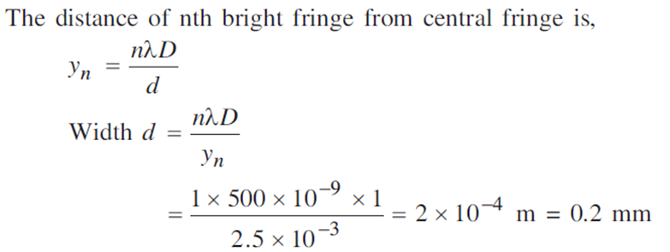
(i) Angular separation=λ/d
It is independent of D; therefore, angular separation remains unchanged if screen is moved away from the slits. But the actual separation between fringes
=λD/d
increases, so visibility of fringes increases.
(ii) When width of source slit is increased, then the angular fringe width remains unchanged but fringes becomes less and less sharp; so visibility of fringes decreases. If the condition s/S < λ/d ,
is not satisfied, the interference pattern disappears. Here s is the size of the source and S its distance from the plane of the two slits.
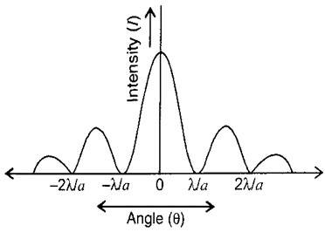
The phenomenon of bending of light around the corner of an obstacle or aperture into a region of geometrical shadow provided the condition of size of obstacle or aperture is comparable to the wave length of light.

 | $$Formula used : Δθ=\frac{λ}{d}$$
For first minima of red light a sin $θ=nλ$_{r}
For first maxima of light of wavelength $λ^{'}$
A sin $θ$’=(2n+1)$\frac{λ^{'}}{2}$Where n=1
Sin $θ^{'}=θ$
- For reflected light v= c/$λ$ c=3x10⁸ m/s
- For refracted light wavelength $λ^{'}=\frac{λ}{μ} v=\frac{c}{μ}$
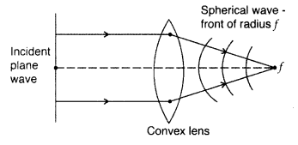
- (i) Point source – Spherical wavefront
(ii) Distant light source – Plane wavefront.

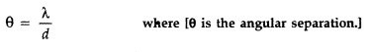
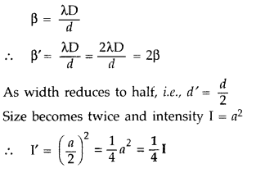
(b)
When the distance D of separation between the slits and the screen is doubled, the angular separation θ remains unchanged.
- In interference all the maxima are of equal intensity.
In diffraction pattern central fringe is of maximum intensity while intensity of secondary maxima falls rapidly.
- 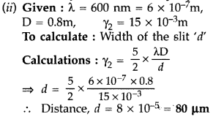
ANSWERS FOR SA ( 3 MARKS)
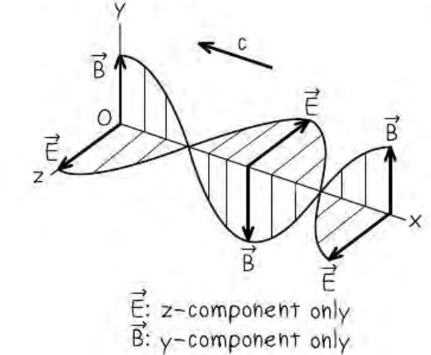
A possible pair of wave functions that describe the
wave are
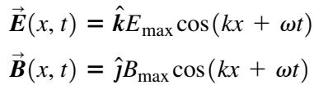
The plus sign in the arguments of the cosine functions indicates that the wave is propagating in the negative x-direction, as it should. Faraday’s law requires that E_{max} = c B_{max}

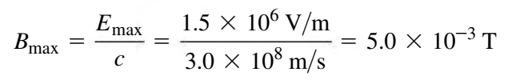
We have λ= 10.6 × 10⁻⁶ m, so the wave number and angular frequency are
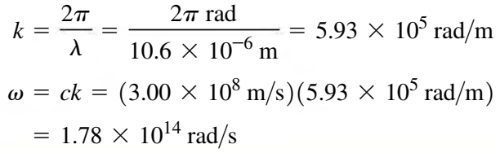
Substituting these values into the above wave functions we get
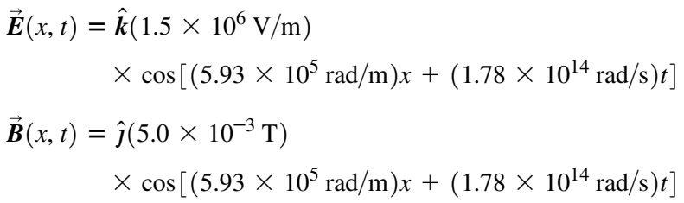
Here n=1 and λ = 6 × 10^{–5} cm
Distance of screen from slit = 100 cm
Distance of first minimum from central maxima = 0.1 cm
Sin θ = $\frac{Distance of first minima from central maxima}{Distace of screen from the slit}$
θ₁ = $\frac{0.1}{100}$ = $\frac{1}{1000}$
We know that a Sin θ = n λ, a = $\frac{λ }{1 }$ = 0.06 cm
The path difference is 2μt
For destructive interference it can be 2μt = $λ/2$, 3$\frac{λ}{2},$ 5$\frac{λ}{2}$ and so on
Therefore μ = $\frac{λ }{4t }$ , $\frac{3λ }{4t }$, $\frac{5λ }{4t }$ and so on

μ = 1.45
Intensity of light (using classical theory) is given as
I ∝ (Width of the slit)
∝ (Amplitude)²
$\frac{I_{max}}{I_{min}}$ = $\frac{{(a_{1}+a_{2})}^{2}}{{(a_{1}-a_{2})}^{2}}$ =$\frac{25}{9}$
$\frac{a_{1}+a_{2}}{a_{1}-a_{2}}$ = $\frac{5}{3}$
$\frac{a_{1}}{a_{2}}$ = $\frac{4}{1}$
$\frac{I_{1}}{I_{2}}$ = $\frac{W_{1}}{W_{2}}$ =$\frac{{(a_{1})}^{2}}{{(a_{2})}^{2}}$
$\frac{W_{1}}{W_{2}}$ =$\frac{{(4)}^{2}}{{(1)}^{2}}$=$\frac{16}{1}$

Differences between interference and diffraction patterns:
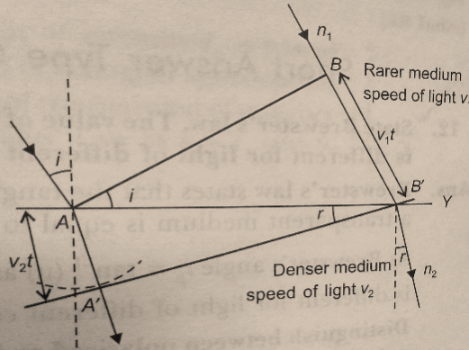
(1) Interference is the superposition of light waves from two different wave fronts originating from the same source, while the diffraction is the interaction of light waves from different parts of the same wave front.
(2) In an interference pattern, fringes may or may not be of the same width, while in diffraction pattern, they are never of the same width.
b)

Wave front: A wave front is the locus of all the points in space which receives the light waves from a source in phase.
According to the Huygens principle, each point of the wave front is the source of secondary disturbance and the wavelengths emitting from these points spread out in all directions with the speed of the wave. A common tangent to all wavelets in the forward direction gives the new position of wave front at a later time.
From 𝛥ABB’, sin i = BB’/AB’ = ʋ₁ × t/AB’
From 𝛥AA’B’, sin r = AA’/AB’ = ʋ₂ × t/AB’
∴ sin i/sin r = ʋ₁/ʋ₂
Which is Snell’s laws of refraction
- Phase difference = $\frac{2μ}{λ}$
- I = 2 I_{o} (1+cos$ϕ$) = 2 I_{o} (1+cos$π/3$)
- Maximum intensity = 4 I_{o}
Condition for minima a sin$θ$=n$λ$
Condition for secondary maxima a sin$θ$=(n$+1/2)λ$
For first order minima n=1
For third order maxima n=3
These sources are needed to ensure that the position of maxima and minima do not change with time.
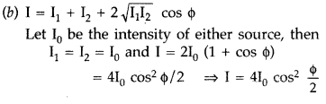
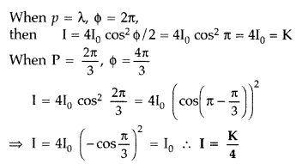
Distance between two bright fringes = Fringe width
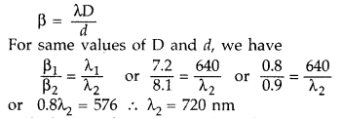
Calculation of minimum value of order: for n to be minimum
(n + 1)th maxima of shorter wavelength should coincide with nth maxima of longer wavelength
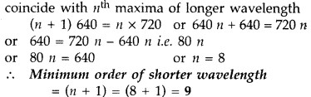
(a) Distance between two dark lines, on either
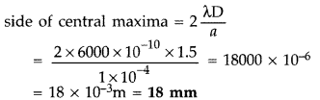
(b) Angular spread of the first diffraction minimum (on either side)
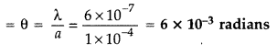
ANSWERS FOR CBQ (4 MARKS)
 | 1)c 2) a 3)d 4)a
 | 1.b 2.c 3.d 4. b
d, all of these
b, 2I₀
d, ¾
c, cos²(δ/2)
 | - C ii) b iii) a iv) b
 | - B ii) b iii) d iv) b

XII PHY CH_11_DUAL NATURE OF RADIATION AND MATTER
Q. NO | QUESTION
MCQ s 1 MARK EACH
If maximum velocity with which an electron can be emitted from a photo cell is 4x108cm/sec, the stopping potential is (mass of electron = 9 x 10-31 kg) (a) 30 volt
(b)45 volt
(c) 59 volt
(d) Information is insufficient
The De-Broglie wavelength associated with a tennis ball of mass 60 gram moving with a velocity
10 m/sec will be (h= 6.6 x 10-34 Js)
(a) 10⁻¹⁶ m
(b) 10⁻²⁵ m
(c) 10⁻³³ m
(d) 10⁻³⁴ m
Consider a beam of electrons (each electron with energy E₀) incident on a metal surface kept in an evacuated chamber. Then
(a) no electrons will be emitted as only photons can emit electrons
(b) electrons can be emitted but all with an energy E₀
(c) electrons can be emitted with any energy, with a maximum of E₀ -φ (φ is the work function)
(d) electrons can be emitted with any energy, with a maximum of E₀
Threshold wavelength for a metal having work function Wo is λ. What is the threshold wavelength for a metal having work function 2W0?
(a)4λ
(b)2 λ
(c) λ/2
(d) λ/4
The work function of a metal is independent of
(i) nature of the surface of the metal
(ii) dimensions of the metal
(iii) properties of the metal
(iv) abundance of the metal
(a) (i) only
(b) (i) and (iii)
(c) (ii) and (iii)
(d) (ii) and (iv)
Assertion : Photosensitivity of a metal is high if its work function is small.
Reason : Work function =hf0, where f0 is the threshold frequency.
A) Both assertion and reason are true and reason is the correct explanation of the assertion.
B) Both assertion and reason are true but reason is not correct explanation of the assertion.
C)Assertion is true but the reason is false.
D)Both the assertion and reason are false
What is the ratio of the de Broglie wavelengths of proton and an alpha particle, if they are accelerated by the same potential difference?
- 2√2: 1
- 3:2
- 3√2: 1
- 2: 1

The stopping potential V0 for photoelectric emission from a metal surface is plotted along with the y-axis and frequency v of incident light along the x-axis. A straight line is obtained as shown. Planck’s constant is given by

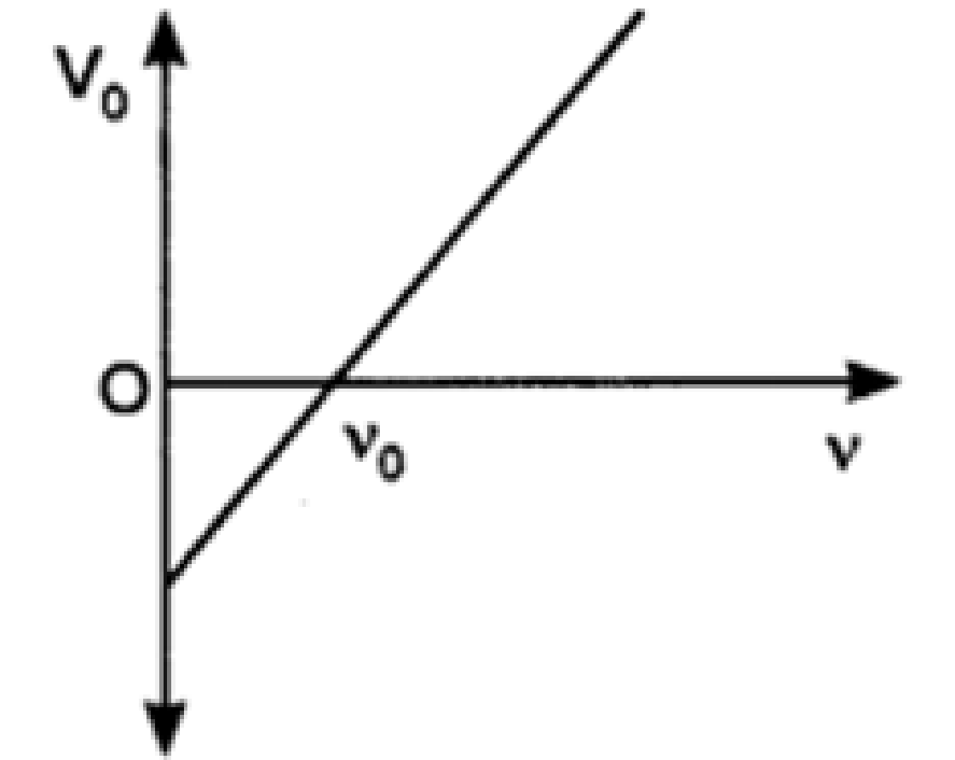

- product of the slope of the line and charge on the electron
- intercept along y-axis divided by the charge on the electron
- product of the intercept along x-axis and mass of the electron
- the slope of the line

When light is incident on a metal surface the maximum kinetic energy of emitted electrons
(a) vary with intensity of light
(b) vary with frequency of light
(c) vary with speed of light
(d) vary irregularly
Which of the following metals is not sensitive to visible light?
(a) Caesium
(b) Sodium
(c) Rubidium
(d) Cadmium

Calculate the de Broglie wavelength associated with the electron which has a kinetic energy of 5 eV.
a)5.47 Å
b)2.7 Å
c)5.9 Å
d)None of the above

Assertion : The energy (E) and momentum (p) of a photon are related by p=E/c
Reason : The photon behaves like a particle.
A) Both assertion and reason are true and reason is the correct explanation of the assertion.
B) Both assertion and reason are true but reason is not correct explanation of the assertion.
C)Assertion is true but the reason is false.
D)Both the assertion and reason are false.

VSA 2 MARKS EACH
 | An alpha particle and a proton are accelerated from rest by the same potential. Find the ratio of their de-Broglie wavelength
 | (a) Define photoelectric work function? What is its unit?
 | Explain briefly the reasons why wave theory of light is not able to explain the observed features in Photoelectric effect?
 | How does a burglar alarm fixed in your entrance door of your house works?
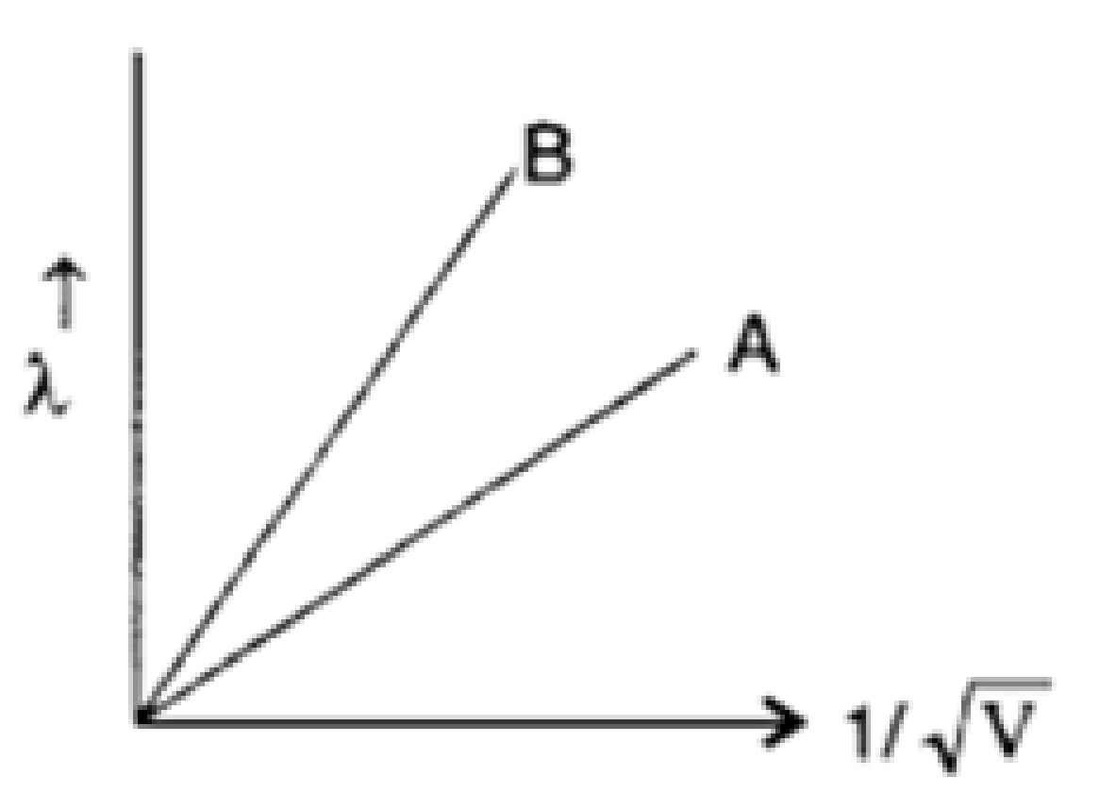
Two lines, A and B, in the plot given below show the variation of de-Broglie wavelength, λ versus 1/$√$V, Where V is the accelerating potential difference, for two particles carrying the same charge. Which one of two represents a particle of smaller mass?

 | Write Einstein’s photoelectric equation and point out any two characteristic properties of photons on which this equation is based.
 | A proton and an electron have same kinetic energy. Which one has greater de-Broglie wavelength and why?
(i) Define the term ‘threshold frequency’ as used in photoelectric effect.
(ii) Plot a graph showing the variation of photoelectric current as a function of anode potential for two light beams having the same frequency but different intensities I₁ and I₂ (I₁ > I₂).
 | Write the basic features of photon picture of electromagnetic radiation on which Einstein’s photoelectric equation is based.
 | Do all the electrons that absorb a photon come out as photoelectrons?
 | Light of wavelength 3500 Å is incident on two metals A and B. Which metal will yield more photoelectrons if their work functions are 5 eV and 2 eV respectively?
SA 3 MARKS EACH
 | Draw a graph showing the variation of stopping potential with frequency of the incident radiations. What does the slope of the line with the frequency axis indicate? Hence define threshold frequency?
(i)Draw a graph showing the variation of de Broglie
wavelength λ of a particle of charge q and mass m, with
the accelerating potential V.
(ii)An α-particle and a proton have the same de-Broglie wavelength equal to 1Å. Explain with calculations, which of the two has more kinetic energy.
 | The photon emitted during the de-excitation from the 1st excited level to the ground state of hydrogen atom is used to irradiate a photo cathode of a photocell, in which stopping potential of 5 V is used. Calculate the work function of the cathode used.
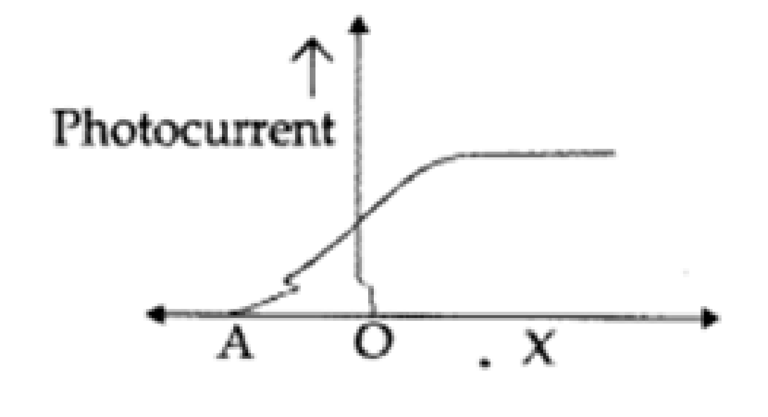
The given graph shows the variation of photocurrent for a photosensitive metal:
(a) Identify the variable X on the horizontal axis.
(b) What does the point A on the horizontal axis represent?
(c) Draw this graph for three different values of frequencies of incident radiation v₁ v₂ and v₃ (v₁ > v₂ > v₃) for same intensity.
(d) Draw this graph for three different values of intensities of incident radiation I₁ I₂ and I₃ (I₁ > I₂ > I₃) having same frequency.
The following table gives the values of work functions for a few sensitive metals.
S. No. | Metal | Work function(eV)
1. | Na | 1.92
2. | K | 2.15
3. | Mo | 4.17
If each of these metals is exposed to radiations of wavelength 3300nm, which of these will not exit photoelectrons and why?
 | Define threshold wavelength for photoelectric effect? Debroglie wavelength associated with an electron associated through a potential difference V is? What will be the new wavelength when the accelerating potential is increase to 4V?
(a) Define photoelectric work function? What is its unit?
(b) In a plot of photoelectric current versus anode potential, how does
(i) Saturation current varies with anode potential for incident radiations of different frequencies but same intensity?
(ii) The stopping potential varies for incident radiations of different intensities but same frequency.
(iii) Photoelectric current vary for different intensities but same frequency of radiations? Justify your answer in each case?
 | Write Einstein’s photoelectric equation and point out any two characteristic properties of photons on which this equation is based.
 | The momentum of photon of electromagnetic radiation is 3.3 X10⁻²⁹ kg-m/s. Find out the frequency and wavelength of the wave associated with it.
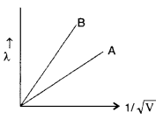
Two lines, A and B, in the plot given below show the variation of de-Broglie wavelength, λ versus 1/√V , Where V is the accelerating potential difference, for two particles carrying the same charge. Which one of two represents a particle of smaller mass ?
CASE BASED QUESTIONS 4 MARKS
Read the paragraph:
The Figure shows the variation of photoelectric current measured in a photo cell circuit as a function of the potential difference between the plates of
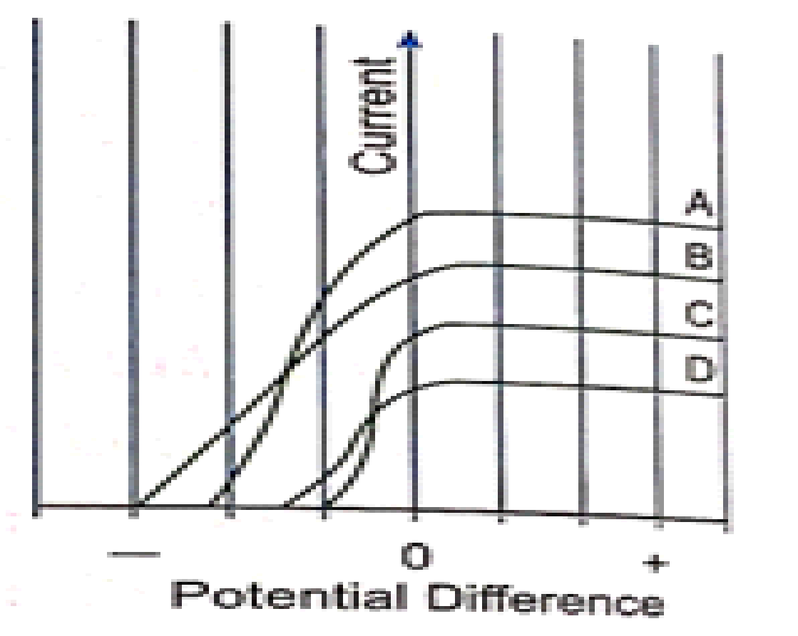
the photo cell when light beams A, B, C and D of different wavelengths are incident on the photo cell Examine the given figure and answer the following questions:
1. Which light beam has the highest frequency?
(a) A (b) B (c) C (d) D

2. Which light beam ejects photoelectrons will maximum momentum?
(a) D (b) C (c) B (d) A

3. Consider beam of electrons (each electrons with energy E_{o}) incident on a metal surface kept in an evacuated chamber then
(a) electrons can be emitted with any energy, with a maximum of E_{o}
(b) electrons can be emitted with any energy, with a maximum of E_{o}-ϕ, (ϕ is the work function)
(c) electrons can be emitted but all with an energy, E_{o}
(d) no electrons will be emitted as only photons can emit electrons.

4. Sodium and copper have work functions 2.3 eV and 4.5 eV respectively. Then the ratio of their threshold wavelengths is nearest to
a) 1:2 b) 1:4 c) 2:1 (d) 4:1
Case Study Question
According to wave theory of light, the light of any frequency can emit electrons from metallic surface provided the intensity of light be sufficient to provide necessary energy for emission of electrons, but according to experimental observations, the light of frequency less than threshold frequency cannot emit electrons; whatever be the intensity of incident light. Einstein also proposed that electromagnetic radiation is quantized.
If photoelectrons are ejected from a surface when light of wavelength λ1 = 550 nm is incident on it. The stopping potential for such electrons is Vs =0.19. Suppose the radiation of wavelength λ2 = 190 nm is incident on the surface.
(i) Photoelectric effect supports quantum nature of light because
(A) there is a minimum frequency of light below which no photoelectrons are emitted.
(B) the maximum K.E. of photoelectric depends only on the frequency of light and not on its intensity.
(C) even when the metal surface is faintly illuminated, the photo electrons leave the surface immediately.
(D) electric charge of the photoelectrons is quantized.
(a) A, B, C
(b) B, C
(c) C, D
(d) A, D, C

(ii) In photoelectric effect, electrons are ejected from metals, if the incident light has a certain minimum
(a) wavelength
(b) frequency
(c) amplitude
(d) angle of incidence
(iii) Calculate the stopping potential Vs2 of surface.
(a) 4.47
(b) 3.16
(c) 2.76
(d) 5.28
(iv) Calculate the work function of the surface.
(a) 3.75
(b) 2.07
(c) 4.20
(d) 3.60
Photoelectric effect is the phenomenon of emission of electrons from a metal surface, when radiations of suitable frequency fallon them. The emitted electrons are called photoelectrons and the current so produced is called photoelectric current.
(i) With the increase of intensity of incident radiations on photoelectrons emitted by a photo tube, the number of photoelectrons emitted per unit time is
(a) increases | (b) decreases
(c) remains same | (d) none of these
(ii) It is observed that photoelectron emission stops at a certain time t after the light source is switched on. The stopping potential (V) can be represented as
(a) 2(KEmax/e) | (b) (KEmax/e)
(c) (KEmax/3e) | (d) (KEmax/2e)
(iii) A point source of light of power 3.2 x 10-3 W emits monoenergetic photons of energy 5.0 eV and work function 3.0 eV. The efficiency of photoelectron emission is 1 for every 106 incident photons. Assume that photoelectrons are instantaneously swept away after emission. The maximum kinetic energy of photon is
(a) 4 eV | (b) 5 eV
(c) 2 eV | (d) Zero
(iv) Which of the following device is the application of Photoelectric effect?
(a) Light emitting diode | (b) Diode
(c) Photocell | (d) Transistor

ELECTRON EMISSION- Minimum energy required to emit the electron from the surface of conductor
is called work function ( W or φ_{o}) . It is measured in eV (electron volt).
1 eV- The energy gained by an electron when it is accelerated by a potential difference of 1 volt.
Methods of electron emission-(i) Thermionic emission, (ii) Field emission, (iii) Secondary emission,
(iv) Photoelectric emission
Work function (φ_{o})- The minimum energy that must be supplied to liberate the most weakly bound surface electrons from a metal without giving them any velocity is called the work function of the
metal. Work function is measured in electron volt (eV). Work function depends on the properties of metal and the nature of its surface.
- Photoelectric emission occurs only when the incident light has more than a certain minimum:
(a) power
(b) wavelength
(c) intensity
(d) none of these
2. Light of wavelength λ falls on a metal having work function
hc/λ0 . Photoelectric effect will take place only if:
(a) λ ≥ λο
(b) λ ≥ 2λο
(c) λ ≤ λο
(d) λ = 4λο
3. A radio transmitter operates at a frequency 880 kHz and a
power of 10 kW. The number of photons emitted per second
(a) 1.72 × 10³¹
(b) 1.327 x 10²⁵
(c) 1.327 x 10⁷
(d) 1.327 x 10⁴⁵
4. The threshold wavelength for photoelectric emission from a
material is 3900 Å. Photoelectrons will be emitted when
this material is illuminated with monochromatic radiation
from:
(a) 50 W infrared lamp
(b) 1 W infrared lamp
(c) 1W ultraviolet lamp
(d) none of these
5. 1 eV is the energy gained by an electron when it is
accelerated by a potential difference of 1 volt. Its value in
joule is
(a) 1.602 x 10⁻¹⁵
(b) 1.612 x 10⁻¹⁹
(c) 2.602 x 10⁻¹⁹
(d) none of these
ANSWERS FOR MCQs
 | B
 | C
 | D
 | C
 | (d) The work function of a metal depends upon the properties of the metal and the nature of its surface.
 | B) Both assertion and reason are true but reason is not correct explanation of the assertion.
 | (a)2√2: 1
 | (a)product of the slope of the line and charge on the electron
 | (b) vary with frequency of light
 | (d) Cadmium
 | (a) 5.47 Å
 | A) Both assertion and reason are true and reason is the correct explanation of the assertion.
ANSWERS FOR VSA ( 2 MARKS)
 | 1: root 2
Definition
eV
 | Explaination
 | In burglar alarms, a photocell is placed or fixed at the doorway. An invisible light like ultraviolet light is falling continuously on it. If any person enters through the door it interrupts the beam of ultraviolet light falling on the photocell due to which there will be sudden change in photoelectric current and hence the bell start ringing. So one can identify or get rectified when someone is coming to the doorsteps.
 | 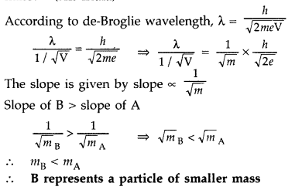
If radiation of frequency (ν) greater than threshold frequency (ν_{o}) irradiate the metal surface, electrons are emitted out from the metal.
So Einstein’s photoelectric equation can be given as 𝐾max= = 1/ 2 m𝑣 ² = hν – h𝜈_{o}
Characteristic properties of photons:
(i) Energy of photon is directly proportional to the frequency (or inversely proportional to the wavelength.
(ii) In photon-electron collision, total energy and momentum of the system of two constituents remains constant.
 | 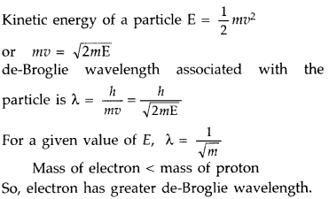
(i) Threshold frequency. The minimum frequency v0 which the incident light must possess so as to eject photoelectrons from a metal surface, is called threshold frequency of the metal.
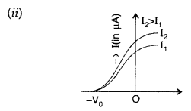
 | Features of the photons: (i)Photons are particles of light having energy E = hν and momentum p = h/λ (ii) Photons travel with the speed of light in vacuum, independent of the frame of reference. (iii) Intensity of light depends on the number of photons crossing unit area in a unit time
 | No, most electrons get scattered into the metal. Only a few come out of the surface of the metal.
 | Metal B will yield more photo electrons. work function of Metal B is lower than that of A for the same wavelength of light. Hence metal B will give more electrons.
ANSWERS FOR SA ( 3 MARKS)
Graph
Plank constant
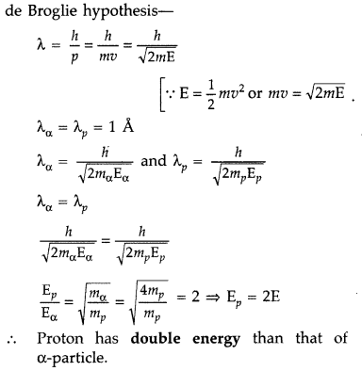
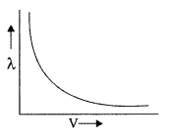

 | 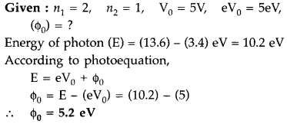
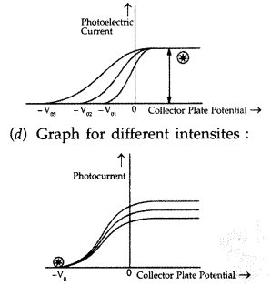
(a) ‘X’ is a collector plate potential.
(b) ‘A’ represents the stopping potential.

That material will not emit photoelectrons whose work function is greater than the energy of the incident radiation.
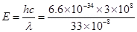
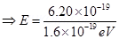
E = 3.76 eV
Hence work function of is (4.17eV) which is greater than the energy of the incident radiation (= 3.76 eV) so will not emit photoelectrons.
The maximum wavelength of radiation needed to cause photoelectric emission is known as threshold wavelength.
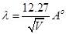
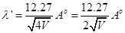
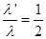
Or
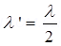
(a) The minimum amount of energy required to take out an electron from the surface of metal. It is measured in electron volt (eV).
(b) (i) Saturation current depends only on the intensity of incident radiation but is independent of the frequency of incident radiation.
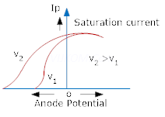
(ii) Stopping potential does not depend on the intensity of incident radiations.
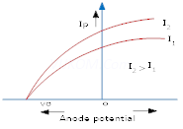
(iii) Photoelectric current is directly proportional to the intensity of incident radiations, provided the given frequency is greater than the threshold frequency.
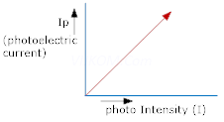
If radiation of frequency (ν) greater than threshold frequency (ν₀) irradiate the metal surface, electrons are emitted out from the metal. So Einstein’s photoelectric equation can be given as 𝐾_{max}= = 1/ 2 m𝑣 ² = hν – h𝜈₀ Characteristic properties of photons:
(i) Energy of photon is directly proportional to the frequency (or inversely proportional to the wavelength. (ii) In photon-electron collision, total energy and momentum of the system of two constituents remains constant.
 | Given, h = 6.63 10⁻³⁴ J/s, c= 3 x10⁸ m/s and p = 3.3 x 10 ⁻²⁹ - kg m/s Momentum, p= ℎ𝜈 𝑐 or ν = 𝑝𝑐/ ℎ = 3.3 𝑥 10⁻²⁹ 𝑥 3 𝑥 10⁸ /6.63 𝑥 10⁻³⁴ = 1.5 x 10¹³ Hz ,λ = 𝑐 𝜈 = 3 𝑥 10⁸ X1.5 𝑥 10¹³ = 2 x 10⁻⁵ m
ANSWERS FOR CBQ (4 MARKS)
1)(b) B
2) (C)B
3) (d) no electrons will be emitted as only photons can emit electrons
4) (c) 2:1
(a) A, B, C
(b) frequency
(a) 4.47 eV
(b) 2.07 eV
(i) (a)
(ii) (b)
(iii) (c)
(iv) (c)
- (d)
- (c)
- (a)
- (c)
- (d)

XII PHY CH_12_ATOMS
Q. NO | QUESTION
MCQ s 1 MARK EACH
When hydrogen atom is in its first excited level, it’s radius is
(a) four times, it ground state radius
(b) twice times, it ground state radius
(c) same times, it ground state radius
(d) half times, it ground state radius.
According to the Bohr theory of H-atom, the speed of the
electron, its energy and the radius of its orbit varies with
the principal quantum number n, respectively, as
(a) 1/n, n2, 1/n2
(b) n, 1/n2, n2
(c) n, 1/n2, 1/n2
(d) 1/n, 1/n2, 1/n2
In terms of Bohr radius r0, the radius of the second Bohr orbit of a hydrogen atom is given by
(a) 4 r0
(b) 8 r0
(c) √2 r0
(d) 2 r0
In which of the following series, does the 121.5 nm line of the spectrum of the hydrogen atom lie?
(a) Lyman series
(b) Balmer series
(c) Paschen series
(d) Brackett series.
In a hydrogen atom, which of the following electronic transitions would involve the maximum energy change
(a) n = 2 to n = 1
(b) n = 3 to n = 1
(c) n = 4 to n = 2
(d) n = 3 to n = 2
According to Bohr the difference between the energies of the electron in the two orbits is equal to
(a) hν
(b) hc/λ
(c) both (a) and (b)
(d) neither (a) nor (b)
Which one did Rutherford consider to be supported by the results of experiments in which α-particles were scattered by gold foil?
(a) The nucleus of an atom is held together by forces which
are much stronger than electrical or gravitational forces.
(b) The force of repulsion between an atomic nucleus and
an α-particle varies with distance according to inverse
square law.
(c) α-particles are nuclei of Helium atoms.
(d) Atoms can exist with a series of discrete energy levels
In Rutherford’s α -particle scattering experiment, what will be correct angle for α scattering for an impact parameter b = 0 ?
(a) 90º
(b) 270º
(c) 0º
(d) 180º
Which of the following parameters is the same for all hydrogen-like atoms and ions in their ground states?
(a) Radius of the orbit
(b) Speed of the electron
(c) Energy of the atom
(d) Orbital angular momentum of the electron
Energy levels A, B, C of a certain atom correspond to increasing value of energy i.e., EA > EB > EC. If λ1, λ2 and λ3 are the wavelengths of radiation corresponding to transition C to B, B to A and C to A respectively, which of these of the following is correct?
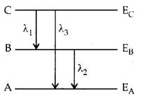
(a) λ3 = λ1 +d λ2
(b) λ3 = λ1λ2/(λ1+λ2)
(c) λ1 + λ2 + λ3 = 0
(d) λ23 = λ21 and λ22
VSA 2 MARKS EACH
Find the ratio of energies of photons produced due to transition of an electron of hydrogen atom from its (i) second permitted energy level to the first level, and
(ii) the highest permitted energy level to the first permitted level.
 | Estimate the distance of closest approach to the nucleus (Z = 80) if a 7.7 MeV a-particle before it comes momentarily to rest and reverses its direction.
 | A 12.5 eV electron beam is used to bombard gaseous hydrogen at room temperature. Up to which energy level the hydrogen atoms would be excited?
SA 3 MARKS EACH
(i) State Bohr’s quantization condition for defining stationary orbits. How does de-Broglie hypothesis explain the stationary orbits?
(ii) Find the relation between the three wave-lengths λ1, λ2 and λ3 from the energy level diagram shown below.
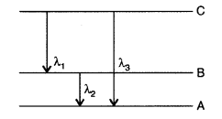
(a) The radius of the innermost electron orbit of a hydrogen atom is
5.3 × 10-11 m. Calculate its radius in n = 3 orbit.
(b) The total energy of an electron in the first excited state of the hydrogen atom is -3.4 eV. Find out its
(i) kinetic energy and
(ii) potential energy in this state.
 | Calculate the wavelengths of the second member of Lyman series and second member of Balmer series. In which region of spectrum they belongs to?
CASE BASED QUESTIONS 4 MARKS
Rutherford scattering experiment: It is also known as the Geiger Marsden experiment.
The trajectory traced by α-particles in the coulomb field of target nucleus is shown in the figure below.
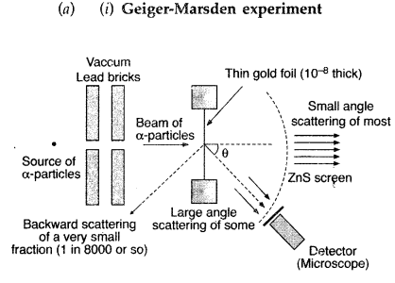

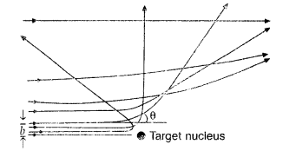
- Why most of the α-particles are passing straight?
- What is the impact parameter of such α-particles?
- Why few α-particles deviates with large angles?
- How this led to estimate the size of the nucleus?
Hydrogen spectrum and wavelength:
In an experiment in which an electric discharge of high voltage is made to pass through a gaseous hydrogen molecule, the hydrogen molecules dissociate. The H atoms get excited by this high power and possess an energy that emits electromagnetic radiation of discrete frequencies. The spectrum of hydrogen thus consists of several series of lines named after the scientists who discovered them; for example, the Lyman series, the Pfund series, and many more. The quantised electronic structure of an atom is perfectly illustrated by the hydrogen spectrum and helps us understand it better.
The electrons transit from lower energy levels to higher energy levels when the hydrogen atom absorbs photons say n = 1 to n = 2. The electron loses the photon and jumps back to lower energy levels to stabilise the atom again, say n = 2 to n = 1. This photon belongs to some wavelength, and the amount of energy radiated depends on the energy levels, which makes the wavelength different for different transitions. For example: when the electron jumps from n = 4 to n = 1, the wavelength corresponding to it is 97 nm. This is known as hydrogen spectrum wavelength.
In his observation, Rydberg concluded that the series of lines in the hydrogen spectrum could be described as an equation determining the wavenumber. The first five of these series are named Lyman, Balmer, Paschen, Brackett, and Pfund, out of which only Balmer belongs to the visible region in the electromagnetic spectrum. Lyman belongs to UV. Paschen, Brackett and Pfund belong to the IR region.
- According to the findings above Bohr’s model of the hydrogen atom, provides two postulates. What are they?
- When the electron absorbs energy, it is excited to higher quantum numbers. What are are two possibilities for the electron?
ANSWERS FOR MCQs
 | (a) r_{n}= r_{o}.n², where r_{o} is radius of ground-state & r_{n} is radius of nth state. (For first excited state n = 2).
 | (d) 1/n, 1/n2, 1/n2
 | (a) As r α n² , therefore, radius of 2nd Bohr’s orbit = 4 r₀
 | (a) Since 121.5 nm line of spectrum of hydrogen atom lies in ultraviolet region, therefore it is Lyman series.
 | (b) n = 3 to n = 1
 | (c) λ_{IR} > λ_{UV} also wavelength of emitted radiation λ α 1/ΔE
(b) The force of repulsion between an atomic nucleus and
an α-particle varies with distance according to inverse
square law.
 | (d) When b = 0, scattering angle, θ = 180º
 | (d) The orbital angular momentum of electron is independent of mass of orbiting particle & mass of nuclei.
 | (b) λ3 = λ1λ2/(λ1+λ2)
ANSWERS FOR VSA ( 2 MARKS)
 | 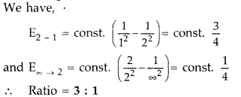
K.E. of the a-particle = Potential energy possessed by beam at distance of closest approach.
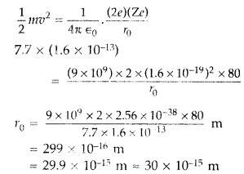
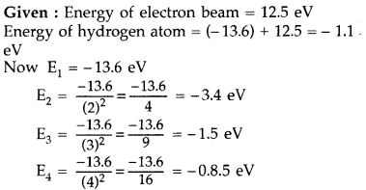
Hydrogen atom will be excited up to third energy level, because energy of electron is less than that of 4th energy level.
ANSWERS FOR SA ( 3 MARKS)
 | 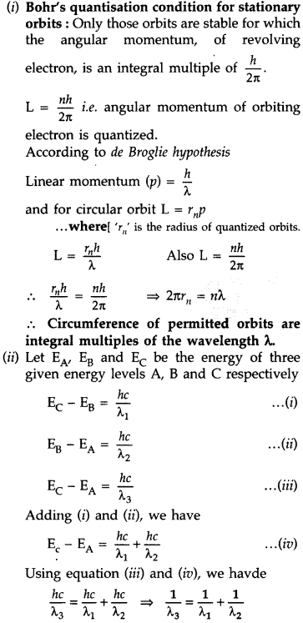
 | 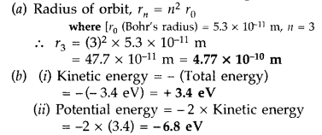
(i) Wavelength of second member of Lyman series : n₁ = 1, n₂ = 3
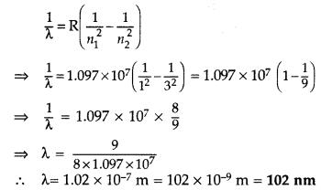
∴ It lies in ultra violet region.
(ii) Wavelength of second member of Balmer series (n₁ = 2, n₂ = 4) similar calculation.
It lies in visible region.
ANSWERS FOR CBQ (4 MARKS)
- It can be concluded that most of the space in the atom is empty.
- For most of the α-particles, impact parameter is large, hence they suffer very small repulsion due to nucleus and go right through the foil.
- As few α-particles are having very less impact parameter they are strongly repelled and deviated by large angle.
- It gives an estimate of the size of nucleus, that it relatively very very small as compared to the size of atom.
- There are circular paths called the orbits around the nucleus in which the electron moves.
- Time is not the factor determining the energy of an electron that revolves in these orbits.
- there are two possibilities: either it completely leaves the atom if the energy is way too much, or it can come back to its normal state after some time. This electron jumping from a high level to a lower level can be achieved in two ways: either it can jump directly to n = 1, or it can be done in steps. If the electron is excited to a level above 2, first it can come to n = 2 and then n = 1.

XII PHY CH_13_NUCLEI
Q. NO | QUESTION
MCQ s 1 MARK EACH
The ratio of nuclear density of ¹²C₆ and ¹⁶O₈ is
a) 3:4 b)3:2 c)3:8 d)1:1
The minimum energy required to free the electron from the ground state of the hydrogen atom is 13.6 eV. What is the energy required in second excited state
a) -13.6eV b)-3.40eV c) -1.51eV d) -0.85eV
For head-on collision of alpha particle incident with nucleus, the impact parameter is
a) 0 b) 1m c) infinite d) cannot be determined
In history class, Sonali had studied that on 6 August 1945 and 9 August 1945, two atom bombs i.e. Little Boy and Fat Man were dropped on Hiroshima and Nagasaki respectively causing great destruction. Her teacher also told her that the natives of these cities are still facing the adverse effects of these bombs. What could be the probable cause?
a) fission process b) fusion process c)both fission and fusion process d) none of these
What is the radius of the nucleus of ²⁷Al₁₃?
a) 1.2×10⁻¹⁵m b) 3.6×10⁻¹⁵m c) 15.6×10⁻¹⁵m d) 10⁻¹⁵m
The perpendicular distance of the initial velocity vector of the alpha particle from the centre of the nucleus is called
a) radius b) distance of closest approach c) diameter d)impact parameter
If the K.E of α-particle incident on gold foil is doubled, the distance of closest approach will be
a) become 4 times b) double c) half d) remain same
What is the ratio of radii of the orbits corresponding to the first excited state and ground state of hydrogen?
a) 1:2 b) 2:1 c) 1:4 d) 4:1
Assertion: An atom is almost empty.
Reason: Experiments on scattering of a-particles demonstrated that the radius of a nucleus was smaller than the radius of an atom by a factor of about 104. This means the volume of a nucleus is about 10⁻¹² times the volume of the atom
a) Both assertion and reason are true and reason is the correct explanation of assertion.
b) Both assertion and reason are true and reason is not the correct explanation of assertion.
c) Assertion is true but reason is false.
d) Assertion is false but reason is true.
Assertion: The minimum orbital angular momentum to the electron in a hydrogen atom is h/2π
Reason: Bohr’s quantization postulate allows discrete stationary orbits.
a) Both assertion and reason are true and reason is the correct explanation of assertion.
b) Both assertion and reason are true and reason is not the correct explanation of assertion.
c) Assertion is true but reason is false.
d) Assertion is false but reason is true.
The longest wavelength in Balmer series of hydrogen spectrum will be
(a) 6557 Ȧ (b) 1216 Ȧ
(c) 4800 Ȧ (d) 5600 Ȧ
The energy of hydrogen atom in the nth orbit is E_{n}, then the energy in the nth orbit of single ionized helium atom is
(a)E_{n}/2 (b)2E_{n}
(c)4E_{n} (d)E_{n}/4
As per Bohr model, the minimum energy(in eV)required to remove an electron from the ground state of double ionized Li atom(Z=3) is
(a)1.51eV (b)13.6eV
(c)40.8eV (d)122.4eV
O2 molecule consists of two oxygen atoms. In the molecule, nuclear force between the nuclei of the two atoms
(a)is not important because nuclear forces are short-ranged
(b)is as important as electrostatic force for binding the two atoms
(c)cancels the repulsive electrostatic force between the nuclei
(d)is not important because oxygen nucleus has equal number of neutrons and protons
The Gravitational force between a H-atom and another particle of mass m will be given by Newton’s law:
F = GMm/r²,where r is in km and
- M=m_{proton} + m_{electron}
- M=m_{proton} + m_{electron} – B/c2(B=13.6 eV)
- M is not related to the mass of the hydrogen atom
- M=m_{proton} + m_{electron} - |V|/c2(|V| =magnitude of the potential energy of electron in the H-atom)

The quantity which is not conserved in a nuclear reaction is
(a)Momentum (b)Charge
(c)Mass (d)None of these
17 | Ratio of the radii of the nuclei with mass numbers 8 and 27 would be  (a)27/8 (b)8/27  (c)2/3 (d)3/2
18 | Binding energy per nucleon of a stable nucleus is  (a)8 eV (b)8 KeV  (c)8 MeV (d)8 BeV
VSA 2 MARKS EACH
In junior classes Sunil had studied that ¹⁶O₈ consists of 8 protons (m_{p}= 1.00727 u), 8 neutrons (m_{n}=1.00866 u) and 8 electrons (m_{e}=0.00055 u), therefore the total mass of ¹⁶O₈ must be 16.12744 u. However, during his higher education, in mass spectroscopy he found out that the mass of ¹⁶O₈ 15.99493 u. What is the reason behind this difference of the masses?
What is the binding energy of ¹⁶O₈?
 | Derive and expression to show whether nuclear density depends on mass number or not.
 | Why did Rutherford use gold foil for alpha scattering experiment? What would have happened if he has used hydrogen foil instead of gold foil?
 | Find the ionization energy and ionization potential of ground state electron in hydrogen atom
 | If both the number of protons and the number of neutrons are conserved in a nuclear reaction like ¹²C₆+¹²C₆🡪²⁰Ne₁₀+⁴He₂,in what way is mass converted into energy?Explain
 | State two characteristics of nuclear force. Why does the binding energy per nucleon decrease with increase in mass number for heavy nuclei like ²³⁵U?
 | An electron and alpha particle have the same de-Broglie wavelength associated with them. How are their kinetic energies related to each other?
 | State the reason, why heavy water is generally used as a moderator in a nuclear reactor?
 | Two nuclei have mass numbers in the ratio 1: 2. What is the ratio of their nuclear densities?
 | The ground state energy of hydrogen atom is -13.6 eV. What are the kinetic and potential energies of the electron in this state?
 | Two nuclei have mass number in the ratio 1 : 3. What is the ratio of their nuclear density?
 | Two nuclei have mass numbers in the ratio 27 : 125. What is the ratio of their nuclear radii?
SA 3 MARKS EACH
 | Using Bohr’s postulates for hydrogen atom, show that the total energy(E) of the electron in the stationary states can be expressed as the sum of kinetic energy(K) and potential energy(U),where K=-1/2U.Hence deduce the expression for the total energy in the n^{th} energy level of hydrogen atom.
Distinguish between nuclear fission and fusion.Show how in both these processes energy is released.
Calculate the energy release in MeV in the deuterium-tritium fusion reaction :
²H 3₁ + ³H_{1🡪}⁴He₂ + n
Using the data :
m(²H₁) = 2.014102 u, m(³H₁)= 3.016049 u,
m(⁴He₂) = 4.002603 u, m_{(n)} = 1.008665 u,
1u = 931.5 MeV/c2
 | Write shortcomings of Rutherford atomic model. Explain how these were overcome by the postulates of Bohr's atomic model.
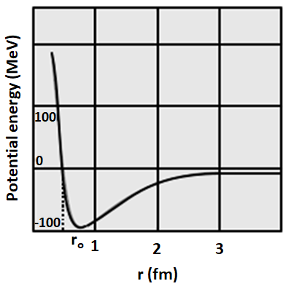

- Analyse the graph and explain, at what distance the repulsion is stronger and at what distance we will be observe attraction?
- What can be concluded about the nature of nuclear force?
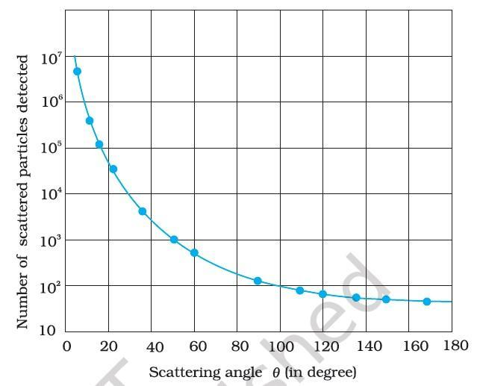

On the basis of the graph explain what observations and conclusions can be drawn regarding an atom.
 | Calculate the shortest wavelength of the spectral lines emitted in Balmer series. (Rydberg constant = 10⁷m⁻¹)
Calculate the energy released in MeV in the following nuclear reaction:
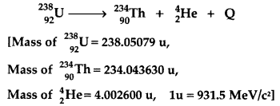
(a) The mass of a nucleus in its ground state is always less than the total mass of its constituents – neutrons and protons. Explain.
(b) Plot a graph showing the variation of potential energy of a pair of nucleons as a function of their separation.
Draw a plot of potential energy of a pair of nucleons as a function of their separation.
Write two important conclusions which you can draw regarding the nature of nuclear forces.
 | Write any three characteristic properties of nuclear force.
 | Calculate the wavelength associated with the electron revolving in the first excited state in hydrogen atom. The ground state energy of the hydrogen atom is -13.6 eV.
 | Write shortcoming of Rutherford atomic model. Explain how these were overcome by the postulates of Bohr’s atomic model.
CASE BASED QUESTIONS 4 MARKS
The fact that more neutrons are produced in fission than are consumed gives the possibility of a chain reaction with each neutron that is produced triggering another fission. The chain reaction is uncontrolled and rapid in a nuclear bomb explosion. It is controlled and steady in a nuclear reactor. In a reactor, the value of the neutron multiplication factor k is maintained at 1.
In fusion, lighter nuclei combine to form a larger nucleus. Fusion of hydrogen nuclei into helium nuclei is the source of energy of all stars including our sun.
- Why is the energy released during both fission and fusion process?
- Why is it difficult to make nuclear fusion reactors?
The Rutherford nuclear model of the atom which involves classical concepts, pictures the atom as an electrically neutral sphere consisting of a very small, massive and positively charged nucleus at the centre surrounded by the revolving electrons in their respective dynamically stable orbits. The electrostatic force of attraction, Fe, between the revolving electrons and the nucleus provides the requisite centripetal force (Fc) to keep them in their orbits. Thus, for a dynamically stable orbit in a hydrogen atom
Fe = Fc
The kinetic energy (K) and electrostatic potential energy (U) of the electron in hydrogen atom are
K= $\frac{e²}{8πε₀r}$ and U= -$\frac{e²}{4πε₀r}$
E= K+U= - $\frac{e²}{8πε₀r}$
1. The total ground state energy of any hydrogen atom is -13.6eV then what is the (i) total energy, (ii) kinetic energy and (iii) potential energy in the first excited state?
2. The ground state of an atom is -13.6eV. What do the negative sign signify?
The mass of a nucleus in its ground state is always less than the total mass of its constituents – neutrons and protons. Explain.
Plot a graph showing the variation of potential energy of a pair of nucleons as a function of their separation.
 | Using the curve for the binding energy per nucleon as a function of mass number A, state clearly how the release of energy in the processes of nuclear fission and nuclear fusion can be explained.
ANSWERS FOR MCQs
 | d
 | c
 | a
 | a
 | b
 | b
 | c
 | d
 | a
 | a
 | (a) 6557 Ȧ
 | (c)4E_{n}
 | (d)122.4eV
 | (a)is not important because nuclear forces are short-ranged
 | (b)M=m_{proton} + m_{electron} – B/c2(B=13.6 eV)
 | (c)Mass
 | (c)2/3
 | (c)8 MeV
ANSWERS FOR VSA ( 2 MARKS)
1. mass defect
2. ΔM= (16.12744 - 15.99493)= 0.13251u= 0.13251×931.5 MeV/c²= 123.43MeV/c²
ΔE_{b}= ΔMc²= 123.43MeV
 | Nuclear density= 3/(4πr₀³)
Gold is highly malleable and the mass of gold atom is more than that of alpha particle
In hydgrogen foil alpha particle will not bounce back as mass of the hydrogen atom is less than the alpha particle.
 | Ionization energy is the energy required to free an electron from the ground state to infinity = E∞-E₁=0-(-13.6/1²)=13.6 eV and the ionization potential will be 13.6 V.[Energy =qV,13.6eV=eV]
In case, the total mass energy of the decay products is less than the mass energy of the original nuclide;(Q value of the process is positive)the energy is liberated.
Though the number of nucleons is same, it is their mass that gets converted into the energy.
The following are the two characteristics of nuclear forces :
(i)Nuclear forces are the strongest forces in nature.
(ii)Nuclear forces depend on spin or angular momentum of nuclei.
B.E. per nucleon decreases with increase in mass number as electrostatic repulsion increases due to increase in number of protons and nucleus becomes less stable.
 | 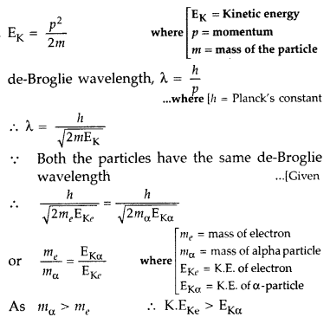
Neutrons produced during fission get slowed if they collide with a nucleus of the same mass. As ordinary water contains hydrogen atoms (of mass nearly that of neutrons), so it can be used as a moderator. But it absorbs neutrons at a fast rate via reaction :
Here d is deutron. To overcome this difficulty, heavy water is used as a moderator which has negligible cross-section for neutron absorption.
 | 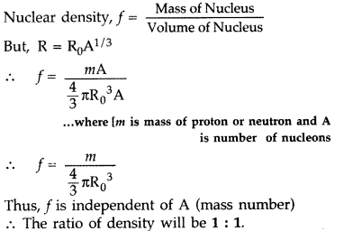
Total energies E= -13.6 Ev
K.E. = -E = 13.6 e V
And P.E. = -2 K.E. = -27.2 e V
As the nuclear density is same for all the nuclei
Therefore ratio of density is 1:1
Here A₁ : A₂ =27 : 125
$$\frac{A_{1}}{A_{2}}=\frac{27}{125}$$
As R =R₀ A^{1/3}
$\frac{R_{1}}{R_{2}}=(\frac{A_{1}}{A_{2}}$)^{1/3}
R₁ : R₂ = 3: 5

ANSWERS FOR SA ( 3 MARKS)
P.E. =-Ke²/r_{n} ---1

K.E. =1/2 mv2 ---2
E= K.E.+P.E. ----3 Mv²/r = Ke²/r² ---4 e⁻
K.E. = 1/2 Ke²/r_{n} ---5
Or, K.E. =-1/2U
Acc. To Bohr’s second postulates, mvr = nh/$2π$
Also, mv²/r_{n}= Ke²/r²
So, r_{n} α n² ---6
En = -1/2(e²/4$π$ε)x $π$e²m/εn²h²
= -me⁴/8n²ε²h² , which is the total energy in nth energy level of hydrogen atom.
So, En α 1/n²

Nuclear fission :The breaking of a heavy nucleus into two or more lighter nuclei is called nuclear fission.
Nuclear Fusion : The joining of two lighter nuclei to form a heavy nucleus is called nuclear fusion.
In nuclear fission and fusion both, the binding energy per nucleon of the daughter nuclei is more than that of the parent nuclei. The difference in binding energy is released in the form of energy. This is due to conversion of some mass into energy.
The energy released in the reaction is calculated as :
Q= [m(²H₁)+m(³H₁)-m(⁴He₂)-m(n)]x 931.5MeV
Q= [2.014102+3.016049-4.002603-1.008665]x931.5MeV
Q= 0.018883x931.5MeV=17.59 MeV
Two important limitations of Rutherford model are:
i) According to Rutherford model, electron orbiting around the nucleus, continuously radiates energy due to the acceleration; hence the atom will not remain stable.

2) As electron spirals inwards, its angular velocity and frequency change continuously, therefore it should emit a continuous spectrum. But an atom like hydrogen always emits a discrete line spectrum.

Bohr's postulates overcome these limitations by:

(1) Bohr stated that negatively charged electrons revolve around positively charged nucleus in certain orbits called stationary orbits. The electrons does not radiate energy when in stationary orbits.

(2) The quantum of energy is released or absorbed when an electron jumps from one orbit to another.
a) Repulsion at r<r₀; Attraction at r>r₀
b) Nuclear force is short range force (or any other salient feature of nuclear force)
 | Observations and conclusions of Rutherford’s alpha scattering experiment.
 | $\frac{1}{λ}$= R[$\frac{1}{n₁ }$ - $\frac{1}{n₂}$], n₁= 2 & n₂= $∞$; λ= 4000 Å
 | 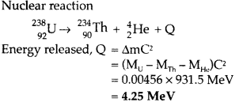
(a) When nucleons approach each other to form a nucleus, they strongly attract each other. Their potential energy decreases and becomes negative. It is this potential energy which holds the nucleons together in the nucleus. The decrease in’ potential energy results in the decrease in the mass of the nucleons inside the nucleus.
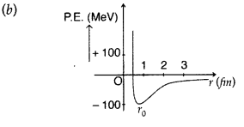
(a) Nuclear force between two nucleons falls rapidly to zero as their distance is more than a few femtometres. This explains constancy of the binding energy per nucleon for large-size nucleus.
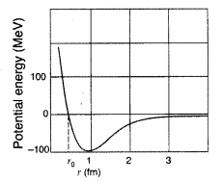
(b) Graph explains that force is attractive for distances larger than 0.8 fin and repulsive for distances less than 0.8 fm.
The following are the three characteristics properties----
(a) Nuclear force is a short range force
(b) Nuclear forces show the saturation effect.
(c) Nuclear forces are charge independent.
In the first excited state (n=2), $E_{2}=\frac{-13.6}{2^{2}} eV$
$K.E.=\frac{13.6}{2^{2}} eV$
= 3.4 eV= 3.4 x 1.6x10⁻¹⁹ J
$λ_{2}=\frac{h}{\sqrt{2mK}}$
$λ_{2}=\frac{6.63*{10}^{-34}}{\sqrt{2*{10}^{-31}*{3.4*1.6*10}^{-19}}}$
= 0.6663x10⁻⁹ m
$=6.663A^{0}$
The Rutherford’s models suffers from several difficulties. The revolving electrons which are constantly accelerated towards the centre, must continuously emit electromagnetic radiation according to classical theory. Hence they should describe paths of less and less radii and ultimately fall into the nucleus. Further in the Rutherford’s model the electron can revolve in orbits of all possible radii and so they should emit continuous radiation of all frequencies. But the experimental fact is that atoms like hydrogen emit line spectra of only certain fixed frequencies.

Bohr suggested that the stability of the atom and the emission of sharp spectral lines could both be explained by applying Planck’s quantum theory of the atom. He proposed that-----

(i) An electron can move only in those orbits for which the angular momentum is an integral multiple of h/2π (mvr = nh/2π).
(ii) The electron does not emit radiation while moving in the orbit in spite of its accelerated motion. Hence atom is stable.
(iii) A quantum of energy called photon is emitted when an electron jumps from an orbit of higher energy to an orbit of lower energy. Hence the emitted spectrum has fixed frequencies.
Bohr’s postulates though successful, were arbitrary without physical interpretation.

ANSWERS FOR CBQ (4 MARKS)
a) fission- total binding energy of fragmented nuclei is more than the parent nucleus
fusion- binding energy per nucleon of the fused heavier nuclei is more than the binding energy nucleon of the lighter nuclei
b)
1. T.E=-3.4eV; K.E=3.4eV; P.E= -6.8eV
2. it is bound to the nucleus with electrostatic force.
 | (a) When nucleons approach each other to form a nucleus, they strongly attract each other. Their potential energy decreases and becomes negative. It is this potential energy which holds the nucleons together in the nucleus. The decrease in’ potential energy results in the decrease in the mass of the nucleons inside the nucleus.
- Nuclear fission : Binding energy per nucleon is smaller for heavier nuclei than the middle ones i.e. heavier nuclei are less stable. When a heavier nucleus splits into the lighter nuclei, the B.E./nucleon changes (increases) from about 7.6 MeV to 8.4 MeV. Greater binding energy of the product nuclei results in the liberation of energy. This is what happens in nuclear fission which is the basis of the atom bomb.
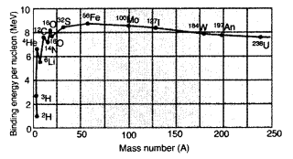
(b) Nuclear fusion : The binding energy per nucleon is small for light nuclei, i.e., they are less stable. So when two light nuclei combine to form a heavier nucleus, the higher binding energy per nucleon of the latter results in the release of energy.

XII PHY CH-14_SEMICONDUCTOR ELECTRONICSMATERIALS DEVICES AND SIMPLE CIRCIUTS
Q. NO | QUESTION
MCQ s 1 MARK EACH
Acceptor Level of a P-Type semiconductor
a) lies at the middle of Energy Band
b) Above the valence band
c) Below the conduction band
d) Inside the valence band

Which will be better to use as a diode for rectifier
a) Si b) Ge c) As d) Al

Voltage Regulation of d.c fluctuating Signal based upon
a) Avalanche Breakdown
b) Zener Breakdown
c) Reverse Saturation Current
d) Cut-in-Voltage

To get constant D.C output in a full wave rectifier
a) Capacitor is connected in series with load resistance
b) An inductor is connected in parallel with the load resistance
c) A capacitor is connected in parallel with the load resistance
d) A Zener diod is connected in parallel with the load resistance

Light Emitting Diode is based upon
a) Electron-Holes recombination in reverse bias
b) Electron-Holes recombination in forward bias
c) Electron-Holes recombination in Zero bias
d) Electron-Holes recombination by absorbing incident photon emerging
Energy Band Gap
a) Is the energy Gap between bottom of conduction band and top of valence band
b) E_{g}>3eV for Insulator
c) doesnot exit in metal, CB and VB overlap
d) all of the above

A semiconducting device is connected in a series circuit with a battery and a resistance. A current is found to pass through the circuit. If the polarity of the battery is reversed, the current drops to almost zero. The device may be
(a) a p-type semiconductor
(b) an intrinsic semiconductor
(c) a p-n junction
(d) an n-type semiconductor.
Reverse bias applied to a junction diode
(a) lowers the potential barrier
(b) raises the potential barrier
(c) increases the majority carrier current
(d) increases the minority carrier current
A p-n junction diode can be used as
(a) condenser
(b) regulator
(c) amplifier
(d) rectifier
In a junction diode, the holes are due to
(a) extra electrons
(b) neutrons
(c) protons
(d) missing of electrons
Application of a forward bias to a p-n junction
(a) widens the depletion zone
(b) increases the potential difference across the depletion zone
(c) increases the number of donors on the n side
(d) decreases the electric field in the depletion zone
The depletion layer in the p-n junction region is caused by
(a) drift of holes
(b) diffusion of charge carriers
(c) migration of impurity ions
(d) Drift of electrons.
Depletion layer consists of
(a) mobile ions
(b) protons
(c) electrons
(d) immobile ions
The increase in the width of the depletion region in a p-n junction diode is due to
(a) forward bias only
(b) reverse bias only
(c) both forward bias and reverse bias
(d) increase in forward current
If a small amount of antimony is added to germanium crystal
(a) it becomes a p-type semiconductor
(b) the antimony becomes an acceptor atom
(c) there will be more free electrons than holes in the semiconductor (d) its resistance is increased
Which one of the following statement is false?
(a) Pure Si doped with trivalent impurities gives a p-type semiconductor.
(b) Majority carriers in a n-type semiconductor are holes.
(c) Minority carriers in a p-type semiconductor are electrons.
(d) The resistance of intrinsic semiconductor decreases with increase of temperature.
17 | The threshold voltage for germanium diode is  (a)0.6V (b)0.4V (c)0.2V (d)0.1V
18 | The energy gap of conductor, semiconductorand insulator are E₁,E₂, and E₃. Then analyze the correct option  - E₁>E₂>E₃ (b) E₁=E₂=E₃ (c) E₁<E₂>E₃ (c)E₃>E₂>E₁
VSA 2 MARKS EACH
Silicon atoms are doped with Arsenic and the majority charge carrier concentration is 4.5× 10^16 m^-3. Silicon atoms are doped with Indium and majority charge carrier concentration is 5×10^15 m^-3. What is the intrinsic carrier concentration of Si.
(a) 1.5×10^16 m^-3,
(b) 15×10^16 m^-3,
(c) 0.9×10^15 m^-3,
(d) 9×10^16 m^-3.
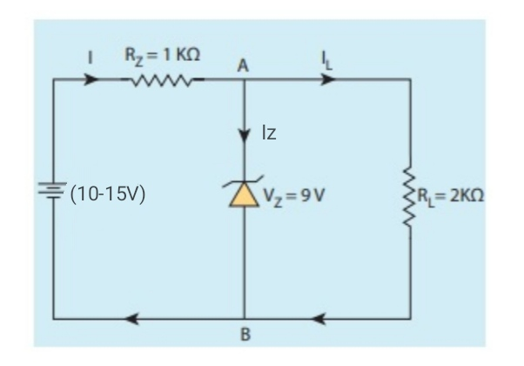
a)Find the current IL through the load resistance. [1]
(b)When the unregulated supply voltage attains it's maximum value. Find the voltage across the resistance Rz=1Kohm. [1]
n-type semiconductor is made by doping Pentavalent elements with pure Tetravalent semiconductor. Which one of the following will be a dopant for n-type semiconductor
(a) ₃₁Ga, (b) ₄₉In, (c) ₃₃As, (d) ₁₃Al
 | A p-n photodiode is made of a material with a band gap of 2.0 eV. Calculate the minimum frequency of the radiation that can be absorbed by the material.
 | An LED is constructed from a p-n junction diode using GaAsP. The energy gap is 1.9 eV. Calculate the wavelength of the light emitted by the LED.
 | Carbon, silicon and germanium atoms have four valence electrons each. Their valence and conduction bands are separated by energy band gaps represented by (E_{g})C, (E_{g})Si and (E_{g})Ge respectively. Arrange their band gap energy according to ascending order.
 | List out the crystal structure of: (a) an intrinsic and (b) an extrinsic semiconductor.
 | On the basis of energy band diagrams, distinguish between (i) metals (ii) an insulator and (iii) a semiconductor
SA 3 MARKS EACH
 | Draw the I-V characteristics curve for a p-n junction diode both for forward biasing and reverse biasing with cut in voltage 0.2V, breakdown voltage 6V, reverse saturation current is in the order of microampere. Forward bias current 10mA for 0.7V and 20mA for 0.8V. Find the forward biased dynamic resistance in the given voltage range. [3 marks]
(i)How does an emf is generated in a solar cell, when light falls on it. [2marks]
(ii)Why are Si(Eg =1.1eV) and GaAs(Eg=1.53eV) are preferred materials rather than the material like CdS or CdSe(Eg=2.4eV) for solar cells? [1mark]
 | The temperature dependence of intrinsic carrier concentration ni is given by, ni=no exp(-Eg/2KBT) where no is constant and KB=1.38×10^-23 J/K is the Boltzmann constant. The ratio of conductivity at 600K to the conductivity at 300K is 1.12×10^4.What is the band gap of the semiconductor Eg in eV?
 | On what factors on which the barrier potential of a p-n junction depends?
C and Si both have same lattice structure; having 4 bonding electrons in each. However, C is insulator whereas Si is intrinsic semiconductor.
Give reasons to support your answer.
 | Draw the energy band diagram to distinguish between Conductors, semiconductors and insulators with examples.
 | With the help of a circuit diagram, show the biasing of a light emitting diodes. Explain its two advantages over conventional incandescent lamps.
 | Draw a circuit diagram of a full-wave rectifier using p-n junction diodes. Explain its working and show the input-output waveforms.
 | With the help of a suitable diagram, explain the formation of depletion region in a p-n junction. How does its width change when the junction is : (i) forward bias and (ii) reverse bias
A semiconductor has equal electron and hole concentration, of 6 x 10⁸ m⁻³. On doping with certain impurity, electron concentration increases to 8 x 10¹² m⁻³.
(i) Identify the new semiconductor obtained after doping.
(ii) Calculate the new hole concentration, and
(iii) How does energy gap vary with doping?

 | Define the terms potential barrier and depletion region for a p – n junction diode. State how the thickness of depletion region will change when the p – n junction diode is ( i ) forward biased ( ii ) reverse biased.
In the following diagrams, identify which of the diodes are forward biased and which are reverse biased ?
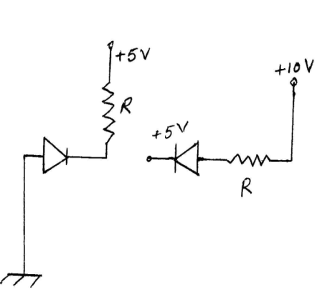

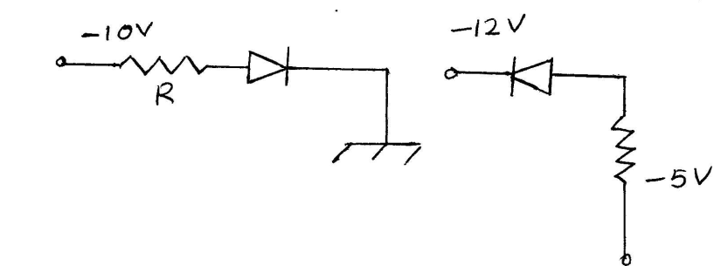
CASE BASED QUESTIONS 4 MARKS
Consider that the Si or Ge crystal contains N atoms. Electrons of each atom will have discrete energies in different orbits. The electron energy will be same if all the atoms are isolated, i.e., separated from each other by a large distance. However, in a crystal, the atoms are close to each other (2 Å to 3 Å) and therefore the electrons interact with each other and also with the neighbouring atomic cores. The overlap (or interaction) will be more felt by the electrons in the outermost orbit while the inner orbit or core electron energies may remain unaffected. Therefore, for understanding electron energies in Si or Ge crystal, we need to consider the changes in the energies of the electrons in the outermost orbit only. For Si, the outermost orbit is the third orbit (n = 3), while for Ge it is the fourth orbit (n = 4). The number of electrons in the outermost orbit is 4 (2s and 2p electrons). Hence, the total number of outer electrons in the crystal is 4N. The maximum possible number of outer electrons in the orbit is 8 (2s + 6p electrons).
So, out of the 4N electrons, 2N electrons are in the 2N s-states (orbital quantum number l = 0) and 2N electrons are in the available 6N p-states. Obviously, some p-electron states are empty. This is the case of well separated or isolated atoms.
Q. 1.1 The energy of electrons of atoms of a substance will be same if:
- atoms are isolated.
- atoms are closely spaced.
- atoms are excited.
- atoms are charged.

Q.1.2 In a crystal, the distance between two atoms is:
- 200 Å to 300 Å
- 2 Å to 3 micron
- 2 Å to 3 Å
- 2 mm to 3 mm

Q.1.3. The overlap (or interaction) will be more felt by the electrons when they are:
(A) in the outermost orbit.
- in the innermost orbit.
- free.
- in any orbit.

Q. 1.4. For Silicon and Germanium, the outermost orbits are respectively: (A)n = 3 and n = 5
- n = 4 and n = 3
- n = 5 and n= 4
(D)n = 3 and n = 4
or
Q. 1.5. The maximum possible electrons in an orbit is:
- 8 (2s + 6p electrons)
- 8 (6s + 2p electrons)
C)8 (4s + 4p electrons
(D)8 (1s + 7p electrons)
It is a heavily doped p-n junction which under forward bias emits spontaneous radiation. The diode is encapsulated with a transparent cover so that emitted light can come out. When the diode is forward biased, electrons are sent from n → p (where they are minority carriers) and holes are sent from p → n (where they are minority carriers). At the junction boundary, the concentration of minority carriers increases as compared to the equilibrium concentration (i.e., when there is no bias). Thus at the junction boundary on either side of the junction, excess minority carriers are there which recombine with majority carriers near the junction. On recombination, the energy is released in the form of photons. Photons with energy equal to or slightly less than the band gap are emitted. When the forward current of the diode is small, the intensity of light emitted is small. As the forward current increases, intensity of light increases and reaches a maximum. Further increase in the forward current results in decrease of light intensity. LED's are biased such that the light emitting efficiency is maximum The V-I characteristics of a LED is similar to that of a Si junction diode. But, the threshold voltages are much higher and slightly different for each colour. The reverse breakdown voltages of LED's are very low, typically around 5 V. So care should be taken that high reverse voltages do not appear across them. LED's that can emit red, yellow, orange, green and blue light are commercially available.

Q.2.1. LED is a:
- Lightly doped p-n junction diode.
- Heavily doped p-n junction diode.
- Moderately doped p-n junction diode.
D)Two back to back p-n junction diode.
Q.2.2. LED emits light:
- when reversed biased?
- When forward biased.
- When forward or reverse biased.
- When heated.

. Q.2.3. During recombination at the junction, emitted photons have:
- Energy greater than the band gap.
- Energy equal to or slightly less than the band gap.
- Energy which has no relation with the band gap.
- Very low energy compared to band gap.

Q.2.4. Threshold voltage of LED is:
- lower compared to other p-n junction diodes and slightly different for each colour.
- Higher compared to other p-n junction diodes and slightly different for each colour.
- Higher compared to other p-n junction diodes and same for all colours.
- lower compared to other p-n junction diodes and same for all colours.
or
Q. 2.5. The reverse breakdown voltages of LED's are: (A)very low and typically around 0.5 V.
- very low and typically around 5 V.
c)very high and typically around 50 V.
(D)very low and typically around 0.05 V.
If an alternating voltage is applied across a diode in series with a load and a pulsating voltage will appear across the load only during the half cycles of the ac input during which the diode is forward biased. Such rectifier circuit is called a half-wave rectifier. The reverse saturation current of a diode is negligible and can be considered equal to zero for practical purposes.

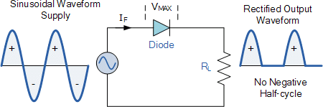
- If input frequency of signal in half wave rectifier is 50 Hz then the output frequency will be
  - 25 Hz
  - 50 Hz
  - 100 Hz
  - Uncertain

- If input frequency of signal in full wave rectifier is 50 Hz then the output frequency will be
  - 25 Hz
  - 50 Hz
  - 100 Hz
  - Uncertain

- Rectifier converts-
  - AC to DC
  - DC to AC
  - AC to AC of different waveform
  - All of these

- Full wave rectifier can be used over half wave rectifier because Full wave rectifier is-
  - More energy efficient
  - More energy consuming
  - More handy to use
More cost effective to manufacture

A solar cell is basically a p-n junction which generates emf when solar radiation falls on the p-n junction. It works on the same principle (photovoltaic effect) as the photodiode, except that no external bias is applied and the junction area is kept much larger for solar radiation to be incident because we are interested in more power. A p-Si wafer of about 300 μm is taken over which a thin layer (~0.3 μm) of n- Si is grown on one-side by diffusion process. The other side of p-Si is coated with a metal (back contact). On the top of n-Si layer, metal finger electrode (or metallic grid) is deposited. This acts as a front contact. The metallic grid occupies only a very small fraction of the cell area (<15%) so that light can be incident on the cell from the top. The generation of emf by a solar cell, when light falls on, it is due to the following three basic processes: generation, separation and collection—
generation of e-h pairs due to light (with hν > E).
- Working principle of solar cell is same as:
a) Photodiode
- Zener diode
- LED
- Half wave rectifier

- Which type of external biasing is applied in Solar cell?
  - Forward
  - Reverse
  - both (a) and (b)
  - No external biasing is applied

- Which of the following is true for a solar cell?
  - hv < E
  - hv>E
  - E = hv
  - None of these

- What is the principle of Solar cell?
  - Photodiode
  - Zener diode
  - LED
  - Photovoltaic Effect

or
- In a solar cell,
  - Junction area is large
  - Junction area is small
  - Junction area is negligible
None of these
ANSWERS FOR MCQs
 | b
 | (a) Reverse saturation current in Si and Ge is in the order of nA and microampere respectively. So Si is more suitable to use as a diode material in rectifier circuit.
 | b
 | c
 | b
 | d
 | C
 | B
 | D
 | D
 | D
 | B
 | D
 | B
 | C
 | B
 | c
 | d
ANSWERS FOR VSA ( 2 MARKS)
(a) 1.5×10^16 m^-3.
ne=4.5×10^16 m^-3, nh=5×10^15 m^-3. Laws of mass action ne×nh=ni^2.
 | (a) IL=VL/RL=VZ/RL=4.5Ma
 | Al=[Ne]3S²3P¹, As=[Ar]3d¹⁰4s²4p³ ,In=[Kr]4d¹⁰5s²5p¹ , Ga=[Ar]3d¹⁰4s²4p¹ only As is pentavalent.
 | 5x10 ¹⁴Hz
 | 654 nm
 | (Eg)C > (Eg)Si > (Eg) Ge
Intrinsic semiconductor: - in case of intrinsic semiconductor the four electrons of the outermost orbit are shared with neighbor electrons covalently. At a temperature close to absolute zero all the electrons in the crystal are tied up strongly by these bonds.
Extrinsic semiconductor:- as this form of semiconductor is the impure form hence due to addition of some impurity there will be some excess of holes and electrons in the crystal.
Conductor: - there is no gap between conduction band and valance band
Semiconductor: - the gap between conduction band and valance band is less than 3 eV
Insulator: - the gap between conduction band and valence band is greater than 3 eV
ANSWERS FOR SA ( 3 MARKS)
forward bias curve is given in NCERT Class XII book,example 14.4,page 482. And the reverse bias current will be rapidly growing at -6V.
Dynamic resistance=(0.8-0.7) V/(20-10) mA=10 Ohm.
i)generation of e-h pair when light having energy larger than band gap energy fall on the junction, ii) separation of electron and hole due to electric field of depletion region, iii) electrons and holes are collected at front and back contact of n- and p-side respectively.
Energy of maximum solar irradiance is near about 1.5eV. Si and GaAs have Eg= 1.1eV and 2.4eV respectively, but CdS has band gap 2.4eV greater than incident photon energy.
Eg=2×1.38×10^-23×(600×300) /(600-300) ×ln(1.12×10^4) in Volt
=0.96 eV
 | (1) type of semiconductor material (2) amount of doping (3) temperature
 | The four bonding electrons in the case of C lie in the second orbit, whereas in the case of Si they lie in the third.
 | Correct diagram showing Eg=0 for conductors, Eg<3 eV for Semiconductors and Eg>3 eV for Insulators
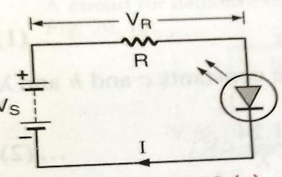
In LED the biasing will be forward bias.
Advantage of LED over incandescent lamp:-
- Long life
- Less power consumption
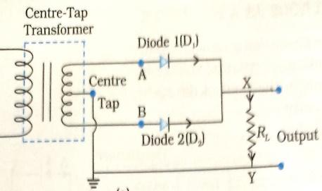
Working of full wave rectifier: - a full wave rectifier contains two diode with a centre tapped transformer. For one of the half cycle first diode will be in forward bias and for second half cycle second diode will be in forward bias hence at the output segment both cycle will be available, hence we get a complete rectified full wave.

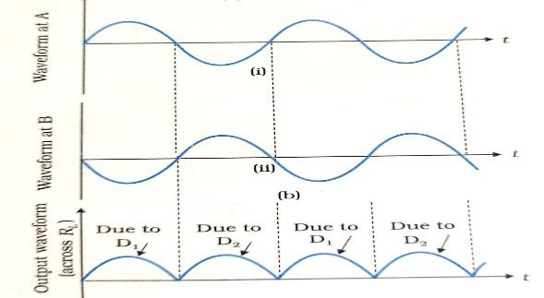
Input output wave form of full wave rectifier: -

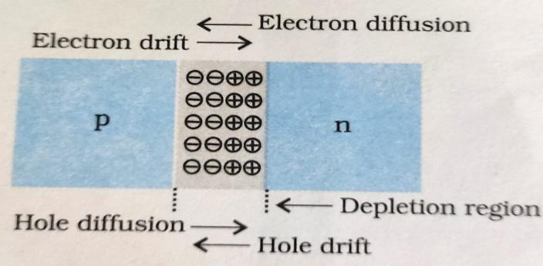
Depletion Region in p-n junction: - in the region of contact, a cloud of free electrons in the n-type crystal diffuses across the boundary to the left into the p-type crystal in the same manner as gas atoms diffuse through a porous pot. Since the electron leaves the n-crystal, that side of the junction acquires a positive potential, while p-crystal gain electrons and acquires negative potential. This positive and negative potential produces potential barrier or depletion region.
In forward bias depletion region reduces where as in reverse bias depletion region increases.
Given n_{i} = 6 x 10⁸ m⁻³, n_{e} = 8 x 10¹² m⁻³
(i) The new semiconductor is n-type, because n_{e} > n_{i}.
(ii) From formula, n_{e} n_{h} = n_{i}² we get, n_{h} = (6 x 10⁸)²/8 x 10¹² = 4.5 x 10⁴ m⁻³
(iii) Since conductivity is increased due to donor electrons, so, energy gap decreases.
Defination of potential barrier
(I )decreases (ii )increases
 | ( i)Reverse biased ( ii)Forward biased (ii i)Reverse biased( iv)Forward biased
ANSWERS FOR CBQ (4 MARKS)
1.1.Option (A) is correct.

  - Option (C) is correct

  - Option (A) is correct.

  - Option (D) is correct Or Option (A) is correct
  - Option (B) is correct.

  - Option (B) is correct

  - Option (B) is correct.

  - Option (B) is correct. Or 2.5. Option (B) is correct
- B
- C
- A
- A
a
d
b
d or a

